BLUETTI's AC200P Remains a Popular Choice for Mobile Power Needs
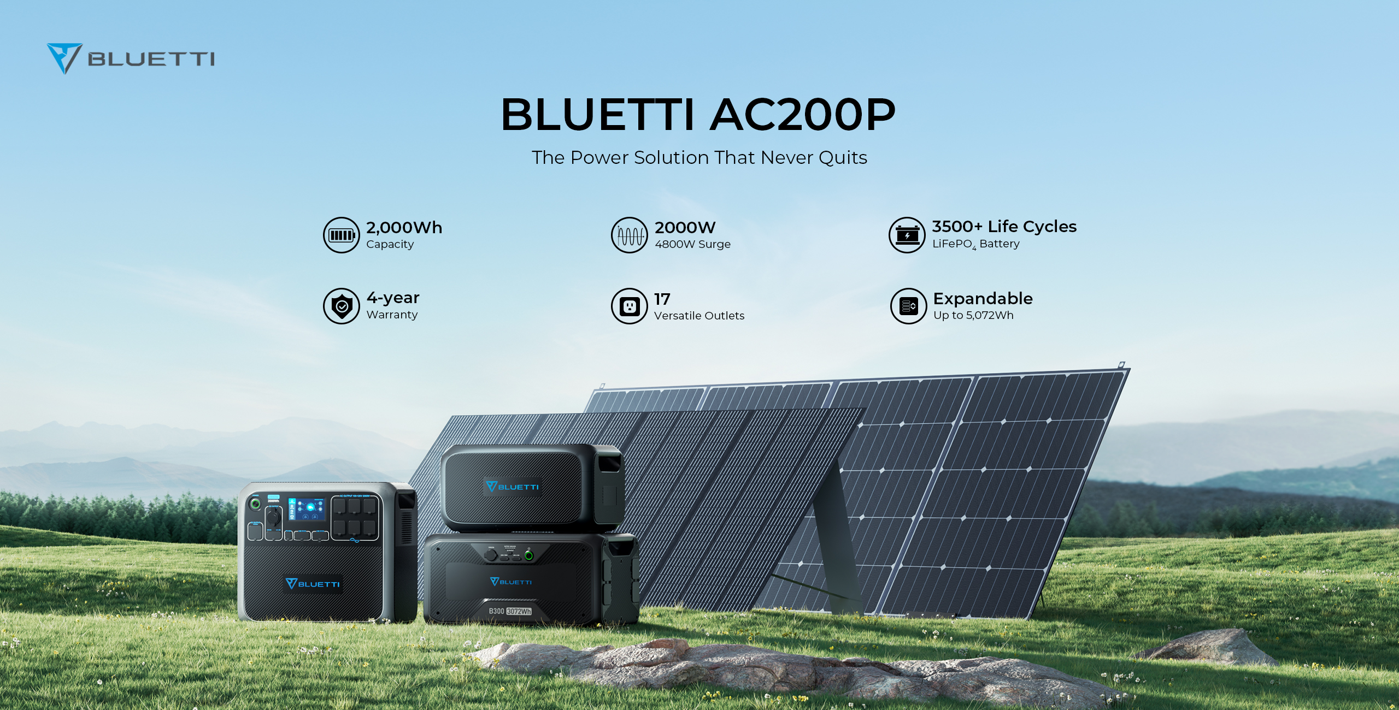
The AC200P power station, made by BLUETTI, a leading provider of portable power solutions, continues to be a top choice for outdoor enthusiasts and homeowners alike, three years after its initial release. With a 2,000W inverter, a 2,000Wh LiFePO4 battery, 7 charging methods, and 17 outlets, the AC200P meets the power needs of users in nearly all scenarios, whether indoors or outdoors.

Great mobile power
What makes the AC200P stand out among competitors is its great capabilities. The AC200P with 2,000W output (4,800W surge) can power various outdoor activities such as camping, RVing, and boating. During power outages, the AC200P is a lifesaver, keeping critical appliances running, such as medical equipment, working devices, refrigerators, and lights, giving users peace of mind at all times.

Durable and expandable battery
The AC200P also features a durable LiFePO4 battery that is a safer, longer-lasting, and more eco-friendly battery type than the Lithium-ion variation. At over 3,500 charge cycles, the AC200P outlasts its competitors' Lithium models with around 500 cycles. Moreover, the AC200P offers expandable capacity, with the ability to connect additional batteries, such as the B230 or B300 expansion battery pack, to increase its capacity to 4,048Wh and 5,072Wh, respectively. This feature is particularly useful for longer trips, glamping, overlanding, prolonged power outages, or whenever extra power is needed.

Multiple charging methods
The AC200P offers various charging options, either separately or in combination to enable dual recharging. The AC200P supports up to 1,100W dual AC+Solar input, or 800W dual AC input with optional T400 or T500 adapters at a low cost. With a max 700W solar input when connected with BLUETTI PV200, PV350, or other brand solar panels, the AC200P can offer endless solar energy on the move. It can maximize the Sun’s rays at 1,200W if there is a D050S charging enhancer plugged into solar panels for an additional 500W.

Cost-effective solar solution
Supporting a more durable battery and many useful features, the AC200P is also more budget-friendly than other well-known brands that provide around 2kWh capacity. BLUETTI’s recent offerings of special solar generator kits, AC200P with either PV200 or PV120 solar panels, even provide a more favorable chance to go solar.

About BLUETTI
BLUETTI has been committed to promoting sustainability and green energy solutions since its inception. By offering eco-friendly energy storage solutions for both indoor and outdoor use, BLUETTI aims to provide exceptional experiences for our homes while also contributing to a sustainable future for our planet. This commitment to sustainable energy has helped BLUETTI expand its reach to over 100 countries and gain the trust of millions of customers worldwide.

For more information, please visit BLUETTI online at https://www.bluettipower.ca/

Or follow us on social media:
Facebook: https://www.facebook.com/bluetti.ca/
Instagram: https://www.instagram.com/bluetti_canada/
Twitter: https://twitter.com/bluetti_inc
Youtube: https://www.youtube.com/@BLUETTIOfficial

