Ainos and ugo to Develop the World’s First Robot with a Sense of Smell
A Major Breakthrough in Ainos’ Mission to Digitize Scent
First-ever Smell-Enabled Robotics Will Unlock New Revenue Streams in Smart Manufacturing, Public Safety and more
Ainos, Inc. (Nasdaq: AIMD, AIMDW), a pioneer of smell digitization, and ugo, Inc., a developer of business digital transformation robots, today announced a strategic partnership to integrate Ainos’ AI Nose technology with ugo’s autonomous robotic platform. This collaboration will mark a major milestone in the digitization of smell, unlocking new capabilities for robots in industrial safety, healthcare, and public security.
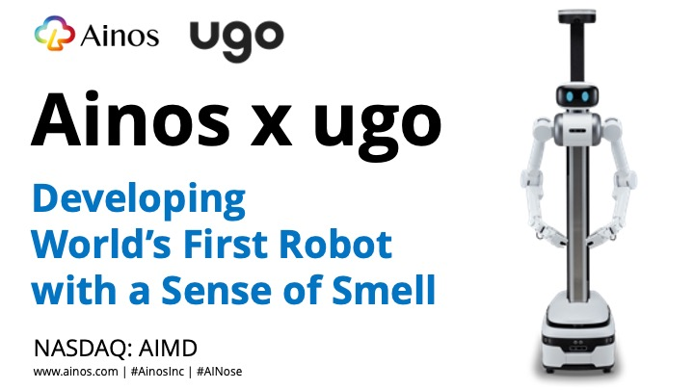

AI Nose, originally developed for medical diagnostics, mimics human olfaction by detecting and analyzing volatile organic compounds (VOCs). Backed by nearly a decade of research and a strong patent portfolio, AI Nose has already demonstrated its effectiveness in healthcare and industrial environments. In semiconductor manufacturing facilities, AI Nose has successfully identified 22 different VOCs with nearly 80% accuracy, proving its potential to enhance real-time safety monitoring and environmental analysis.
Pioneering a Breakthrough: Giving Robots the Power to Smell
Until now, robots have relied primarily on vision, sound, and touch to perceive their surroundings. Smell has remained an unsolved technological challenge—but Ainos is about to change that. With the integration of AI Nose, ugo robots will gain olfactory perception, enabling them to:
• Enhance Industrial Safety: Detect gas leaks, identify toxic chemicals, and prevent equipment failures in semiconductor, chemical, and manufacturing plants.
• Strengthen Public Safety: Assist in security patrols by detecting explosives, narcotics, and hazardous substances in transportation hubs and critical infrastructure.
• Advance Environmental Monitoring: Provide continuous air quality assessments, detect pollutants, and support smart city initiatives.
• Transform Healthcare: Analyze VOC samples for early disease detection, support infection control in hospitals, and monitor elderly care facilities for hygiene and health risks.
“This partnership will be a defining moment in our journey to digitize smell,” said Chun-Hsien (Eddy) Tsai, Chairman, President and CEO of Ainos. “By combining AI Nose’s cutting-edge olfactory sensing with ugo’s advanced robotics, we will create a new category of intelligent machines that can see, hear, and now—smell.”
Ken Matsui, Representative Director of ugo, added, “Olfaction is the next frontier in robotics. Integrating AI Nose into our robots will significantly expand their sensory intelligence, making them more effective in real-world applications across industries. Our robots, including ugo Pro, ugo Ex and ugo mini, are deployed in Japanese sectors facing worker shortages, such as security patrols and inspection tasks, in office buildings, data centers, manufacturing plants, and public facilities. By equipping ugo robots with AI-driven scent detection, we are taking automation to the next level—providing intelligent solutions that improve workplace safety, environmental monitoring, and healthcare support.”
Exploring the Future of Robotics with AI-Powered Scent Detection
By exploring the integration of AI Nose into ugo’s robotic platform, there is potential to create new revenue opportunities through various business models:
• Technology Licensing & Hardware Sales: Ainos will license AI Nose technology to ugo, enabling ugo to offer premium olfaction-enabled robots.
• Robotics-as-a-Service (RaaS): Businesses can deploy AI Nose-equipped ugo robots through subscription-based models for continuous air monitoring and safety inspections.
• Cloud-Based Scent Intelligence: AI Nose-generated data will be integrated into cloud analytics platforms, offering insights for smart factories, healthcare, and security applications.
• Maintenance & Sensor Optimization: Ongoing servicing, software updates, and sensor calibration will ensure long-term reliability and accuracy.
From Concept to Reality: The Roadmap to a Smarter Robot
This collaboration will advance through a structured development plan designed to bring AI-powered olfaction to robotics:
• Seamless Technology Integration & Prototyping: Ainos and ugo will merge AI Nose with ugo robots and conduct initial performance testing.
• Real-World Pilot Deployments: The companies will validate the integrated solution in industries such as semiconductor manufacturing and public safety.
• AI Optimization & Performance Enhancement: System performance and AI models will be refined based on real-world data.
• Global Commercialization & Market Expansion: Ainos and ugo will scale the deployment of AI Nose-enabled robots worldwide.
Empowering Industries and Addressing Labor Shortages with Intelligent Automation
Beyond its commercial value, this collaboration will help address one of the most pressing challenges faced by industries worldwide: the growing labor shortage in critical sectors.
• Manufacturing & Industrial Safety: Skilled workers are increasingly difficult to find, and ensuring workplace safety remains a top priority. AI Nose-equipped ugo robots will take on hazardous inspection tasks, reducing risks and allowing human workers to focus on higher-value roles.
• Security & Public Safety: From airports to industrial sites, there is an increasing need for security personnel to handle safety threats. AI Nose-integrated robots will provide continuous, automated surveillance, enhancing security operations without additional staffing burdens.
• Healthcare & Elderly Care: The demand for healthcare services is surging due to aging populations, while shortages of medical and caregiving staff continue to grow. AI Nose-enabled robots will assist in monitoring patient health, detecting infections early, and supporting hygiene management in hospitals and elderly care facilities.
By combining AI-powered scent detection with autonomous robotics, Ainos and ugo will help industries improve efficiency, reduce operational costs, and enhance workplace safety—while addressing the global labor gap.
As the world faces increasing challenges in workforce shortages, sustainability, and public safety, this partnership will contribute to a smarter, healthier, and safer future. Ainos and ugo are committed to driving innovation that improves lives and supports industries in need of intelligent automation.
About Ainos, Inc.
Headquartered in San Diego, California, Ainos, Inc. develops disruptive medical and healthcare solutions based on its proprietary AI Nose and VELDONA® technologies. The name "Ainos" combines "AI" and "Nose" to signify the Company's commitment to enabling AI with the ability to smell and individuals to live healthier. The Company's clinical-stage product pipeline includes AI-driven, telehealth-friendly POCT solutions powered by AI Nose, VELDONA® human and animal oral therapeutics, and human orphan drugs. To learn more, visit https://www.ainos.com. Follow Ainos on X, formerly known as Twitter, (@AinosInc) and LinkedIn to stay up-to-date.

About ugo, Inc.
ugo, Inc. is a developer of business digital transformation robots. "ugo" is a next-generation avatar robot that realizes a sustainable work style with humans and robots. By combining the advantages of both conventional simple remote-controlled robots and fully automated robots, it provides operations that fit the site. ugo was founded in 2018 and headquartered in Tokyo, Japan. For more information, visit website https://ugo.plus or its X (@ugo_robot)
Forward-Looking Statements

Certain statements in this press release are forward-looking statements within the meaning of Section 27A of the Securities Act of 1933, as amended, and Section 21E of the Securities Exchange Act of 1934, as amended. All statements other than statements of historical fact are forward-looking statements. Forward-looking statements are based on management’s current assumptions and expectations of future events and trends, which affect or may affect the Company’s business, strategy, operations or financial performance, and actual results and other events may differ materially from those expressed or implied in such statements due to numerous risks and uncertainties. Forward-looking statements are inherently subject to risks and uncertainties, some of which cannot be predicted or quantified. There are a number of important factors that could cause actual results, developments, business decisions or other events to differ materially from those contemplated by the forward-looking statements in this press release. These factors include, among other things, our expectation that we will incur net losses for the foreseeable future; our ability to become profitable; our ability to raise additional capital to continue our product development; our ability to accurately predict our future operating results; our ability to advance our current or future product candidates through clinical trials, obtain marketing approval and ultimately commercialize any product candidates we develop; the ability to obtain and maintain regulatory approval of our product candidates; delays in completing the development and commercialization of our current and future product candidates; developing and commercializing additional products, including diagnostic testing devices; our ability to compete in the marketplace; compliance with applicable laws, regulations and tariffs, and factors described in the Risk Factors section of our public filings with the Securities and Exchange Commission (SEC). Because forward-looking statements are inherently subject to risks and uncertainties, you should not rely on these forward-looking statements as predictions of future events. These forward-looking statements speak only as of the date of this press release and, except to the extent required by applicable law, the Company undertakes no obligation to update or revise these statements, whether as a result of any new information, future events and developments or otherwise.

Contact Information
Feifei Shen
ir@ainos.com

