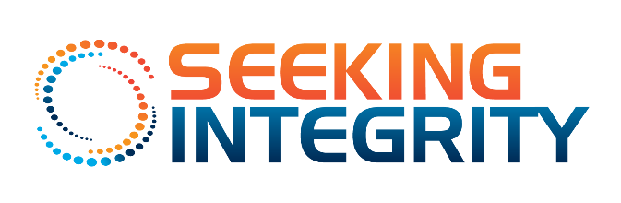
June 5, 2019 Seeking Integrity, Tami VerHelst
747.234.4325 Tami@SeekingIntegrity.com

SEEKING INTEGRITY OPENS MEN'S MULTI-ADDICTION TREATMENT PROGRAM IN LOS ANGELES
Seeking Integrity Offers Treatment for Sex, Porn, and Co-Occurring Sex and Drug Addiction (Chemsex)
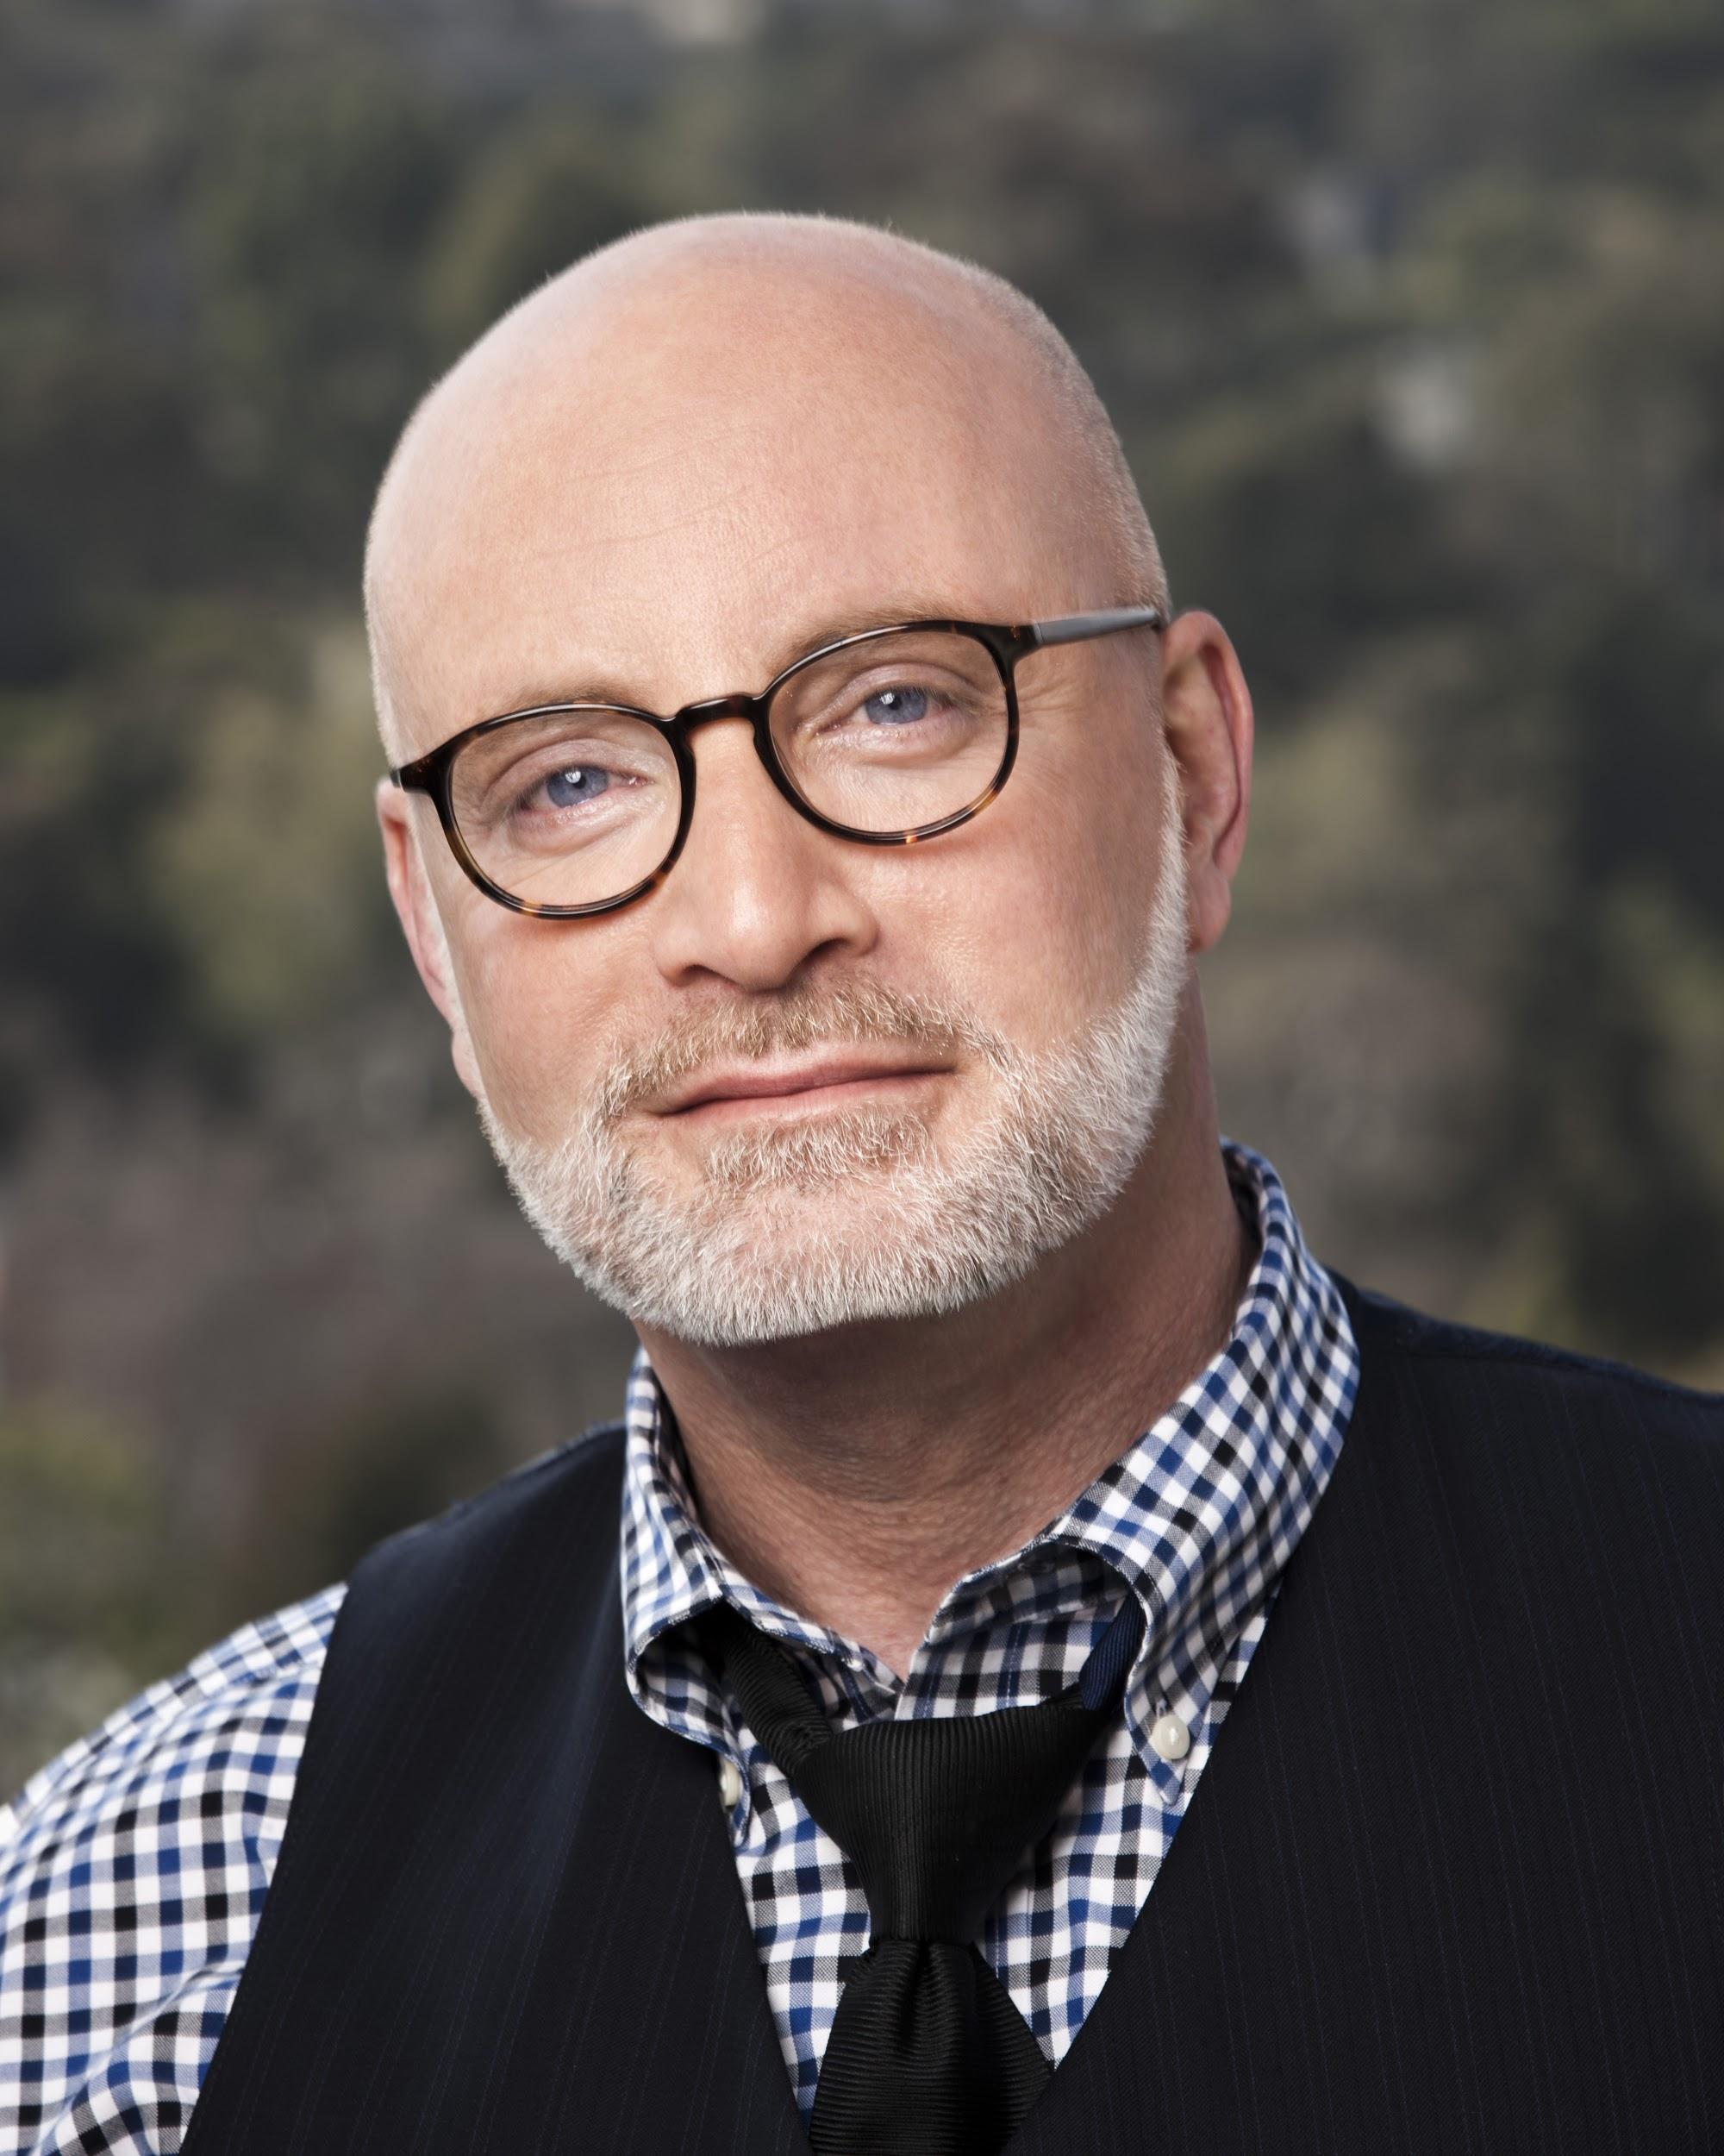
(Los Angeles, CA, June 5, 2019) – Seeking Integrity announces the opening of its flagship men’s multi-addiction treatment program, Seeking Integrity: Los Angeles. Seeking Integrity offers dedicated, attachment-focused treatment for male sex and porn addicts, as well as men struggling with co-occurring drug and sex problems (often referred to as chemsex addiction). Clients begin treatment by attending a 14-day immersive program that encourages each man to evolve his own highly individualized, deeply personal, and structured plan for long-term behavior change. Extended programming is available providing a safe place for clients to continue working on related problems such as complex trauma, depression, burnout, chronic anger, and other related emotional blocks to men’s healing.

Now that The World Health Organization and the ICD-11 have legitimized the sexual compulsivity/addiction diagnosis (May 25, 2019), Seeking Integrity founder and intimacy expert Dr. Rob Weiss says, “The need for complex, multi-issue, expert-driven, men's addiction treatment has truly arrived. Let’s move past cookie-cutter approaches to healing by embracing more holistic and complex views of men, trauma, intimacy, and addiction.” At Seeking Integrity, we encourage clients to build the kinds of meaningful, supportive, and healthy peer bonds that are the cornerstone of long-term sobriety and relationship health. To this end, Seeking Integrity: Los Angeles provides innovative, evidence-based, sex/porn addiction and drug addiction with fused sexual behavior treatment for men.
Dr. David Fawcett, Seeking Integrity’s Vice President of Clinical Programming and the author of Lust, Men and Meth, believes that traditional addiction rehabs often miss underlying relapse triggers by not bringing issues of attachment, intimate relationships and sexuality into the clinical work. “In today’s world, the fusion of drugs and sexual behavior is ever more common. Individuals with co-occurring sex and drug problems cannot achieve long-term sobriety and recovery without dealing with their substance and relational concerns in tandem. This is the work we are doing at Seeking Integrity.”
Today our lives are inexorably divided between the online world and real life. Seeking Integrity is bridging these worlds by offering a continuum of online education, peer support, and family support available not only to our clients, but also at no charge to anyone suffering with sex addiction via SexandRelationshipHealing.com. In this way, Seeking Integrity is pushing long-term real-world care into the digital age.
###
For more information, please visit SeekingIntegrity.com and SexandRelationshipHealing.com or contact Tami VerHelst, Chief Relationships Officer, at 747.234.4325 or Tami@SeekingIntegrity.com.

