Idaho Strategic Releases 2024 Year in Review

COEUR D'ALENE, Idaho, January 7, 2024 (ACCESSWIRE) – Idaho Strategic Resources, Inc. (NYSE American: IDR) (“IDR” or the “Company”) is pleased to celebrate its team’s accomplishments in 2024 as the Company looks forward to a busy and productive 2025.
Idaho Strategic’s President and CEO, John Swallow commented, “On behalf of our team at Idaho Strategic, I would like to thank our shareholders and broader stakeholders for their support during 2024. Our Company has turned the corner on profitability which has allowed us to reinvest in the business in ways we weren’t able to in the past. Through the first three reported quarters, IDR has increased its total revenue by 84%, its net income by 744%, and its earnings per share by 600% - and the Company closed out the year strongly with its best quarter ever. Additionally, the Company’s cash per share increased from approximately $0.18 at the end of 2023, to $0.85 at the end of the third quarter in 2024, a 372% increase.”
Key accomplishments at the Golden Chest mine during 2024 include the construction of an 80 foot x 150 foot steel-framed building to be utilized as the Company’s planned paste backfill plant with the potential to also house a new mill onsite. The planned paste backfill plant is expected to save the Company approximately $500k-$800k annually in full operation. All the necessary equipment for the paste backfill plant has been delivered or is on order, with plant commissioning expected in mid 2025. Also in 2024, Idaho Strategic completed the purchase of the Butte Gulch property, located immediately to the east of the Golden Chest mine site, increasing the Company’s strategic private landholdings within the Murray Gold Belt District by an additional 169 acres. All of IDR’s private landholdings are owned free of debt. Exploration at the Golden Chest included approximately 10,600 meters of core drilling over the course of 2024. While many of the drill holes completed in the third and fourth quarters are awaiting core logging, sampling, and assaying, the drilling thus far has resulted in the discovery of the recently announced Red Star Vein. Highlights from the Red Star Vein drilling include drill hole GC 24-258 which intercepted 34.1 grams per tonne (gpt) gold over 1.8 meters within 9.3 meters assaying 8.2 gpt gold, reported in drilled thickness.
Idaho Strategic continued to advance its extensive rare earth elements landholdings in 2024, albeit at a reduced rate compared to what the Company has planned for 2025. During the year many new relationships were formed with various stakeholders scattered throughout the domestic REE supply chain and within various arms of the US Government. In addition to sampling and mineralogical studies completed in 2024, the Company announced the impressive mix of REEs seen in numerous samples at its Lemhi Pass project, which include a unique concentration of magnet REEs in excess of 70% of the total rare earth elements concentration.
On the corporate development front, during 2024 Idaho Strategic received a Rural Community Investment Fund grant from the state of Idaho in the amount of $430k to help pay to upgrade the power infrastructure from Wallace, ID to the town of Murray, ID – approximately 23 line-miles worth of upgrades. The upgrades were necessary to facilitate the operation of the planned paste backfill plant and additional mine development activities. Additionally, Idaho Strategic executed a Memorandum of Understanding with Radiant Industries to participate in their Frontier Program designed to aid in the advancement of Radiant’s Kaleidos micronuclear reactor being developed with remote mine sites as a potential use case. Members from IDR participated in numerous industry events in 2024 including the Vancouver Resource Investment Conference, Idaho Mining Day at the Capitol, US DoE Critical Minerals Workshop, MicroCapClub Annual Summit, Adamas Mines, Magnets, and Motors Conference, International Rare Earth Elements Conference, and the annual Idaho Mining Association Conference.
John Swallow concluded, “While much was accomplished in 2024, it is my belief that if we continue to execute, the accomplishments of 2024 will pale in comparison to those planned for 2025. Many of the exploration and operational plans that were added to a ‘wish list’ in the early days are now becoming reality, actively being revaluated, and logically implemented - the construction of the paste backfill plant is a great example of this. Overall, the investments made throughout 2024 have set the foundation and provided our team with the resources necessary for another great year in 2025. Please enjoy our 2024 Year in Photos below.”

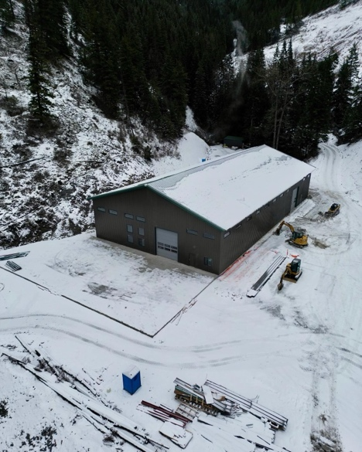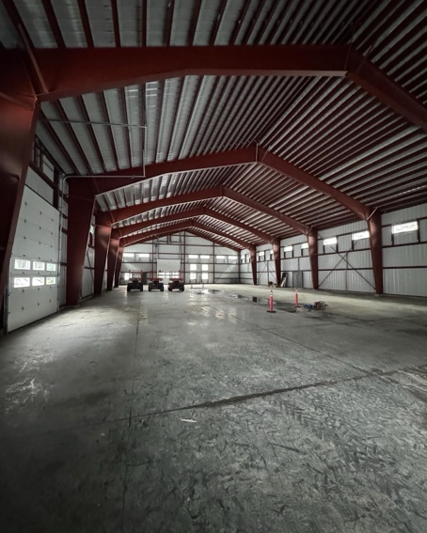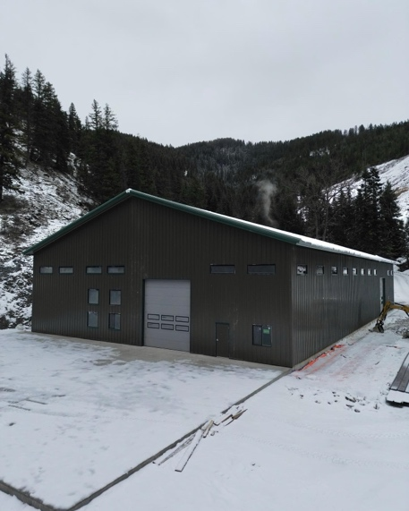

Completed paste backfill building – this building went from an idea on paper in February 2024 to a reality by Christmas 2024

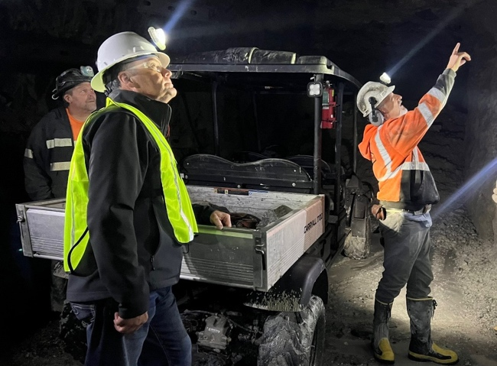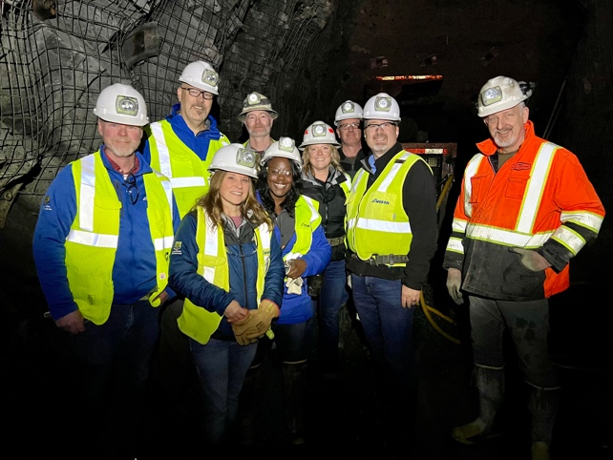

Two separate Golden Chest underground tours – Idaho’s Congressman Russ Fulcher and executives from Avista Utilities

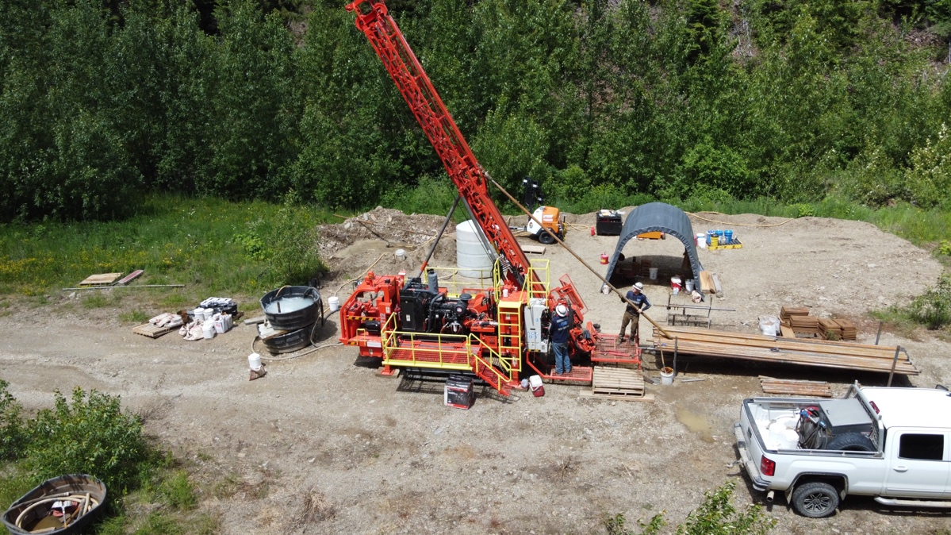

One of three drill rigs that spent a lot of time at the Golden Chest mine this year

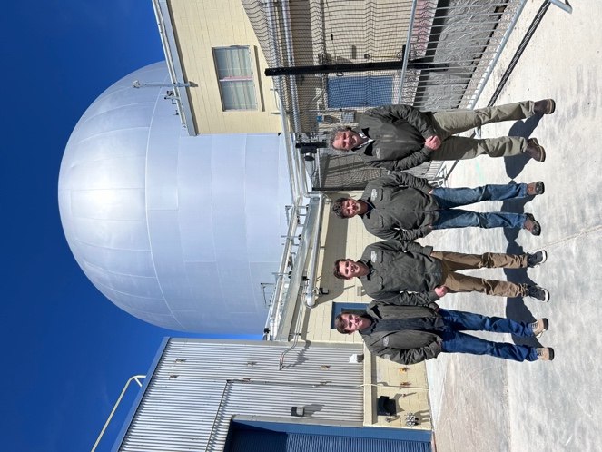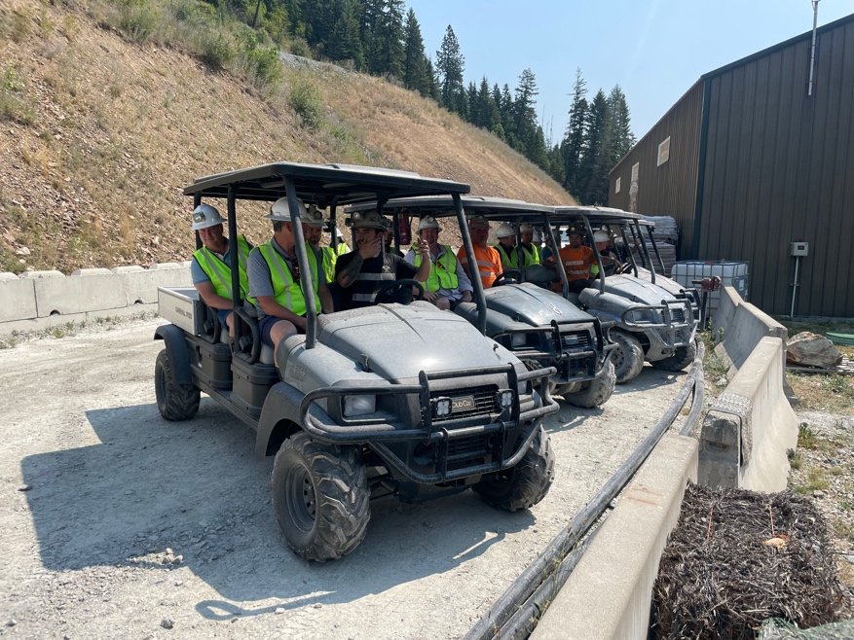

Members from IDR invited to tour Idaho National Lab’s Advanced Test Reactor and IDR’s team members getting ready to take the MicroCapClub Investor Summit underground

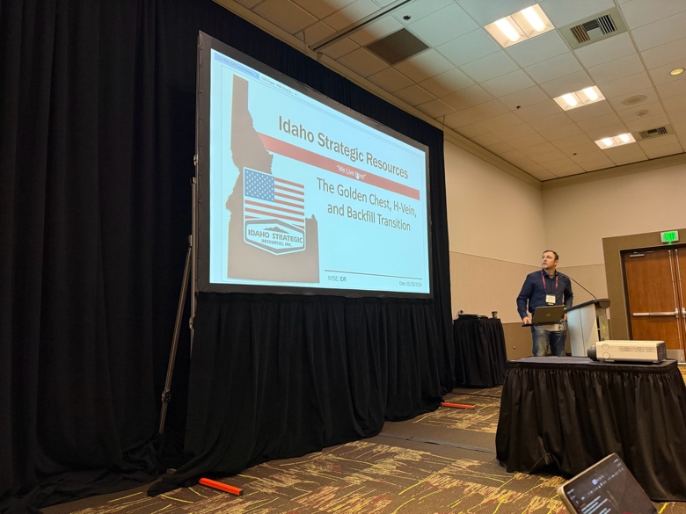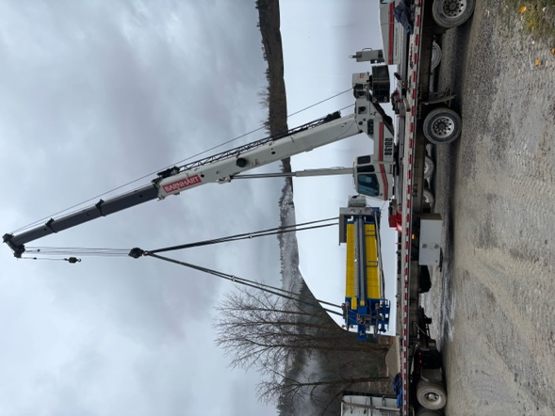

Andrew Brackebusch presenting on IDR’s paste backfill transition at the Idaho Mining Conference while the paste backfill filter press was being unloaded at the New Jersey Mill

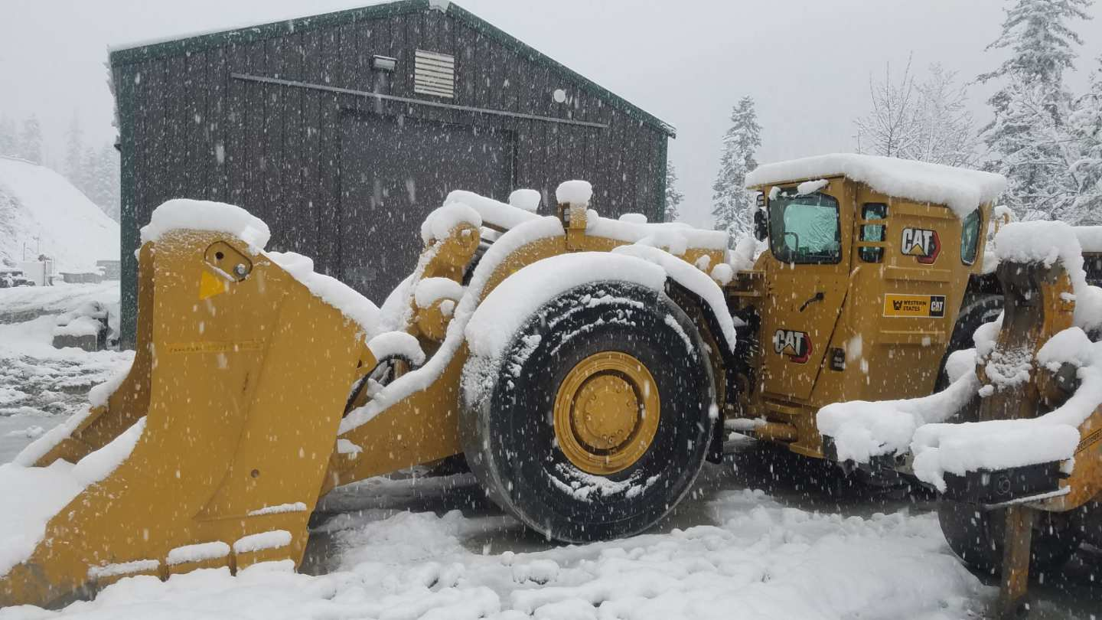

IDR’s newest piece of equipment – a 6-cubic yard underground loader with an ejector bucket. The newest of two of these “workhorse” machines

About Idaho Strategic Resources, Inc.
Idaho Strategic Resources (IDR) is an Idaho-based gold producer which also owns the largest rare earth elements land package in the United States. The Company’s business plan was established in anticipation of today’s volatile geopolitical and macroeconomic environment. IDR finds itself in a unique position as the only publicly traded company with growing gold production and significant blue-sky potential for rare earth elements exploration and development in one Company.
For more information on Idaho Strategic Resources, visit https://idahostrategic.com/presentation/, go to www.idahostrategic.com or call:
Travis Swallow, Investor Relations & Corporate Development
Email: tswallow@idahostrategic.com
Phone: (208) 625-9001
Forward Looking Statements
This release contains “forward-looking statements” within the meaning of Section 27A of the Securities Act of 1933, as amended, and Section 21E of the Securities Exchange Act of 1934, as amended that are intended to be covered by the safe harbor created by such sections. Often, but not always, forward-looking information can be identified by forward-looking words such as “intends”, “potential”, “believe”, “plans”, “expects”, “may”, “goal’, “assume”, “estimate”, “anticipate”, and “will” or similar words suggesting future outcomes, or other expectations, beliefs, assumptions, intentions, or statements about future events or performance. Forward-looking information is based on the opinions and estimates of Idaho Strategic Resources as of the date such information is provided and is subject to known and unknown risks, uncertainties, and other factors that may cause the actual results, level of activity, performance, or achievements of IDR to be materially different from those expressed or implied by such forward-looking information. Additionally, a recount of past performance should not be taken as an indication of future performance and mentions of Q4 being the Company’s best ever are subjective to specific metrics and does not include all metrics one could evaluate when making that claim. Investors should note that IDR’s claim as the largest rare earth elements landholder in the U.S. is based on the Company’s internal review of publicly available information regarding the rare earth landholdings of select companies within the U.S., which IDR is aware of. Investors are encouraged not to rely on IDR’s claim as the largest rare earth elements landholder in the U.S. while making investment decisions. The forward-looking statement information above, and those following are applicable to both this press release, as well as the links contained within this press release. With respect to the business of Idaho Strategic Resources, these risks and uncertainties include risks relating to widespread epidemics or pandemic outbreaks; interpretations or reinterpretations of geologic information; the accuracy of historic estimates; unfavorable exploration results; inability to obtain permits required for future exploration, development or production; general economic conditions and conditions affecting the industries in which the Company operates; the uncertainty of regulatory requirements and approvals; fluctuating mineral and commodity prices; the ability to obtain necessary future financing on acceptable terms; the ability to operate the Company’s projects; and risks associated with the mining industry such as economic factors (including future commodity prices, and energy prices), ground conditions, failure of plant, equipment, processes and transportation services to operate as anticipated, environmental risks, government regulation, actual results of current exploration and production activities, possible variations in ore grade or recovery rates, permitting timelines, capital and construction expenditures, reclamation activities. Although the Company has attempted to identify important factors that could cause actual results to differ materially from those contained in forward-looking information, there may be other factors that cause results not to be as anticipated, estimated, or intended. Readers are cautioned not to place undue reliance on such information. Additional information regarding the factors that may cause actual results to differ materially from this forward‐looking information is available in Idaho Strategic Resources filings with the SEC on EDGAR. IDR does not undertake any obligation to update publicly or otherwise revise any forward-looking information whether as a result of new information, future events or other such factors which affect this information, except as required by law.

