

Speed, Clarity, Action:

CORAS Intelligence
R

Mission-Ready AI for the DoD

FedRAMP High / IL5 on Classified Environments
NAVSEA Strategic Planning & Forecasting (SPF)
Transforming shipyard planning
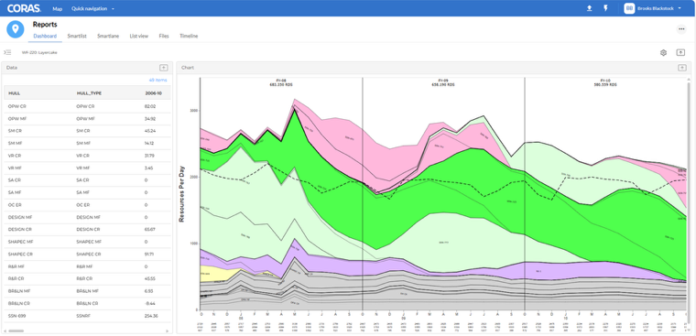
NAVSEA needed a modern way to manage shipyard workload and workforce forecasts — replacing a 20+ year-old PowerBuilder system that was difficult to maintain and disconnected from real-time data. CORAS delivered a next-generation Strategic Planning & Forecasting (SPF) system that unified resource, schedule, expenditure, and performance data into a secure, IL5-capable environment.
With Gary and CORAS, planners can now:
- Interactively adjust forecasts using live operational data
- Model different resourcing strategies with real-time impact analysis
- Automatically recalculate downstream metrics as scenarios evolve
- Collaborate on plans with versioning, visual change tracking, and embedded commentary
The result: smarter resource allocation, faster scenario testing, and better alignment across Navy shipyards — all in a secure, cloud-ready system built for scale.
Use Case: PMA-299 Aircraft Readiness & Fleet Planning
Smarter sustainment and lifecycle decisions
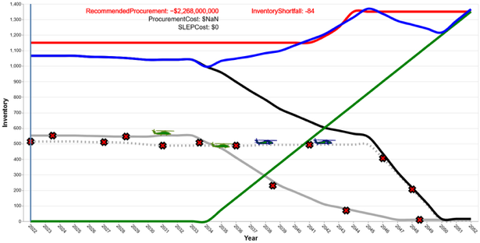
PMA-299 manages the readiness of Navy helicopters across a globally deployed fleet. Traditional planning tools couldn’t keep pace with evolving mission demands, delayed parts, or fluctuating budgets and offered little insight into future availability.
CORAS gives PMA-299 a predictive, mission-aware platform for planning and sustainment. By integrating data from AMSRR, RAMP, and maintenance systems, CORAS enables proactive forecasting and smarter decision-making.
With Gary and CORAS, PMA-299 can:
- Predict future operational readiness across aircraft variants using live and historical data
- Optimize WIP and PMI schedules based on real-world constraints and maintenance demand
- Run what-if scenarios to evaluate impacts of funding cuts, delayed parts, or supply chain disruptions
- Generate brief-ready insights for leadership — faster and with full rationale traceability
The result: increased availability, reduced downtime, and a more agile sustainment operation — built on real data and aligned to mission priorities.
Outcome: Mission-Ready AI for the Department of Defense
CORAS gives teams more than just answers. It delivers a secure, explainable AI environment that helps them plan, decide, and act with confidence. From conversational insights to real-time execution, CORAS turns language into outcomes.
BUILT FOR THE MISSION. POWERED BY AI. READY TO DEPLOY.

CORAS Decision Intelligence
FedRAMP High / IL5 on all Classified Environments

Unlike generic LLMs that guess based on static inputs, Gary is embedded directly within the IL5-certified CORAS platform with live access to data, logic, and decision tools. Gary doesn’t just summarize — he understands your mission context, pulls real data, and activates real functions.

CORAS LLM (Gary) + Data Layer

Capability | Description
Natural Language Interface (Gary) | Ask plain-English questions about performance, trends, or drivers
Context-Aware Q&A | Understands DoD taxonomy, mission context, and prioritization logic
Persistent Data Storage (Lists & Memory) | CORAS retains and manages mission data internally — no need to re-upload or recontextualize with each session
Structured & Unstructured Ingestion | Analyze data from lists, tables, PDFs, memos, and other formats
API Data Integration | Feed structured data into CORAS for live analysis by Gary
Access to Embedded Agents | Execute select CORAS-native functions through Gary
Auto-Generated Documents & Briefings | Draft summaries, memos, and reports using live mission data
Customizable Prompt Library | Custom prompts aligned to mission roles and patterns
IL5/FedRAMP High Security | All interactions remain within CORAS’s compliant, secure boundary
Scoped Session Memory | Retains context across user sessions (secure and user-specific)

CORAS LLM + Decision Intelligence Platform
Everything above plus advanced decision tooling

Capability | Description
Full AI Agent Ecosystem | Execute complex functions across data, modeling, reporting, and automation
What-If Scenario Modeling | Simulate tradeoffs in funding, readiness, or performance outcomes
Workflow Automation | Trigger downstream actions based on decision logic
Advanced AI Engines (ML, NLP, Similarity, Predictive) | Classify, compare, and forecast using trained models and mission-aligned logic
Predictive/Prescriptive Analytics | Recommend optimized paths, simulate outcomes, and mitigate risk
SmartBoard Execution Layer | Drive updates, decisions, and collaboration in a live visual workspace
Automated Driver Trees | Visualize and reason over interconnected performance metrics, dependencies, and outcomes
Interactive & Actionable Data Layer | Edit values, version decisions, trigger follow-ups — all in real time, within CORAS

www.CORAS.ai CORAS | 7918 Jones Branch Dr | Ste 800 | McLean, VA 22102 703-797-1881

