Visionaize V-Plant selected as Core 3D Digital Twin Solution within Chiyoda's plantOSTM Framework at MGC Niigata
June XX, 2025 - San Jose, CA, USA — Visionaize Inc., a leading provider of 3D Digital Twin and GenAI solutions, is pleased to announce that its V-Plant®*1 platform has been selected for implementation at Mitsubishi Gas Chemical Company, Inc. {MGC) as the visualization and contextual data engine within Chiyoda Corporation's plantOSTM*2 total operations and maintenance (O&M) solution suite.
The agreement, led by Chiyoda in partnership with MGC, reflects a major step forward in
digital transformation within Japan's chemical manufacturing sector. By embedding V-Plant as the visual and contextual layer of plantOSTM, MGC will gain access to an immersive 3D environment that unifies siloed plant data and supports smarter decision-making at its
Niigata Plant.

”We’re proud that V-Plant serves as the immersive interface within Chiyoda’s plantOSTM,” said Vikas Agrawal, CEO of Visionaize. “Together, we’re delivering scalable innovation that helps MGC streamline maintenance, improve safety, and unlock operational intelligence across the plant.”

A Phased Digital Twin Journey
V-Plant enables MGC to pursue a flexible, value-based rollout strategy. Starting with
Panoramic image integration and mesh model*3 visualization, the plantOSTM
deployment will progressively scale to a comprehensive 3D Digital Twin*4, fully navigable through a single platform. This "crawl-walk-run" approach ensures rapid time-to-value and business-aligned expansion as digital maturity advances. This phased approach is structured into three maturity tiers:
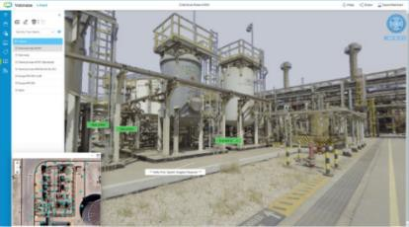
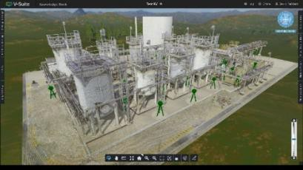
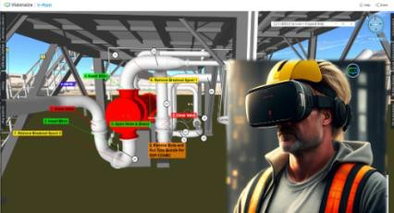

1: V-Plant Explorer
360º Panoramic Image Integration
2: V-Plant Pro
Integrated Mesh Model
3: V-Plant 360
Comprehensive 3D Digital Twin

Strategic Partnership for Industrial Innovation

The Visionaize–Chiyoda collaboration brings together advanced 3D visualization and contextual AI with deep domain knowledge in plant operations. V-Plant not only visualizes data—it contextualizes it, connecting documents, assets, and operational logs into a
unified 3D experience. Chiyoda will continue to lead system integration, lifecycle support, and platform expansion across MGC's operations. As part of its broader commitment to sustainability and digital innovation, Chiyoda's plantOSTM empowers clients to modernize operations through integrated solutions that enhance productivity and reduce risk.
This milestone validates V-Plant's global applicability and reinforces Visionaize's growing impact across Asia's industrial landscape. Visionaize remains committed to accelerating digital transformation through scalable 3D and AI-powered solutions that evolve with customer needs.
*1: A Visionaize, Inc. Trademark, the 3D Digital Twin platform developed by Visionaize as an essential part of plantOS. https://visionaize.com/
*2: Chiyoda Corporation Trademark
*3: A digital surface representation of real-world assets, composed of vertices, edges, and polygons that form a high-fidelity 3D model. Mesh models provide a more immersive and spatially accurate experience than 360° panoramic images. They enable users to perform virtual walkthroughs, spatial orientation, and planning tasks with improved realism. As a mid-tier digital twin format, mesh models bridge the gap between image-based
visualization and fully modeled 3D twins—unlocking broader use cases such as layout planning, hazard mapping, and remote collaboration without requiring a full CAD-grade model.
*4: A comprehensive, structured digital replica of physical plant assets, geometry, and tag-based metadata. These models support data integration across inspection, maintenance, and engineering workflows, enabling interaction with real-time plant data within a unified 3D interface. Full digital twins allow for advanced use cases such as simulation, predictive analytics, asset performance management, and interactive work
planning. Built incrementally based on client priorities, the 3D digital twin tier enables a scalable transition to fully digital operations when the organization is ready.
――――――――――――――――――――――――――――――――――――――――――――
For further information, please contact:
Visionaize Inc.
Email: info@Visionaize.com
URL: https://visionaize.com/company/#contact-us

