Celebrating Success: Ryde and Delivery Chinatown Strengthen Partnership to Elevate Singapore’s Delivery Ecosystem
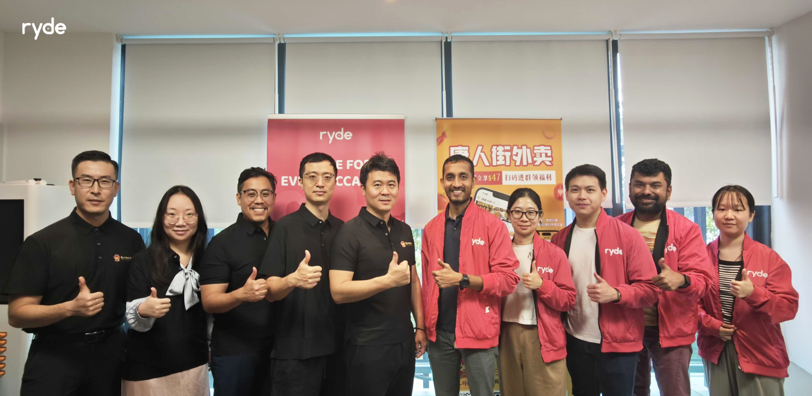
SINGAPORE, January 8, 2025 – Ryde Group Ltd (NYSE American: RYDE) ("Ryde'' or the “Company"), a technology company with a leading platform for mobility and quick commerce in Singapore, is excited to share its successful collaboration with Delivery Chinatown. This collaboration has transformed the local delivery landscape, empowering Chinatown’s F&B merchants, creating meaningful opportunities for Ryde’s driver-partners, and delivering authentic flavors and fresh produce to customers across Singapore.

This partnership reflects Ryde’s unwavering commitment to fostering innovation, strengthening communities, and bridging cultural heritage with modern logistics.
Empowering Driver-Partners
The collaboration has opened new opportunities for Ryde’s driver-partners by creating consistent delivery jobs and increasing earning potential. By leveraging efficient delivery routes, driver-partners have maximized their earnings while ensuring timely deliveries. The partnership has also introduced cross-collaboration opportunities, allowing driver-partners to fulfill orders from multiple platforms and maintain a steady flow of income.
A Milestone in Service Expansion
Ryde and Delivery Chinatown have worked hand-in-hand to diversify delivery services, catering to Singapore’s culturally rich and vibrant food scene. By connecting traditional F&B merchants in Chinatown with cutting-edge logistics solutions, the partnership has ensured customers can seamlessly enjoy their favorite Chinatown delicacies from the comfort of their homes.

Preserving Singapore’s Rich Food Heritage
Both Ryde and Delivery Chinatown share a deep commitment to celebrating and preserving Singapore’s unique culinary heritage. By equipping Chinatown’s F&B merchants with logistics support, the partnership ensures that iconic dishes remain accessible to future generations while thriving in an increasingly digital economy.

Driving Growth and Innovation
As the partnership evolves, Ryde and Delivery Chinatown are focused on increasing delivery orders, streamlining logistics, and enhancing customer satisfaction. Together, the two brands are creating a seamless delivery experience that keeps customers coming back while driving growth for both businesses.
“We are thrilled to celebrate our enduring partnership with Delivery Chinatown,” said Nitin Dolli, CTO of Ryde Group. “Our proprietary AI algorithms play a crucial role in optimizing delivery routes, enabling faster turnaround times for merchants like Delivery Chinatown thereby increasing earnings for our driver-partners. This partnership with Delivery Chinatown highlights how we apply technology to strengthen local ecosystems while delivering exceptional value to both businesses and consumers”
Gao Shan, CTO of Delivery Chinatown, added: "Our partnership with Ryde has enabled us to bring the authentic flavors of Chinatown to even more households in Singapore. By integrating traditional food culture with cutting-edge logistics solutions, we have empowered our merchants to thrive in a digital economy while preserving the rich heritage of Chinatown. We are excited to continue this journey of growth and innovation with Ryde."
About Ryde Group Ltd
Ryde, a homegrown super mobility app founded in Singapore, is the world's FIRST on-demand carpooling app since 2014! As a publicly listed company on the NYSE, we are reimagining the way people and goods move around. We offer a full suite of services, including carpooling, private hire, taxi, and delivery, but what truly sets us apart is our commitment to empower our private-hire and taxi partners. We take 0% commission, ensuring that more of every hard-earned dollar goes to driver-partners on our platform. For more information, please visit https://rydesharing.com/ to learn more.

Contacts

For Media Relations:
Media Team
Ryde Group Ltd
Email: media@rydesharing.com

For Investor Relations:
Investor Relations Team
Ryde Group Ltd
Email: investor@rydesharing.com

FORWARD-LOOKING STATEMENTS
Statements in this press release about future expectations, plans and prospects, as well as any other statements regarding matters that are not historical facts, may constitute "forward-looking statements" within the meaning of The Private Securities Litigation Reform Act of 1995. These statements include, but are not limited to, statements relating to the expected trading commencement and closing dates. The words "anticipate," "believe," "continue," "could," "estimate," "expect," "intend," "may," "plan," "potential," "predict," "project," "should," "target," "will," "would" and similar expressions are intended to identify forward-looking statements, although not all forward-looking statements contain these identifying words. Actual results may differ materially from those indicated by such forward-looking statements as a result of various important factors . Any forward-looking statements contained in this press release speak only as of the date hereof, and Ryde Group Ltd specifically disclaims any obligation to update any forward-looking statement, whether as a result of new information, future events or otherwise, except as required by law.

