In a Country Known for Agave, a Gin Takes Top Honors: Condesa Gin Named Mexico’s Spirit of the Year 2025
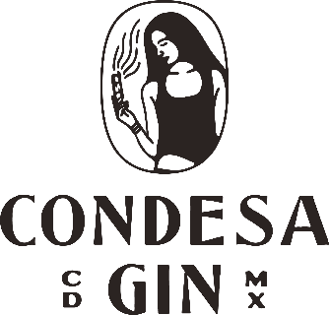

MEXICO CITY, MAY 2025 - In a country internationally revered for its tequila and mezcal, a gin has just taken top national honors. Condesa Gin Clásica has been named “Spirit of the Year – Mexico” at the 2025 London Spirits Competition with 97 points, and also won a Gold Medal at the 2025 San Francisco World Spirits Competition—putting Mexico City firmly on the global gin map.
Condesa Gin Clásica has been named “Spirit of the Year – Mexico” at the 2025 London Spirits Competition, surpassing a field of iconic agave distillates. The award, which comes with a Gold Medal and an impressive 97-point rating, signals a changing tide in Mexican spirits—and puts Mexico City on the map of global gin, a space long dominated by Europe. The win marks a historic moment for the capital’s exploding mixology scene. Not only is Condesa Gin Clásica now the highest-rated spirit from Mexico at the competition, but both of the brand’s flagship gins—Condesa Gin Clásica and Prickly Pear & Orange Blossom—also took home Gold Medals at the 2025 San Francisco World Spirits Competition, cementing this mixologist favorite as one of the world’s leading gins.
Master Distiller Hillhamn Salome, 29, expressed her pride in receiving international acclaim and reaffirmed the brand’s deep commitment to craftsmanship and artistry.
“It’s an honor to see both of our gins recognized. These accolades reflect the care and creativity behind our work and show that Mexican spirits—beyond agave—can stand among the world’s best. Mexico City is taking its place in the global conversation, and I’m proud to be part of that journey.”

About Condesa Gin
From its Mexico City workshop, Condesa Gin blends botanicals such as palo santo, sage, jasmine, and more, drawing inspiration from Mexican rituals of cleansing, renewal and the amplification of consciousness.
As part of its commitment to environmental stewardship, Condesa Gin partners with Reforestamos México to support native reforestation efforts and help protect Mexico’s biodiverse ecosystems for future generations.
Condesa is now available across North America, the UK, and Europe, Latin America and the Caribbean.
Press inquiries, interview requests, or additional information:
Mayra Ascencio
Director of Marketing
+52 55 6161 53619
mayra@condesagin.com
www.condesagin.com

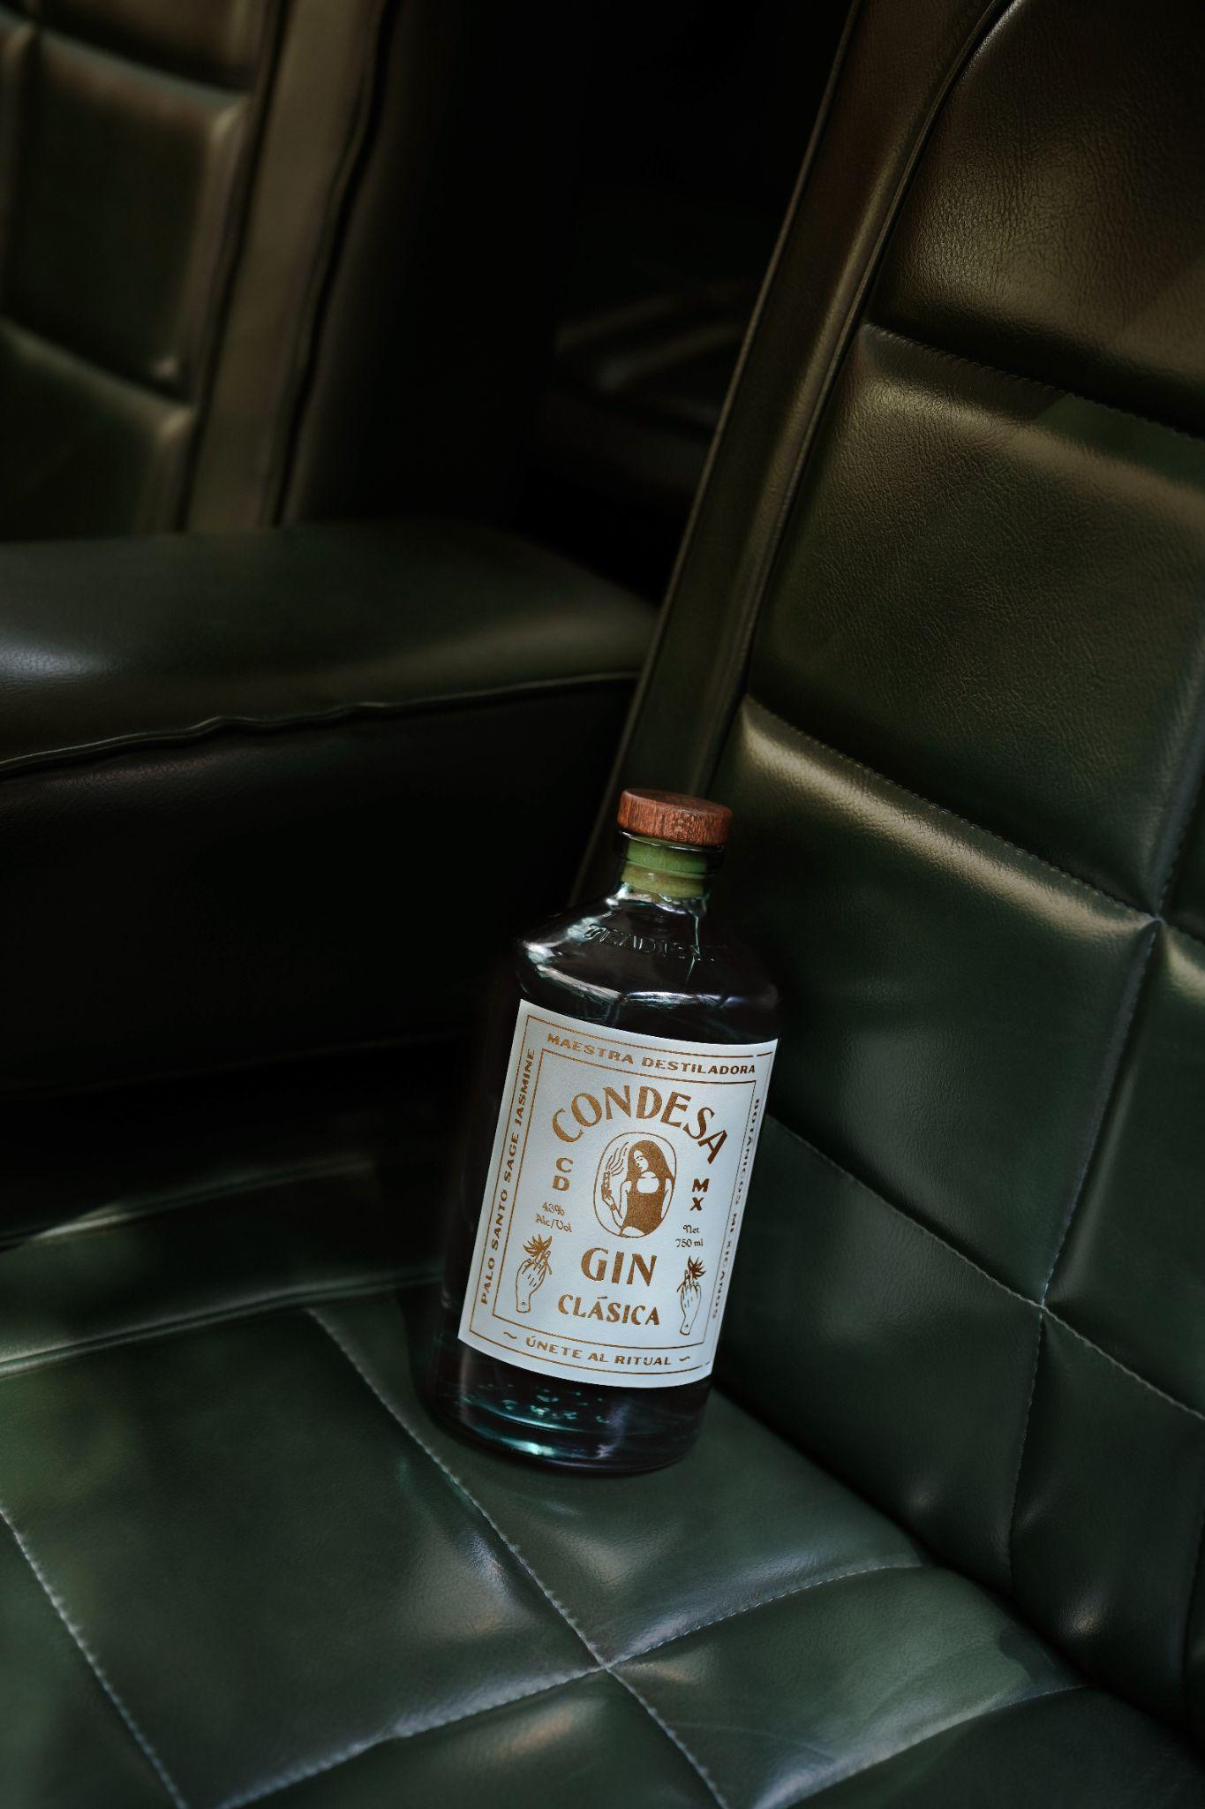

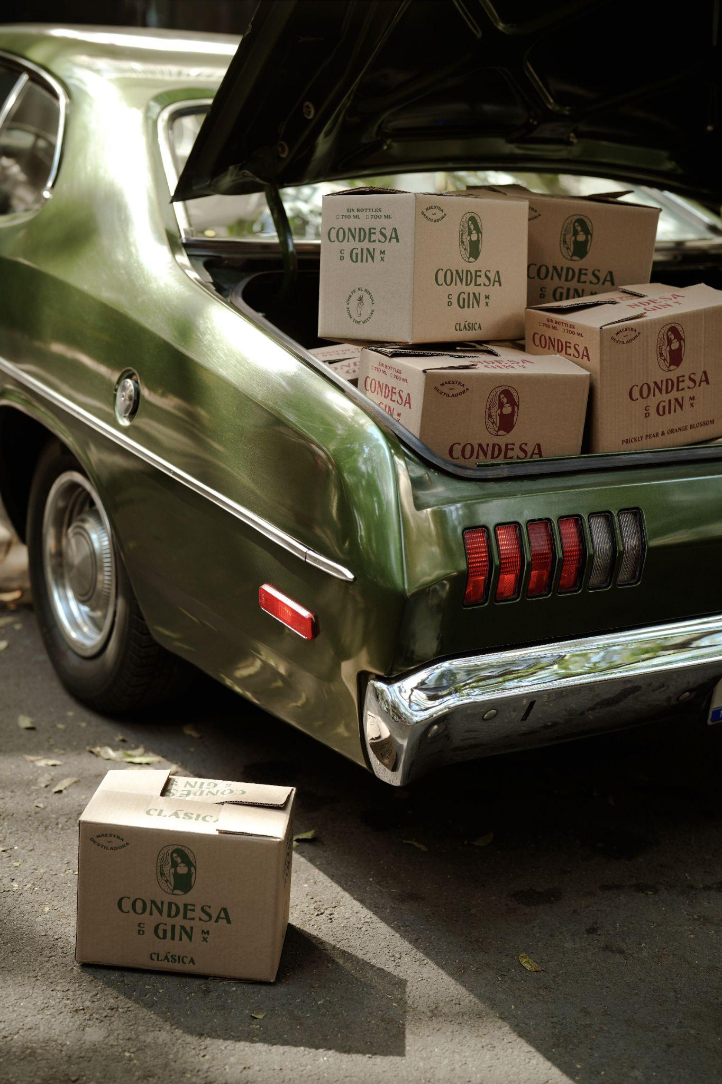
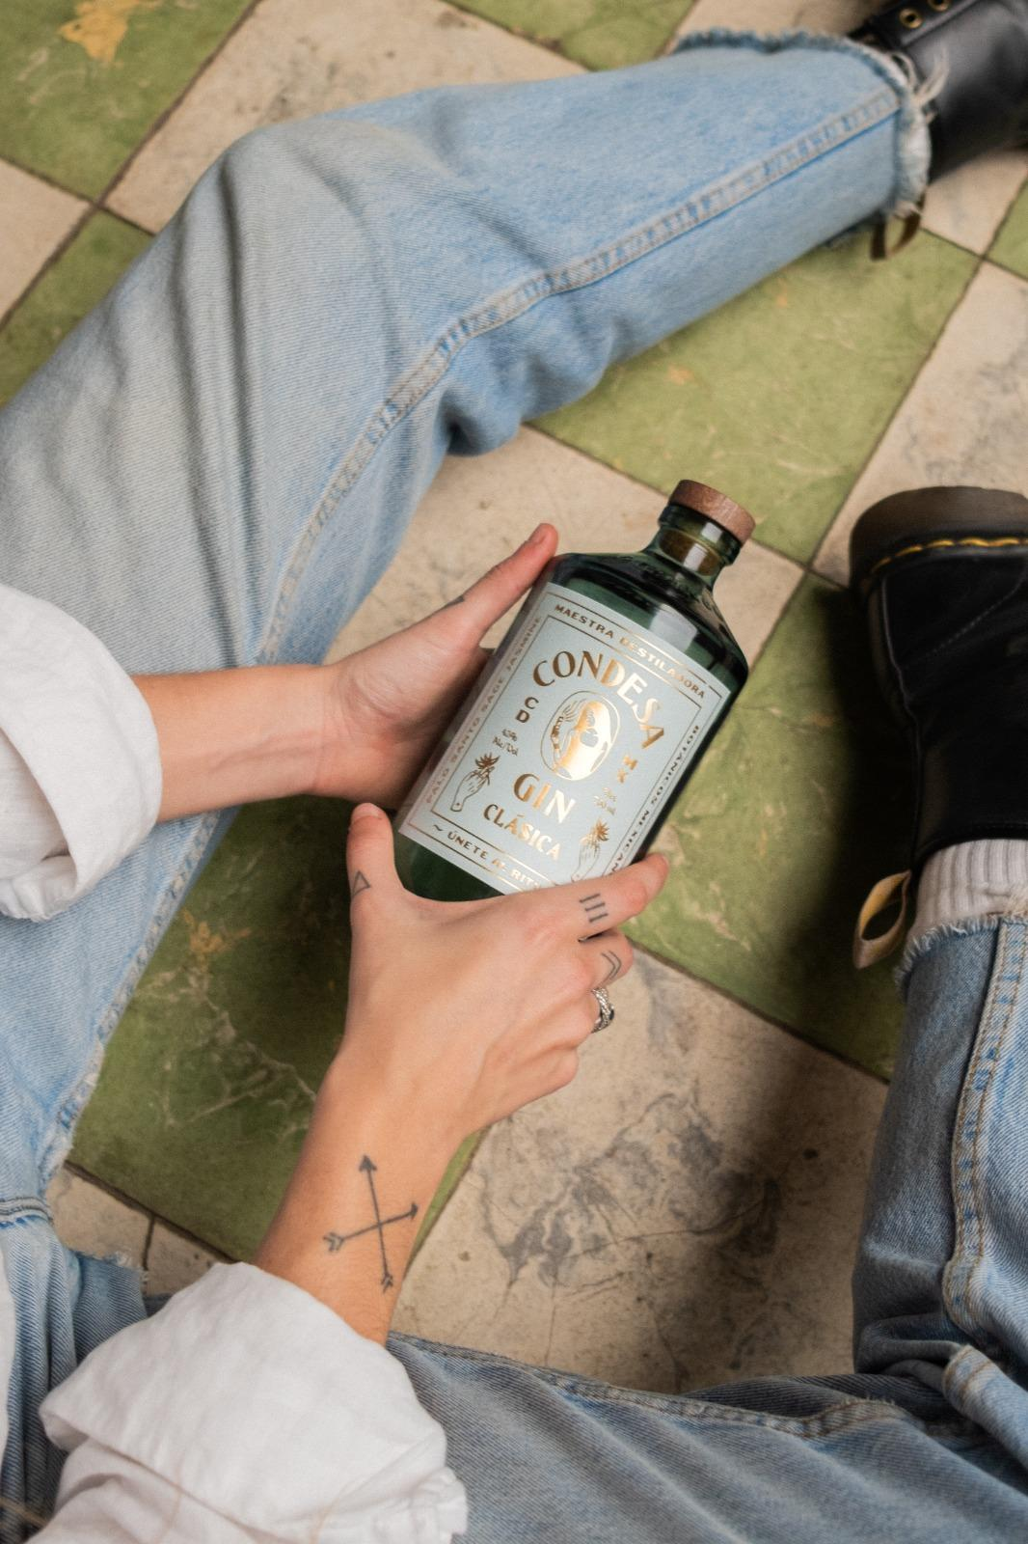
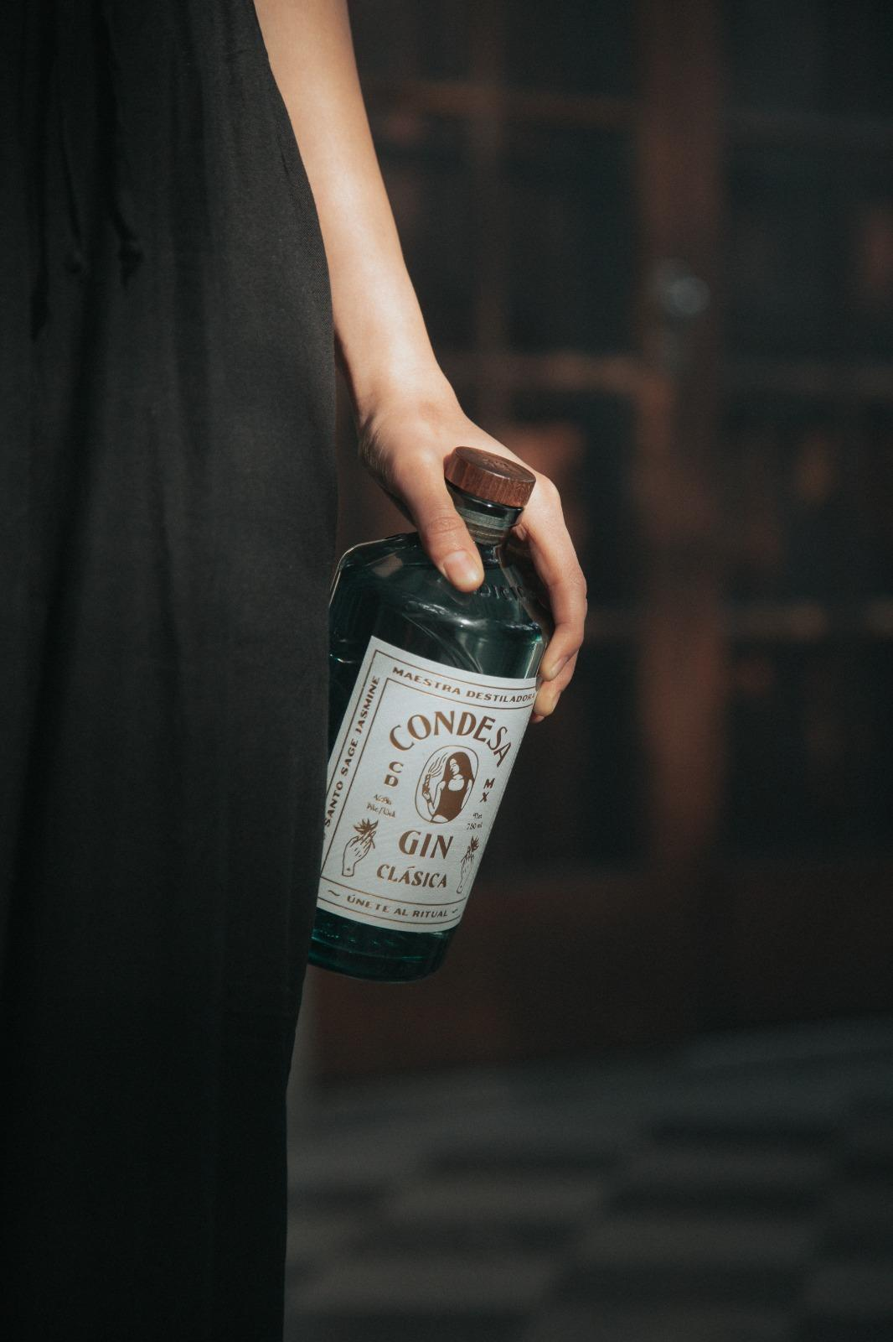
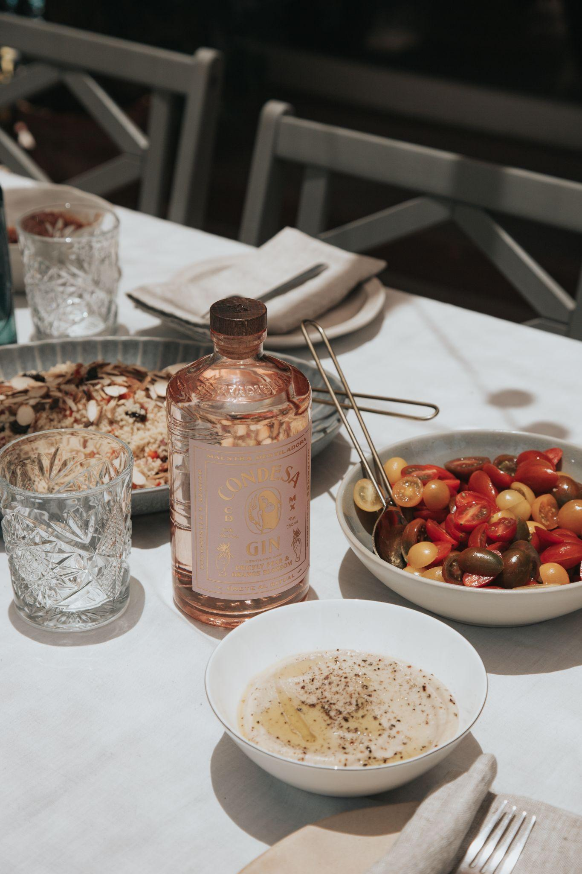
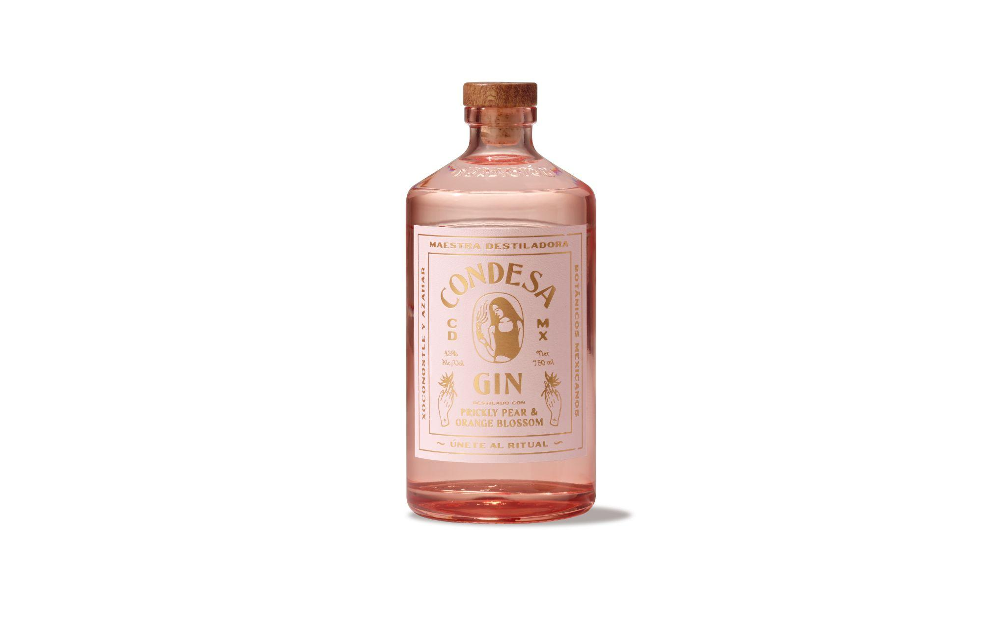

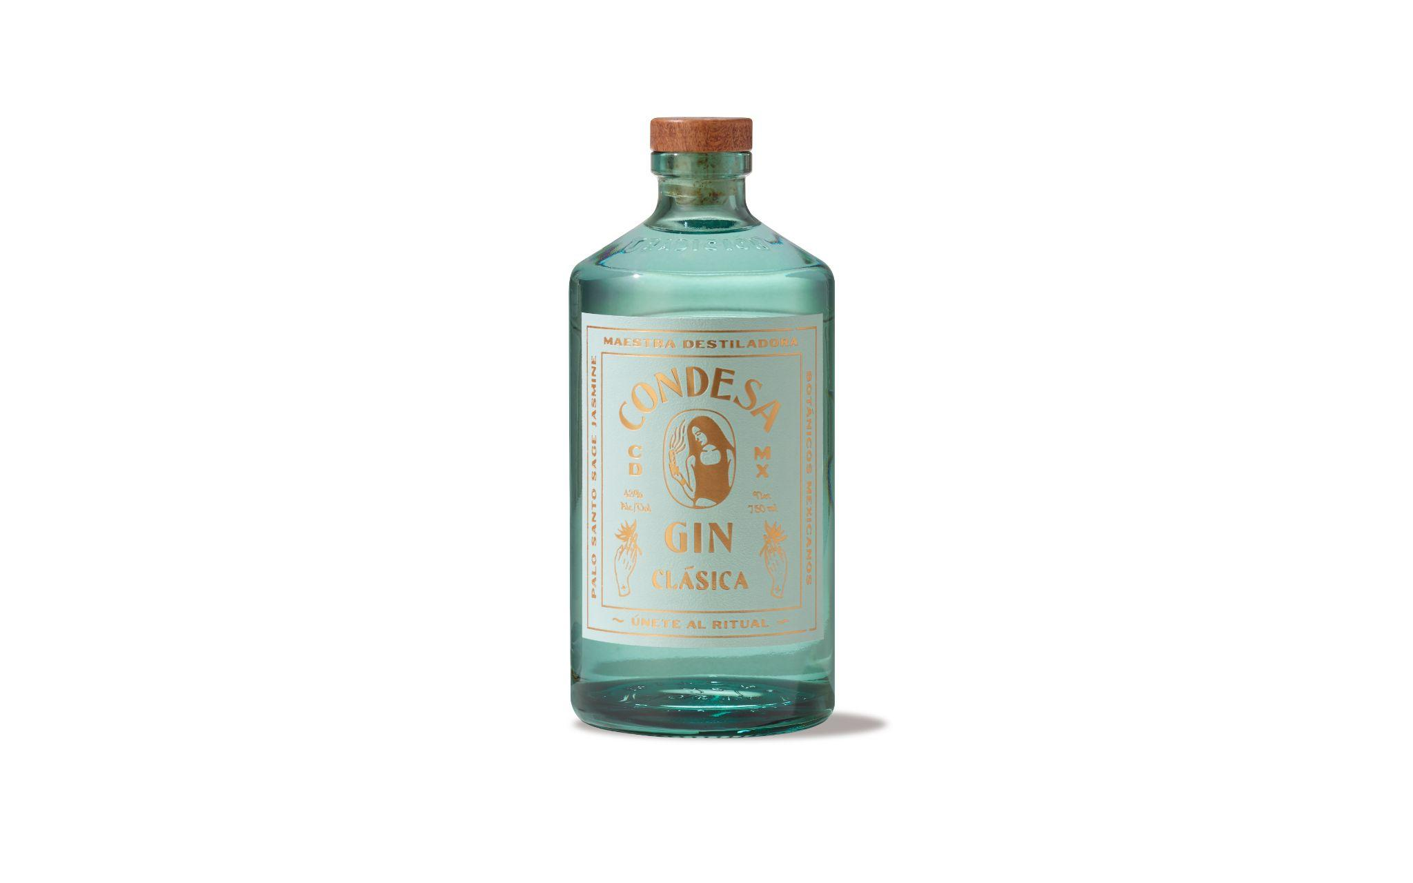SOURCE: CONDESA GIN

