Ryde Bets Big on EVs: Targets 1,200 Additional EVs by 2027 in Singapore
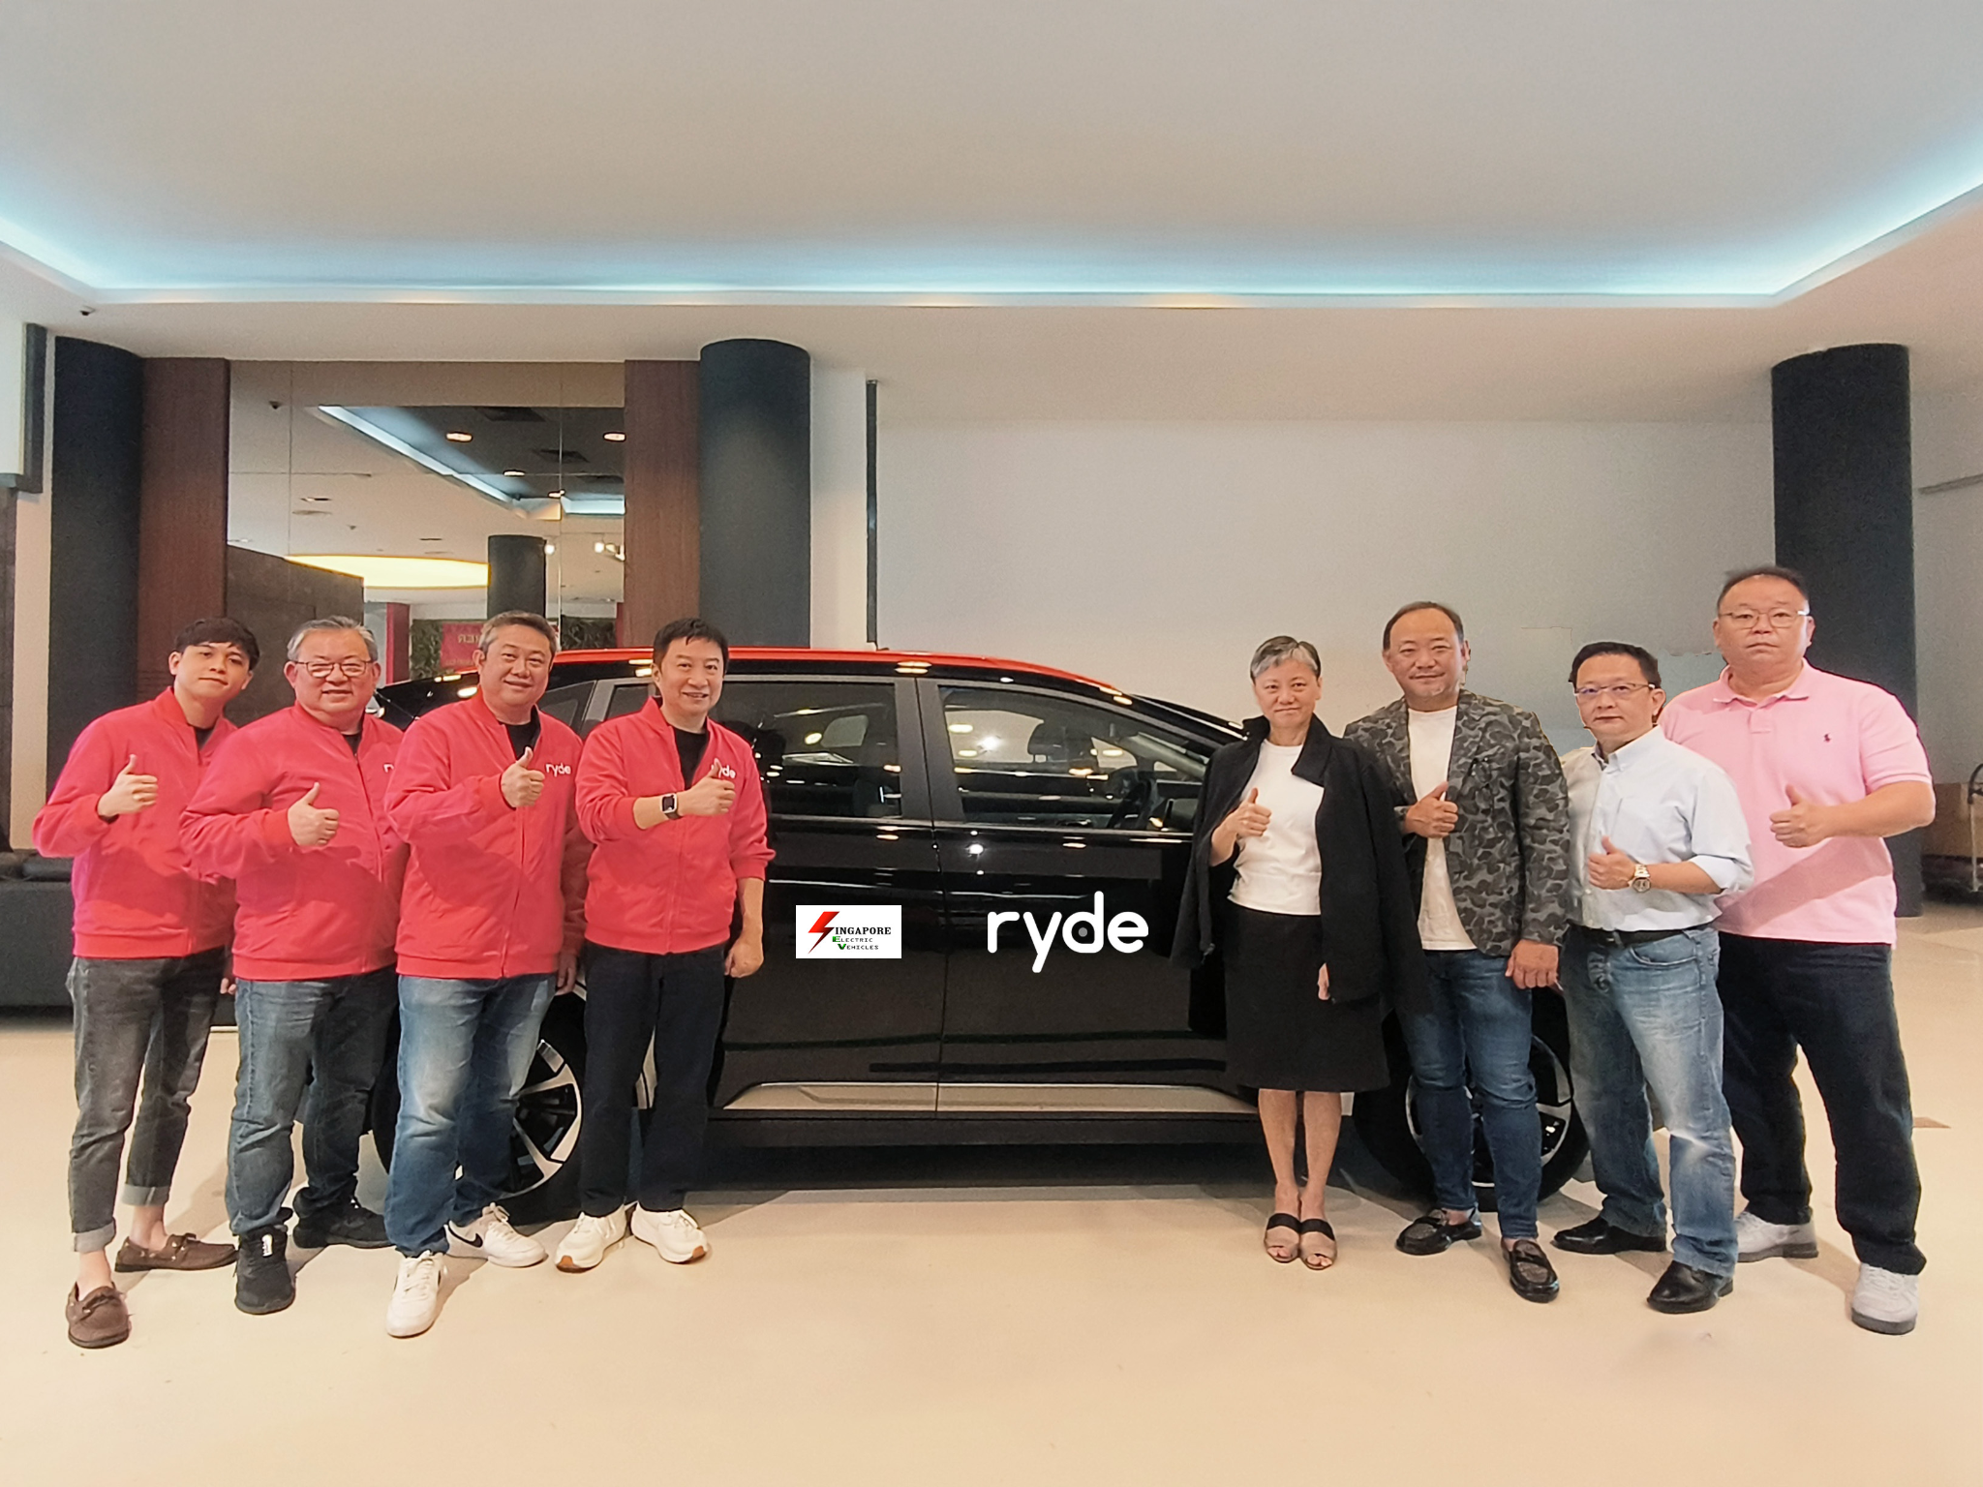
SINGAPORE, December 30, 2024 – Ryde Group Ltd (NYSE American: RYDE) ("Ryde'' or the “Company"), a technology company with a leading platform for mobility and quick commerce in Singapore, is accelerating the green mobility revolution in Singapore with its RydeGreen Program, a comprehensive initiative aimed at driving electric vehicle (EV) adoption, empowering driver-partners, and reducing carbon emissions.

As part of this transformative initiative, Ryde is targeting to introduce an additional 1,200 EVs under its RydeGreen Program by 2027.
This bold commitment, in partnership with Singapore Electric Vehicles (SEV), the largest EV leasing company in Singapore, offers driver-partners affordable EV leasing solutions and access to an extensive charging network. This network is further strengthened by SEV’s collaboration with their partners, which aims to install up to 250 charging stations across Singapore by 2030.

RydeGreen Program - Leading the charge for a greener future
The RydeGreen Program embodies Ryde’s mission to build a smarter, greener, and more inclusive future for urban mobility. It is also a strategic initiative to strengthen Ryde’s market share and drive revenue growth through exclusive partners such as Singapore Electric Vehicles (SEV), who have the largest commercial electric vehicle fleet in Singapore.
By investing in green mobility, Ryde in collaboration with SEV are poised to:
- Accelerate EV Adoption
- Targeting additional 1,200 EVs by 2027, with 900 EVs by 2026 and 600 EVs by 2025.
- Partnering with Singapore Electric Vehicles (SEV), the largest EV leasing company in Singapore, to offer driver-partners affordable leasing options. SEV’s collaboration with key partners further enhances access to a growing charging network across Singapore, ensuring convenience and reliability for EV adoption.
- Increase Driver-Partner Engagement and Retention
- Financial Incentives: Driver-partners leasing EVs through SEV will receive a monthly Green Bonus, with Ryde committing over $1 million green bonus to support its driver-partners.
- Affordable EV rental options to support driver-partners’ financial stability and operational efficiency.
- Support the Singapore Green Plan 2030
- Advancing the Green Plan’s Energy Reset & City in Nature Pillars by facilitating the shift to cleaner energy through the reduction of carbon emissions and reducing reliance on fossil fuels.
- Playing a key role in achieving 2030 emission reduction targets with sustainable transportation solutions.
- Leveraging AI-powered routing algorithms to optimize routes and minimize carbon emissions by adding additional EV Fleet.
- Long Term Growth through EV Adoption Strategy
The expansion of EV adoption enhances the RydeGreen Program, generating increased revenue through increased EV trip bookings. As Singapore accelerates its transition to green mobility, Ryde’s proactive EV adoption strategy ensures it remains competitive in a rapidly evolving market.
Strategic Partnership Driving Green Mobility
This collaboration between Ryde and SEV unites two industry leaders to accelerate the adoption of EVs in the ride-hailing ecosystem. By combining Ryde’s AI-powered routing capabilities with SEV’s expertise in providing well-maintained EV fleets, the program enhances accessibility to electric vehicles and promotes cleaner transportation solutions.
Terence Zou, Founder, Chairman, and CEO of Ryde Group, shared “Ryde’s commitment to sustainability goes beyond words — It’s about creating real impact on the ground. Through the RydeGreen Program and our partnership with SEV, we can lead Singapore’s transition toward a sustainable and inclusive mobility ecosystem, fully aligned with the goals of Singapore Green Plan 2030.”
Steven Kwek, COO of SEV, added: "We are thrilled to collaborate with Ryde as a strategic partner. Together, we will expand the EV fleet under the RydeGreen Program and align with Singapore’s sustainability goals for greener urban mobility."
About Ryde Group Ltd
Ryde, a homegrown super mobility app founded in Singapore, is the world's FIRST on-demand carpooling app since 2014! As a publicly listed company on the NYSE, we are reimagining the way people and goods move around. We offer a full suite of services, including carpooling, private hire, taxi, and delivery, but what truly sets us apart is our commitment to empower our private-hire and taxi partners. We take 0% commission, ensuring that more of every hard-earned dollar goes to drivers on our platform. For more information, please visit https://rydesharing.com/ to learn more.

Contacts

For Media Relations:
Media Team
Ryde Group Ltd
Email: media@rydesharing.com

For Investor Relations:
Investor Relations Team
Ryde Group Ltd
Email: investor@rydesharing.com

FORWARD-LOOKING STATEMENTS
Statements in this press release about future expectations, plans and prospects, as well as any other statements regarding matters that are not historical facts, may constitute "forward-looking statements" within the meaning of The Private Securities Litigation Reform Act of 1995. These statements include, but are not limited to, statements relating to the expected trading commencement and closing dates. The words "anticipate," "believe," "continue," "could," "estimate," "expect," "intend," "may," "plan," "potential," "predict," "project," "should," "target," "will," "would" and similar expressions are intended to identify forward-looking statements, although not all forward-looking statements contain these identifying words. Actual results may differ materially from those indicated by such forward-looking statements as a result of various important factors . Any forward-looking statements contained in this press release speak only as of the date hereof, and Ryde Group Ltd specifically disclaims any obligation to update any forward-looking statement, whether as a result of new information, future events or otherwise, except as required by law.

