
FOR IMMEDIATE RELEASE

Sapphire Chic Fashions Launches Sporty Chic Collection
Handmade embellished sports theme bras now available from Sapphire Chic Fashions

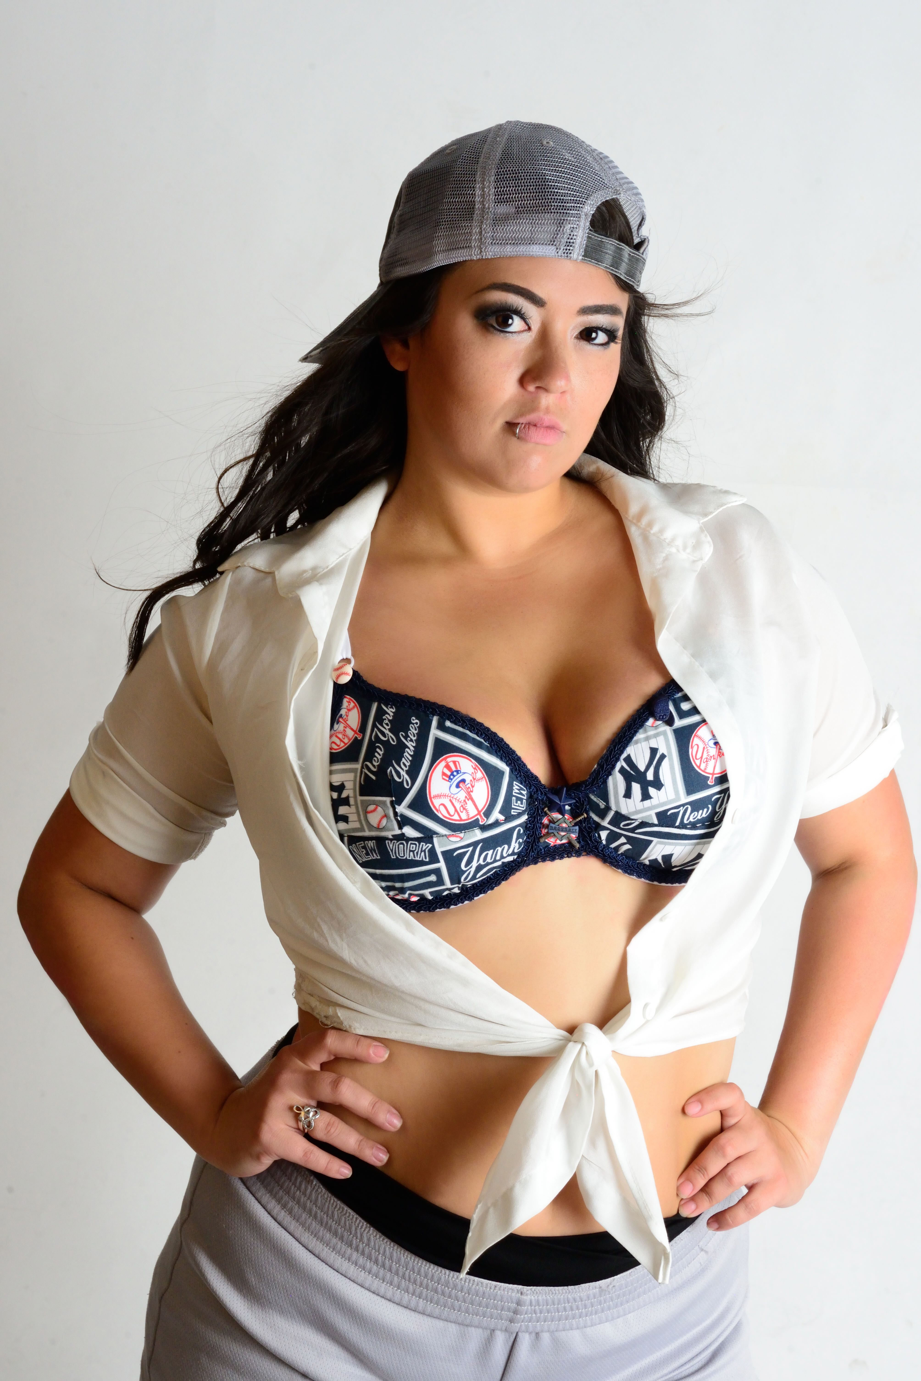
ARLINGTON, TEXAS, JULY 18, 2016 - Sapphire Chic Fashions is excited to announce the launch of their latest collection, the Sporty Chic Collection on ESTY. https://www.etsy.com/shop/SAPPHIRECHICFASHIONS
With the Sporty Chic Collection, ladies looking for a handmade, high quality, embellished bras with their favorite team’s insignia can find exactly what they’re looking for.

Sapphire Chic Fashions offers a variety of premier, handcrafted, embellished bras for belly dancers, ravers, and more, and the company proudly makes bras in all sizes. Every bra is hand sewn a stitch at a time, promising the height of quality and customization for all customers.

Sapphire Chic Fashions empowers women and encourages wellness while delivering bras, ready to wear corsets, lingerie, swimwear, and yoga gear that goes beyond the garden variety. As opposed to generic apparel and accessories, women can shop from the Sapphire Chic Fashions ready-to-wear collection.

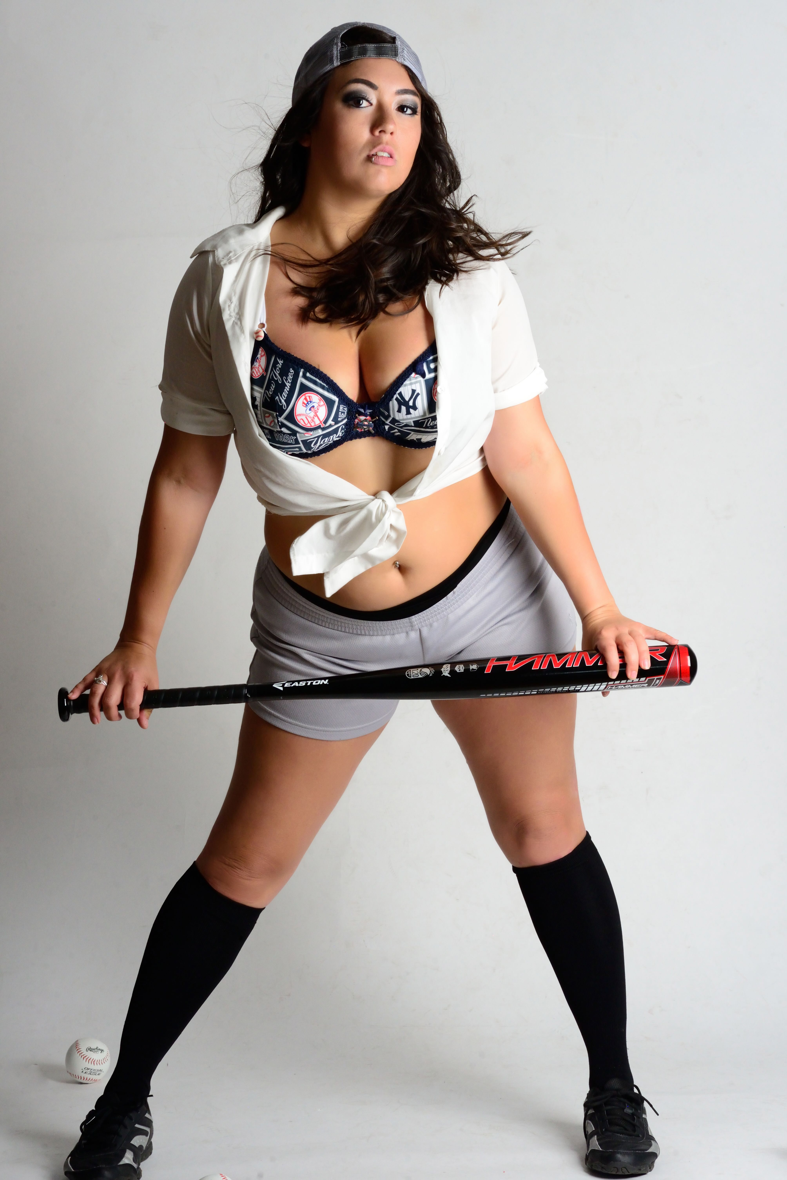
The team at Sapphire Chic Fashions is thrilled to announce the launch of the Sporty Chic Collection ahead of football season. While the collection includes options outside of football, the Sporty Chic Collection makes its debut during a season when sports fans are gearing up for football season.

Customers can see the collection and submit orders for Sporty Chic items. Sapphire Chic Fashions can cover bras from scratch. Customers can choose their colors, sizes, and more. According to the Sapphire Chic Fashions team, orders usually ship in about 3 weeks after approval.

“Every cup is full - You are beautiful,” said Sapphire Chic Fashions.

Sapphire Chic Fashions is proud to unveil the Sporty Chic Collection, offering women a new and exciting way to show their team spirit. More information can be found at http://www.sapphirechicfashions.com/

About Sapphire Chic Fashions

Sapphire Chic Fashions creates handmade, embellished bras for belly dancers, ravers, and more and offers ready-to-wear corsets, swimwear, yoga gear, and more.

Contact

Sapphire Chic Fashions
Midora Smith
Phone: 682-248-0073
E-mail: sapphirechicfashions@icloud.com
Etsy: https://www.etsy.com/shop/SAPPHIRECHICFASHIONS
Facebook: https://www.facebook.com/sapphirechicfashions
Twitter: https://twitter.com/sapphirechic1
YouTube: https://www.youtube.com/channel/_{UCU4hl2uXS}_PJ0zxCJLUSLLg
Website: http://www.sapphirechicfashions.com/

