Passing the Torch: A Legacy of Leadership at the Gaston Community Foundation

Honoring Ernest Sumner’s Remarkable Tenure
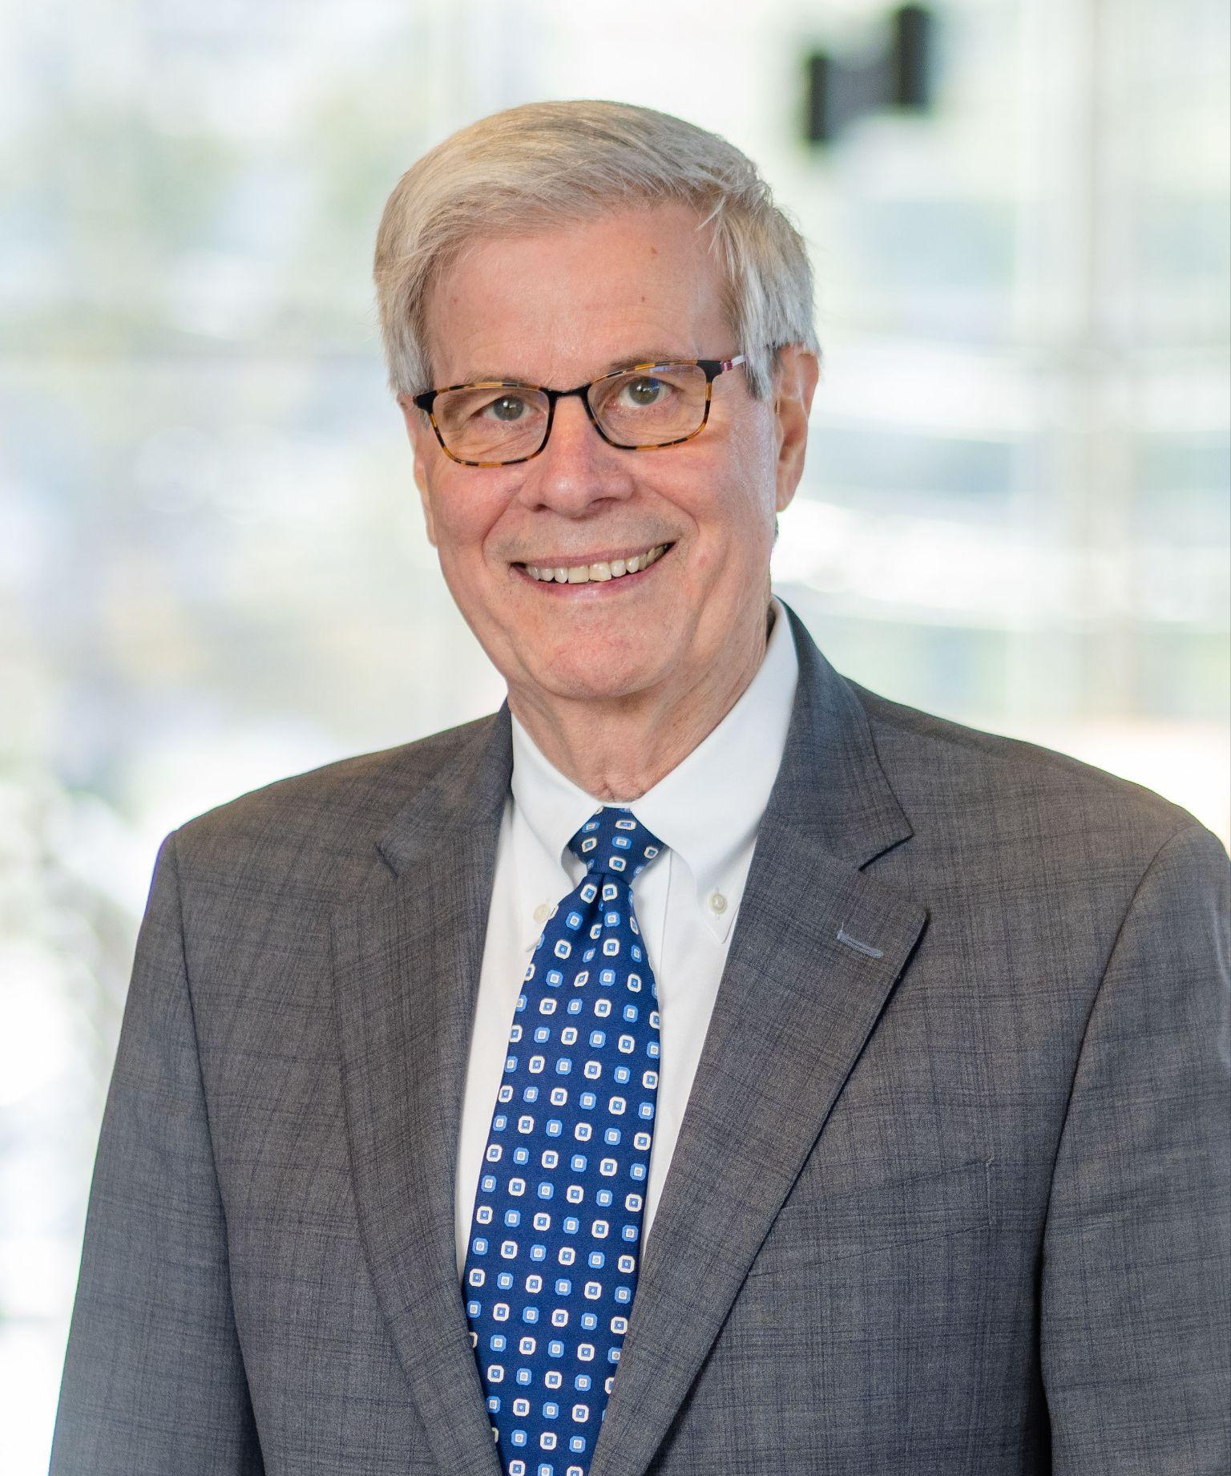
After fifteen years of visionary leadership and service, Ernest Sumner will retire on June 30, 2025, as President of the Gaston Community Foundation. His departure marks the end of a chapter defined by transformational growth, quiet humility, and a steadfast commitment to community.
When Ernest joined the Foundation in 2010, GCF held $49 million in assets. Today, that number has grown to nearly $145 million—an extraordinary testament to his steady hand and strategic vision. But beyond the numbers, Ernest’s legacy lies in the relationships he nurtured, the nonprofits he championed, and the community he so deeply loved.
A lifelong Gaston County resident and decorated civic leader, Ernest brought to the Foundation not only business acumen from a successful private-sector career, but also a servant’s heart.
In recognition of his decades-long impact, Ernest received the W. Duke Kimbrell Lifetime Civic Achievement Award in
“Ernest has an easygoing manner that allows him to connect comfortably with individuals from all walks of life,” shared longtime friend Anderson Warlick. “He is both confident and humble... devoted to the best outcomes for the organizations he serves and the community at large – with very little recognition for his remarkable accomplishments.”

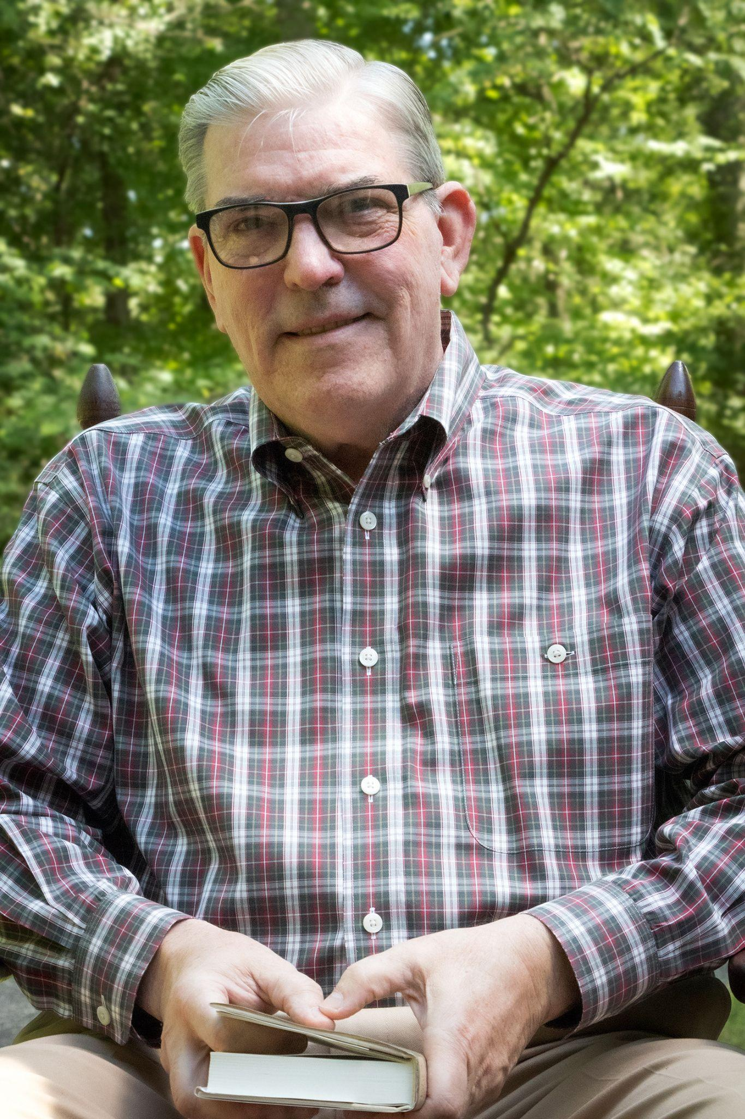
Welcoming Richard Rankin: A Leader Rooted in Service
Taking the reins is Richard Rankin, whose name may already be familiar to many in Gaston County. A seasoned leader, educator, author, and fundraiser, Richard brings with him a wealth of experience and a deep-rooted passion for community advancement.
For over two decades, Richard served as Head of Gaston Day School, where he transformed the institution into one of North Carolina’s top independent schools. Under his leadership, enrollment surged, the endowment grew and three major capital campaigns raised over $24 million. His ability to lead with vision and empathy was evident not only in outcomes, but in the lives of students, families, and staff he uplifted.

“With a career defined by vision, empathy, and service, Richard is uniquely positioned to carry forward Ernest’s legacy.”
Beyond education, Richard’s career includes major roles in institutional advancement, including Vice President of Institutional Advancement at Queens University of Charlotte, where he secured over $50 million in gifts. A respected historian and published author, he has served on numerous civic boards, including a previous term as President of the Gaston Community Foundation from 2013–2015.
With accolades like the Order of the Long Leaf Pine, the W. Duke Kimbrell Civic Achievement Award, and a career defined by service, Richard is uniquely positioned to carry forward Ernest’s legacy while bringing his own voice to the next chapter of the Foundation’s growth.

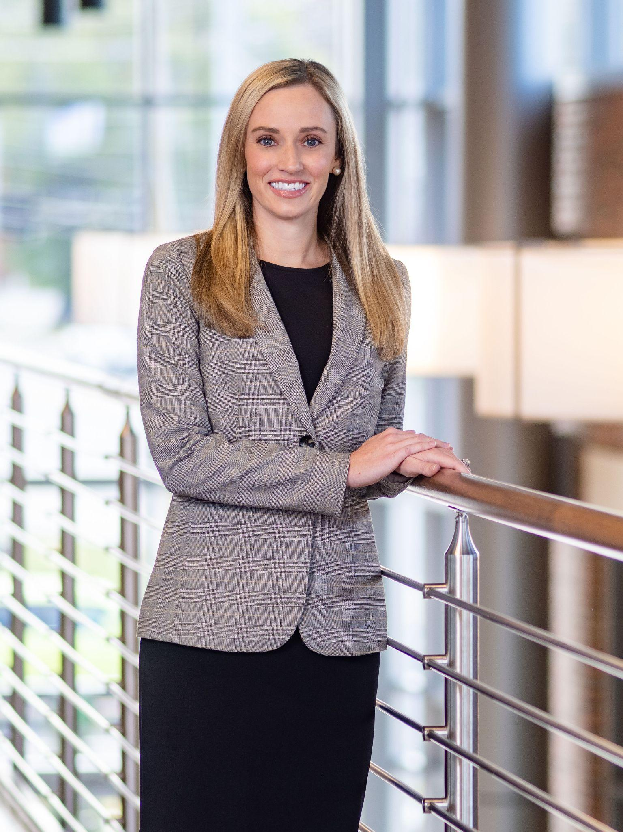
Celebrating Elizabeth Patton’s Well-Deserved Promotion
As part of this new era, the Foundation is also proud to announce the promotion of Elizabeth Patton, a dynamic and dedicated member of the GCF team as Executive Vice President. Elizabeth has been instrumental in developing donor relationships and elevating the Foundation’s role in the region’s philanthropic ecosystem.
Ms. Patton has worked with the Foundation for the past 12 years, gaining strong work experience across key areas including grants, scholarships, and programming. In 2018, she was promoted to Chief Development and Donor Services Officer, a role in which she has excelled for the past seven years. She is a graduate of NC State University with a B.A. degree in Communications. Prior to joining the Gaston Community Foundation, she served as the Annual Fund and Public Relations Manager of the John Avery Boys and Girls Club in Durham, as well as working in Community Relations with the Carolina Hurricanes in Raleigh. Both Dr. Rankin and Ms. Patton are Gaston County natives—with Richard residing in Mt. Holly and Elizabeth in Belmont.

A Future Built on Legacy
This moment of transition is more than a change in personnel. It’s a powerful reflection of continuity, commitment, and the enduring mission of the Foundation: to uplift the region by connecting people, passions, and purpose.

