
76.4 m – 76.5 m
Peak: 21,940 CPS
76.4 m – 76.5 m
Peak: 21,940 CPS

ANGILAK URANIUM PROJECT GEOPHYSICAL SURVEY SUCCESSFULLY INCREASES DEPTH EXTENT AT LAC 50 DEPOSIT TO >1 KM; IDENTIFIES NEW 25 KM TREND ASSOCIATED WITH HISTORIC UNCONFORMITY-TYPE ALTERATION AND MINERALIZATION WITH GRADES UP TO 5.6% U3O8

HIGHLIGHTS

- An Airborne Mobile MagnetoTellurics (“MMT”) survey totaling 5,946-line kilometres was completed in September of 2024. The survey covers the northern half of the Angilak Project (Figure 1) – representing approximately 85% of the original project area, pre-2024 staking – inclusive of the Lac 48, 50, 52, and 54 mineralized trends (known as the “Lac 50 Deposit”), as well as the eastern, western, and northern margins of the Angikuni Basin

- More than 100 km of cumulative prospective conductors were identified

- The survey successfully achieved its four primary objectives

- Determine the depth extent of prospective conductive horizons hosting uranium mineralization at the Lac 50 Deposit
- Determine the depth and lateral extent of prospective conductive horizons at regional high-grade uranium showings, such as the Nine-Iron Discovery
- Mapping prospective conductors within the Angikuni sub-basin, representing high-priority Athabasca-style unconformity type targets
- Identify new high-priority structural targets along the margins of the Angikuni Basin

- A 25 km conductive trend along the western margin of the Angikuni Basin – more conductive than Lac 50 and Nine Iron – has been identified. The Western Margin Trend (“WMT”) shows substantial similarities with typical Athabasca Basin unconformity-style deposits and is coincidental with numerous historic uranium showings such as Rib and Yat

  - The Rib Discovery consists of 30 diamond drill holes that intersected shallow mineralization (<25 m depth) with grades of up to 5.6% U₃O₈. Rib was drilled during the late 1970s and is situated within the western margin of the Angikuni Basin where drill holes intersecting Athabasca style unconformity alteration, structure, and lithologies associated with uranium mineralization. Importantly, as was typical of 1970 – 1980’s Athabasca Basin exploration, the maximum depth of drilling at Rib is ~100 m, ending in what is now considered to be prospective alteration and lithologies. The 2024 MMT survey demonstrates that the prospective conductive horizon along the WMT extends from surface to depths of more than 1 km, within and along the margins of the Angikuni Basin

- The Lac 50 Deposit has a baseline 2024 Exploration Target Model ranging between 60.8M lbs U₃O₈ and 98.2M lbs U₃O₈, with an average grade range of 0.37% U₃O₈ and 0.48% U₃O₈ (see November 25, 2024, NI-43-101 Technical Report) (Table 1). The 2024 Exploration Model was restricted to drill results with a maximum modelled depth extent of ~500 m. The MMT results demonstrate the prospective conductive horizons that host mineralization extend to depths greater than 1 km, significantly increasing the prospectivity of the mineralized envelop

- The Nine Iron Discovery consists of 5 diamond drill holes, all of which intersected uranium mineralization with grades of up to 1.25% U₃O₈. Nine Iron is located approximately 5.5 km southeast of the Lac 50 Deposit along the western margin of the Angikuni Basin and was not included in the 2024 Exploration Model. Drilling at Nine Iron has a maximum depth of ~150 m and results from the MMT survey indicate the prospective conductive horizons extend from surface to more than 800 m depth.
Troy Boisjoli, CEO commented: “The results from our 2024 MMT survey represent a significant milestone in unlocking the full potential of the Angilak Project, and importantly, the Angikuni Basin as a whole. The confirmation of down-dip conductive horizons at the Lac 50 Deposit and Nine Iron Discovery, along with the newly identified 25 km conductive trend along the western margin of the Angikuni Basin, underscores the immense scale and prospectivity of this project. These findings reinforce our belief that Angilak has the potential to emerge as one of the most significant uranium districts globally, and we are excited to continue defining the potential of this project.”
Cliff Revering, VP Exploration added: “The 2024 exploration program was designed to demonstrate the potential scale and prospectivity of the Angilak Project, and the results of the 2024 MMT survey is yet another layer of evidence to support our thesis on this uranium district. In addition to the depth potential observed at the Lac 50 Deposit within the MMT data, the identification of large, regional scale conductive horizons within the Angikuni Basin corroborated by historical drilling at Nine-Iron and Rib, which intersected favorable geology, significant alteration, and uranium mineralization, continues to grow the discovery potential within the Angilak Uranium District.”
Vancouver, British Columbia, January 15th, 2025 – ATHA Energy Corp. (TSX.V: SASK) (FRA: X5U) (OTCQB: SASKF) (“ATHA” or the “Company”), holder of the largest uranium exploration portfolio in two of the highest-grade uranium districts globally, is pleased to announce results from its Airborne Mobile MagnetoTellurics (“MMT”) survey at its 100%-owned Angilak Uranium Project (the “Project”) in Nunavut, Canada.
The MMT survey at Angilak was completed in September of 2024 by Expert Geophysics. The system combines the latest advances in electronics, airborne system design, and sophisticated signal processing techniques. The objectives of the MMT survey were to:
- Determine the depth extent of prospective conductive horizons hosting uranium mineralization at the Lac 50 Deposit
- Determine the depth and lateral extent of prospective conductive horizons at regional high-grade uranium showings, such as the Nine-Iron Discovery
- Mapping prospective conductors within the Angikuni sub-basin, representing high-priority Athabasca-style unconformity type targets
- Identify new high-priority structural targets along the margins of the Angikuni Basin
All objectives were successfully achieved with the identification of conductive lithological horizons hosting sulphides and graphite, which are known indicators for uranium mineralization across the Angilak Project – and are analogous to Athabasca Basin style uranium deposits. A total of 5,946-line kilometres were flown over the northern half of the Angilak Project, representing approximately 85% of the original project area, pre-2024 staking (Figure 1) – inclusive of the Lac 48, 50, 52, and 54 mineralized trends (known as the “Lac 50 Deposit”), as well as the eastern, western and northern margins of the Angikuni Basin.
Results from the MMT survey confirm the depth extent of the prospective conductive horizons that host uranium mineralization at the Lac 50 Deposit and Nine Iron Discovery (Figure 1). At the Lac 50 Deposit, the survey indicates that the prospective conductive horizons extend to 1 km depth, while at Nine Iron Discovery, the prospective horizons extend to approximately 800 m depth. At both areas the results demonstrate the potential for mineralization to extend well beyond the current envelops of mineralization. Additionally, along the western margin of the Angikuni Basin, a 25 km conductive trend has been identified that is more conductive than Lac 50 and Nine Iron. During the late 1970’s several rounds of exploration took place along the Western Margin Trend (“WMT”), inclusive of diamond drilling, trenching and soil sampling, which resulted in the discovery of numerous uranium showings, including Rib and Yat.
At the Rib Discovery – located ~30 km southwest of the Lac 50 Deposit, situated along the western margin of the Angikuni Basin – early exploration programs were conducted by Noranda Exploration Company (“Noranda”). Between 1977 and 1979 Noranda completed 30 diamond drill holes at the Rib Discovery, intersecting Athabasca Basin-style unconformity alteration, structure, and lithologies associated with shallow (<25 m depth) uranium mineralization with grades of up to 5.6% U₃O₈ hosted within graphitic mylonites. These historic drill results demonstrate that the Angikuni Basin has the potential to host Athabasca Basin-style, basement- and unconformity-type uranium mineralization. When the historic drill results are coupled with the 2024 MMT survey results at the Rib Discovery, the scale and potential of the WMT to host multiple additional unconformity and basement type uranium mineralized zones along the 25 km trend is high. Importantly, as was typical of 1970 – 1980s Athabasca Basin exploration, the maximum depth of drilling at Rib is ~100 m, ending in what is now considered to be prospective alteration and lithologies. The 2024 MMT survey demonstrates that the prospective conductive horizon along the WMT extends from surface to depths of more than 1 km, within and along the margins of the Angikuni Basin.
ANGILAK PROJECT – NUNAVUT
The Angilak Uranium Project is situated within the Angikuni Basin, approximately 225 km southwest of Baker Lake in the Kivalliq Region of Nunavut (Figure 1). The Project notably hosts the Lac 50 Uranium Deposit, which has a historical mineral resource estimate of 43.3M lbs at an average grade of 0.69% U₃O₈.¹ and a 2024 Exploration Target for the Lac 50 Deposit ranging between 60.8M lbs U₃O₈ and 98.2M lbs U₃O₈, with an average grade range between 0.37% U₃O₈ and 0.48% U₃O₈ (Table 1) - restricted to drill results from the Lac 48, 50, 52, and 54 mineralized trends. Additionally, numerous regional discoveries of uranium mineralization have been made outside of the Lac 50 Deposit area, both within the Angikuni Basin as well as along its rim – demonstrating many similarities to high-grade uranium discoveries in the Athabasca Basin, Saskatchewan. One such prominent regional discovery within the Angilak Project area is the Dipole Showing, located along the western rim of the Angikuni Basin 25 km to the southwest of the Lac 50 Corridor. Previous operators of the Project completed 24 diamond drill holes in the Dipole Showing and intersected grades of up to 5.53% U₃O₈ over 0.5 m.
Surficial mapping was completed as part of the 2024 Angilak Exploration Program (the “Mapping Program”), which also included expansion-focused diamond drilling and geophysics. The Mapping Program has successfully achieved its objective by discovering high-grade uranium mineralization on surface beyond the extents of the Lac 50 Deposit’s exploration target model (the “Exploration Target Model”) (Figure 3), as defined in the updated 2024 Technical Report in accordance with the guidelines set forth in the National Instrument NI 43-101. The Technical Report establishes a baseline exploration target for the Lac 50 Deposit ranging between 60.8M lbs U₃O₈ and 98.2M lbs U₃O₈, with an average grade range between 0.37% U₃O₈ and 0.48% U₃O₈ (the “Exploration Target”) (Table 1) and is notably restricted to drill results from the Lac 48, 50, 52, and 54 mineralized trends (the “Lac 50 Deposit”) (Figures 2a & 2b).
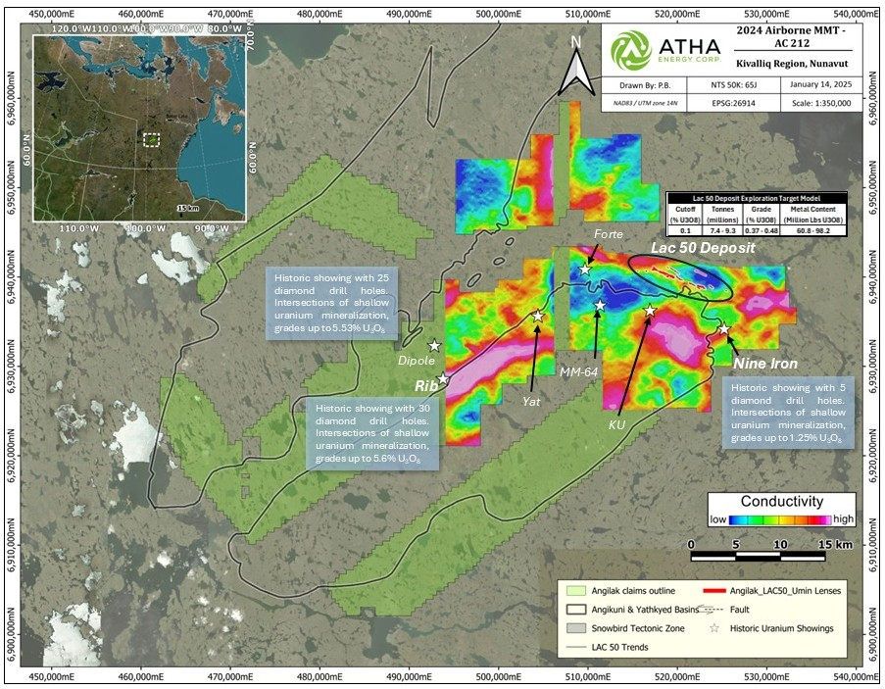
Figure 1: Plan Map detailing Lac 50 Deposit location with the Angilak Uranium Project
Table 1: Lac 50 Deposit Exploration Target Model
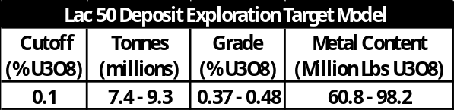
*Notes - The stated potential quantity and grade is conceptual in nature, and there has not been sufficient exploration to define a mineral resource, and it is uncertain if further exploration will result in the target being delineated as a mineral resource. **Significant digits have been rounded to the nearest decimal. ***The ranges were derived from a block model approach using interpreted vein wireframes, drill core assays, grade interpolation via Ordinary Kriging, and applied uncertainty bandwidths.
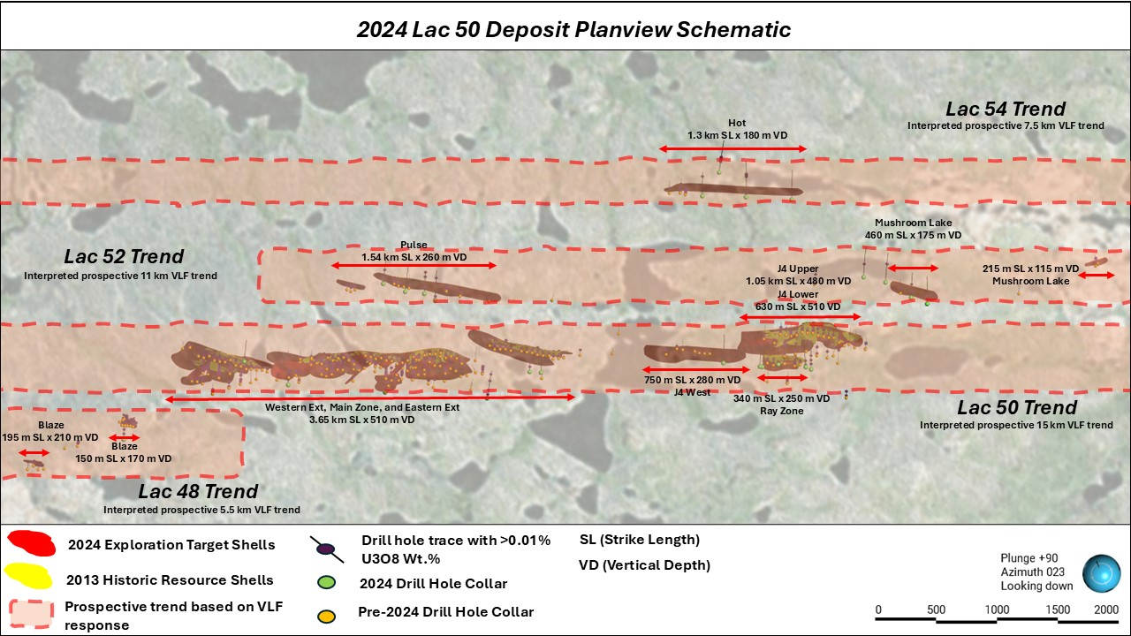
Figure 2a: 2024 Lac 50 Deposit Planview Schematic
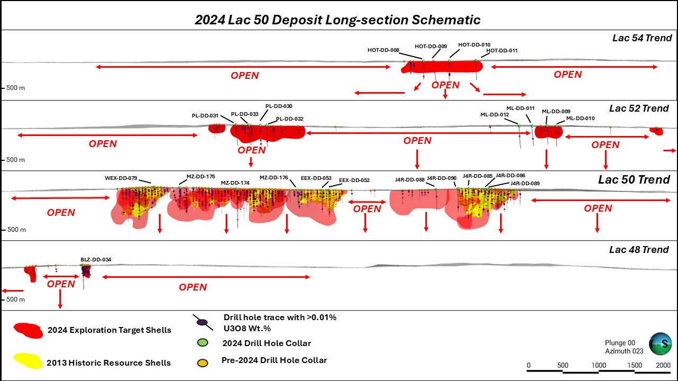
Figure 2b: 2024 Lac 50 Deposit Long-section Schematic
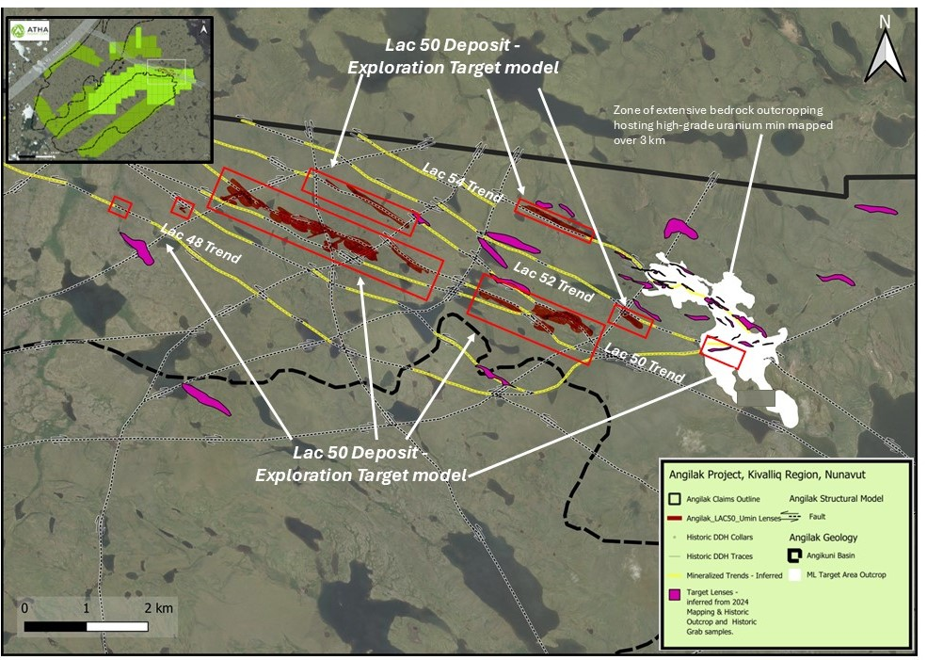
Figure 3: 2024 Lac 50 Deposit Area and Mapped Mineralized Outcrops
NOVEMBER 2024 ANGILAK PROJECT TECHNICAL REPORT
Understood Mineral Resources Ltd. (“UMR”) provided ATHA with ranges for potential uranium quantity and grade as a target for further exploration on Angilak's Lac 50 Deposit. The ranges were derived from a block model approach using interpreted vein wireframes, drill core assays, grade interpolation via Ordinary Kriging, and applied uncertainty bandwidths.
The wireframes were modelled using a grade intercept limit equal to or greater than a minimum grade of 0.01% U₃O₈, although lower grades were incorporated in places to maintain continuity and represent the structural setting and continuity of the mineralized system. Extension distance for the mineralized wireframes was halfway to the next hole, or 200 m in areas of no drilling, representing the potential at the deposit.
Assays were composited to 4 metre lengths within the mineralized boundaries, capped at 5% U₃O₈, and used for variography. The blocks within the wireframes were interpolated with grade values using the composites, variography, ordinary kriging (OK), and a High Yield Limit set at 2.5% U₃O₈ (50% of search range).
UMR applied an uncertainty bandwidth to define a range for potential uranium using the block model as the midpoint. The well-informed portions of the wireframes with < 50 m drill hole spacing used a bandwidth of ± 5% tonnes and ± 15% metal content. An uncertainty bandwidth of ± 10% tonnes and ± 30% metal content was used for the remaining wireframes with drill hole spacing greater than 50 m. The stated potential quantity and grade is conceptual in nature, and there has not been sufficient exploration to define a mineral resource, and it is uncertain if further exploration will result in the target being delineated as a mineral resource.
Qualified Person
The scientific and technical information contained in this news release have been reviewed and approved by Cliff Revering, P.Eng., Vice President, Exploration of ATHA, who is a "qualified person" as defined under National Instrument 43-101 – Standards of Disclosure for Mineral Projects.
The ranges for potential uranium quantity and grade for the Lac 50 Deposit were completed by Mr. Matthew Batty, MSc, P.Geo of Understood Mineral Resources Ltd. Mr. Batty is an independent Qualified Persons in accordance with the requirements of National Instrument (NI) 43-101 and he has approved the disclosure herein.
About ATHA
ATHA is a Canadian mineral company engaged in the acquisition, exploration, and development of uranium assets in the pursuit of a clean energy future. With a strategically balanced portfolio including three 100%-owned post discovery uranium projects (the Angilak Project located in Nunavut, and CMB Discoveries in Labrador hosting historical resource estimates of 43.3 million lbs and 14.5 million lbs U₃O₈respectively, and the newly discovered basement hosted GMZ high-grade uranium discovery located in the Athabasca Basin). In addition, the Company holds the largest cumulative prospective exploration land package (7.3 million acres) in two of the world’s most prominent basins for uranium discoveries - ATHA is well positioned to drive value. ATHA also holds a 10% carried interest in key Athabasca Basin exploration projects operated by NexGen Energy Ltd. and IsoEnergy Ltd. For more information visit www.athaenergy.com. ^{1,2,3.}
About Understood Mineral Resources Ltd.
Understood Mineral Resources Ltd. is a small, well-trained team with experience in numerous commodities and geologic environments, specializing in project development, geological modeling, deterministic and probabilistic mineral resource estimation, production reconciliation, grade control, and mine planning. UMR’s academic training gives them the unique skills to generate probabilistic resource modelling products in conjunction with more conventional techniques such as ordinary kriging. UMR’s primary objective is to bring high-quality, reliable, auditable resource models to all mining companies using the latest geostatistical techniques and strategies.
On Behalf of the Board of Directors
Troy Boisjoli, CEO, ATHA Energy Corp
Neither the TSX Venture Exchange nor its Regulation Services Prover (as the term is defined in the policies of the TSX Venture Exchange) accepts responsibility for the adequacy or accuracy of this release.
For more information, please contact:
Troy Boisjoli
Chief Executive Officer
Email: info@athaenergy.com
www.athaenergy.com

Historical Mineral Resource Estimates
All mineral resources estimates presented in this news release are considered to be “historical estimates” as defined under NI 43-101, and have been derived from the following (See notes below). In each instance, the historical estimate is reported using the categories of mineral resources and mineral reserves as defined by the CIM Definition Standards for Mineral Reserves, and mineral reserves at that time, and these “historical estimates” are not considered by ATHA to be current. In each instance, the reliability of the historical estimate is considered reasonable, but a Qualified Person has not done sufficient work to classify the historical estimate as a current mineral resource, and ATHA is not treating the historical estimate as a current mineral resource. The historical information provides an indication of the exploration potential of the properties but may not be representative of expected results.
Notes on the Historical Mineral Resource Estimate for the Angilak Deposit:
1. This estimate is considered to be a “historical estimate” under NI 43-101 and is not considered by any of to be current. See below for further details regarding the historical mineral resource estimate for the Angilak Property.
- Mineral resources which are not mineral reserves do not have demonstrated economic viability.
- The estimate of mineral resources may be materially affected by geology, environment, permitting, legal, title, taxation, sociopolitical, marketing or other relevant issues.
- The quality and grade of the reported inferred resource in this estimation are uncertain in nature and there has been insufficient exploration to define these inferred resources as an indicated or measured mineral resource, and it is uncertain if further exploration will result in upgrading them to an indicated or measured resource category.
- Contained value metals may not add due to rounding.
- A 0.2% U3O8 cut-off was used.
- The mineral resource estimate contained in this press release is considered to be “historical estimates” as defined under NI 43-101 and is not considered to be current.
- The “historical estimate” is derived from a Technical Report entitled “Technical Report and Resource Update For The Angilak Property, Kivalliq Region, Nunavut, Canada”, prepared by Michael Dufresne, M.Sc., P.Geol. of APEX Geosciences, Robert Sim, B.Sc., P.Geo. of SIM Geological Inc. and Bruce Davis, Ph.D., FAusIMM of BD Resource Consulting Inc., dated March 1, 2013 for ValOre Metals Corp.
- As disclosed in the above noted technical report, the historical estimate was prepared under the direction of Robert Sim, P.Geo, with the assistance of Dr. Bruce Davis, FAusIMM, and consists of three-dimensional block models based on geostatistical applications using commercial mine planning software. The project limits area based in the UTM coordinate system (NAD83 Zone14) using nominal block sizes measuring 5x5x5m at Lac Cinquante and 5x3x3 m (LxWxH) at J4. Grade (assay) and geological information is derived from work conducted by Kivalliq during the 2009, 2010, 2011 and 2012 field seasons. A thorough review of all the 2013 resource information and drill data by a Qualified Person, along with the incorporation of subsequent exploration work and results, which includes some drilling around the edges of the historical resource subsequent to the publication of the 2013 technical report, would be required in order to verify the Angilak Property historical estimate as a current mineral resource.
- The historical mineral resource estimate was calculated in accordance with NI 43-101 and CIM standards at the time of publication and predates the current CIM Definition Standards for Mineral Resources and Mineral Reserves (May, 2014) and CIM Estimation of Mineral Resources & Mineral Reserves Best Practices Guidelines (November, 2019).
- A thorough review of all historical data performed by a Qualified Person, along with additional exploration work to confirm results would be required to produce a current mineral resource estimate prepared in accordance with NI 43-101.

2. Notes on the Historical Mineral Resource Estimate for the Moran Lake Deposit:
  - Jeffrey A. Morgan, P.Geo. and Gary H. Giroux, P.Eng. completed a NI 43-101 technical report titled “Form 43-101F1 Technical Report on the Central Mineral Belt (CMB) Uranium Project, Labrador, Canada, Prepared for Crosshair Exploration & Mining Corp.” and dated July 31, 2008, with an updated mineral resource estimate for the Moran Lake C-Zone along with initial mineral resources for the Armstrong and Area 1 deposits. They modelled three packages in the Moran Lake Upper C-Zone (the Upper C Main, Upper C Mylonite, and Upper C West), Moran Lake Lower C-Zone, two packages in Armstrong (Armstrong Z1 and Armstrong Z3), and Trout Pond. These mineral resources are based on 3D block models with ordinary kriging used to interpolate grades into 10 m x 10 m x 4 m blocks. A cut-off grade of 0.015% U3O8 was used for all zones other than the Lower C Zone which employed a cut-off grade of 0.035%. A thorough review of all historical data performed by a Qualified Person, along with additional exploration work to confirm results, would be required to produce a current mineral resource estimate prepared in accordance with NI 43-101 standards.
3. Notes on the Historical Mineral Resource Estimate for the Anna Lake Deposit:
- The mineral resource estimate contained in this table is considered to be a “historical estimate” as defined under NI 43-101, and is not considered to be current and is not being treated as such. A Qualified Person has not done sufficient work to classify the historical estimate as current mineral resources. A qualified person would need to review and verify the scientific information and conduct an analysis and reconciliation of historical drill and geological data in order to verify the historical estimate as a current mineral resource.
- Reported by Bayswater Uranium Corporation in a Technical Report entitled “Form 43-101 Technical Report on the Anna Lake Uranium Project, Central Mineral Belt, Labrador, Canada”, prepared by R. Dean Fraser, P.Geo. and Gary H. Giroux, P.Eng., dated September 30, 2009.
- A 3-dimensional geologic model of the deposit was created for the purpose of the resource estimate using the Gemcom/Surpac modeling software. A solid model was created using a minimum grade x thickness cutoff of 3 meters grading 0.03% U3O8. Intersections not meeting this cutoff were generally not incorporated into the model. The shell of this modeled zone was then used to constrain the mineralization for the purpose of the block model. Assay composites 2.5 meters in length that honoured the mineralized domains were used to interpolate grades into blocks using ordinary kriging. An average specific gravity of 2.93 was used to convert volumes to tonnes. The specific gravity data was acquired in-house and consisted of an average of seventeen samples collected from the mineralised section of the core. The resource was classified into Measured, Indicated or Inferred using semi-variogram ranges applied to search ellipses. All resources estimated at Anna Lake fall under the “Inferred” category due to the wide spaced drill density. An exploration program would need to be conducted, including twinning of historical drill holes in order to verify the Anna Lake Project estimate as a current mineral resource.

Cautionary Statement Regarding Forward-Looking Information
This press release contains “forward-looking information” within the meaning of applicable Canadian securities legislation. Generally, forward-looking information can be identified by the use of forward-looking terminology such as “plans”, “expects” or “does not expect”, “is expected”, “budget”, “scheduled”, “estimates”, “forecasts”, “intends”, “anticipates” or “does not anticipate”, or “believes”, or variations of such words and phrases or state that certain actions, events or results “may”, “could”, “would”, “might” or “will be taken”, “occur” or “be achieved”. These forward-looking statements or information may relate to ATHA’s proposed exploration program, including statements with respect to the expected benefits of ATHA’s proposed exploration program, any results that may be derived from ATHA’s proposed exploration program, the timing, scope, nature, breadth and other information related to ATHA’s proposed exploration program, any results that may be derived from the diversification of ATHA’s portfolio, the successful integration of the businesses of ATHA, Latitude Uranium and 92 Energy, the prospects of ATHA’s projects, including mineral resources estimates and mineralization of each project, the prospects of ATHA’s business plans and any expectations with respect to defining mineral resources or mineral reserves on any of ATHA’s projects, and any expectation with respect to any permitting, development or other work that may be required to bring any of the projects into development or production.
Forward-looking statements are necessarily based upon a number of assumptions that, while considered reasonable by management at the time, are inherently subject to business, market and economic risks, uncertainties and contingencies that may cause actual results, performance or achievements to be materially different from those expressed or implied by forward-looking statements. Such assumptions include, but are not limited to, assumptions that the anticipated benefits of ATHA’s proposed exploration program will be realized, that no additional permit or licenses will be required in connection with ATHA’s exploration programs, the ability of ATHA to complete its exploration activities as currently expected and on the current anticipated timelines, including ATHA’s proposed exploration program, that ATHA will be able to execute on its current plans, that ATHA’s proposed explorations will yield results as expected, the synergies between ATHA, 92 Energy and Latitude Uranium’s assets, and that general business and economic conditions will not change in a material adverse manner. Although each of ATHA and 92E have attempted to identify important factors that could cause actual results to differ materially from those contained in forward-looking information, there may be other factors that cause results not to be as anticipated, estimated or intended. There can be no assurance that such information will prove to be accurate, as actual results and future events could differ materially from those anticipated in such statements. Accordingly, readers should not place undue reliance on forward-looking information.
Such statements represent the current view of ATHA with respect to future events and are necessarily based upon a number of assumptions and estimates that, while considered reasonable by ATHA, are inherently subject to significant business, economic, competitive, political and social risks, contingencies and uncertainties. Risks and uncertainties include, but are not limited to the following: inability of ATHA to realize the benefits anticipated from the exploration and drilling targets described herein or elsewhere; in ability of ATHA to complete current exploration plans as presently anticipated or at all; inability for ATHA to economically realize on the benefits, if any, derived from the exploration program; failure to complete business plans as it currently anticipated; overdiversification of ATHA’s portfolio; failure to realize on benefits, if any, of a diversified portfolio; unanticipated changes in market price for ATHA shares; changes to ATHA’s current and future business and exploration plans and the strategic alternatives available thereto; growth prospects and outlook of the business of ATHA; any impacts of COVID-19 on the business of ATHA and the ability to advance the Company projects and its proposed exploration program; risks inherent in mineral exploration including risks related worker safety, weather and other natural occurrences, accidents, availability of personnel and equipment, and other factors; aboriginal title; failure to obtain regulatory and permitting approvals; no known mineral resources/reserves; reliance on key management and other personnel; competition; changes in laws and regulations; uninsurable risks; delays in governmental and other approvals, community relations; stock market conditions generally; demand, supply and pricing for uranium; and general economic and political conditions in Canada, Australia and other jurisdictions where ATHA conducts business. Other factors which could materially affect such forward-looking information are described in the filings of ATHA with the Canadian securities regulators which are available on ATHA’s profile on SEDAR+ at www.sedarplus.ca. ATHA does not undertake to update any forward-looking information, except in accordance with applicable securities laws.

