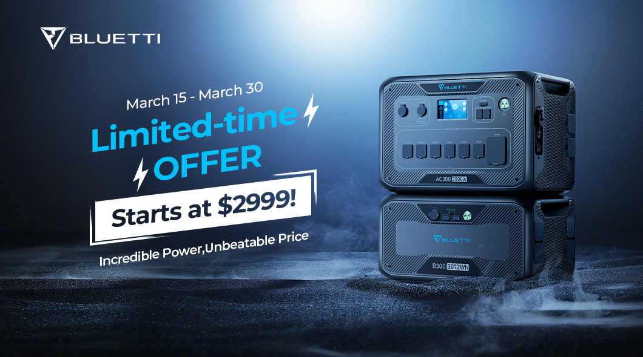BLUETTI AC300: The Ultimate Portable Power Station for Home, Work, and Play

From March 16 to March 30, BLUETTI will run a time-limited promotion on AC300&B300, the customizable power for any situation.

Scalable Capacity for Longer Runtime
The AC300 can team up with the B300 expansion battery for a staggering 12,288Wh. This flexible capacity can meet various needs. With a single B300 attached, the AC300 can run a 1500W heater for 1.7 hours, a 1000W washing machine for 2.6 hours, and an 800W refrigerator for 3 hours.

Safer, Greener, More Durable LFP Battery
With the most stable LFP(LiFePO4) battery, AC300 has a lifetime of 3,500+ life cycles to 80%, about three times longer than ternary lithium and other battery materials. Moreover, AC300 is more sustainable because LFP batteries do not contain toxic heavy metals such as cobalt or nickel.

Big Output Power for Anything Plugged in
The AC300 can deliver up to 3000W of continuous power for any common home appliance. It has 16 outlets, including six 120V/20A AC outlets, a 120V/30A TT-30 for a travel trailer, a 12V/30A RV outlet, a 24V/10A car outlet, two 15W wireless charging pads, and multiple USB ports for small devices.

Multiple Charging for Fast Top-up
The AC300 accepts charging from the wall, solar panel, car, generator, and lead-acid battery, making charging fast and convenient. For example, it can be fully charged at 5,400W in just 1.5 hours using AC+Solar charging, or 1.8-2.3 hours using solar panels alone.

Extreme Compatible With Solar Systems
The AC300 uses MC4 connectors for solar charging, designed to work seamlessly with the most common solar panels in the market. That ensures AC300 can harness the power of the sun to reduce energy bills and protect the earth.

24/7 UPS Home Backup For Power Outage
The AC300 also serves as an all-day home backup power, providing uninterrupted power during power outages. It only takes less than 20ms to switch, so quickly that even sensitive devices won't notice the grid fails.

Easy to Monitor, Control, and Setup
The AC300 features a touch screen and APP control for easy operation and monitoring. The screen displays functions, historical data, and unit information for checking at any time. It can realize remote control on the BLUETTI APP through Bluetooth or Wi-Fi connections.

240V Split Phase Bonding for More Possibilities
Two AC300&B300 sets will enable split-phase bonding which changes its voltage from 120V to 240V. The output power also doubles from 3,000W to 6,000W. This means the AC300 can drive heavier loads and recharge almost twice as fast.

About BLUETTI
From the very beginning, BLUETTI has tried to stay true to a sustainable future through green energy storage solutions for both indoor and outdoor use while delivering an exceptional eco-friendly experience for everyone and the world. BLUETTI is making its presence in 70+ countries and is trusted by millions of customers across the globe. For more information, please visit BLUETTI online at https://www.bluettipower.com/

