FOR IMMEDIATE RELEASE
AI To Transforms Independent and Assisted Living with Addison Virtual Caregiver
The Competitive Edge in AI-Powered Senior Living
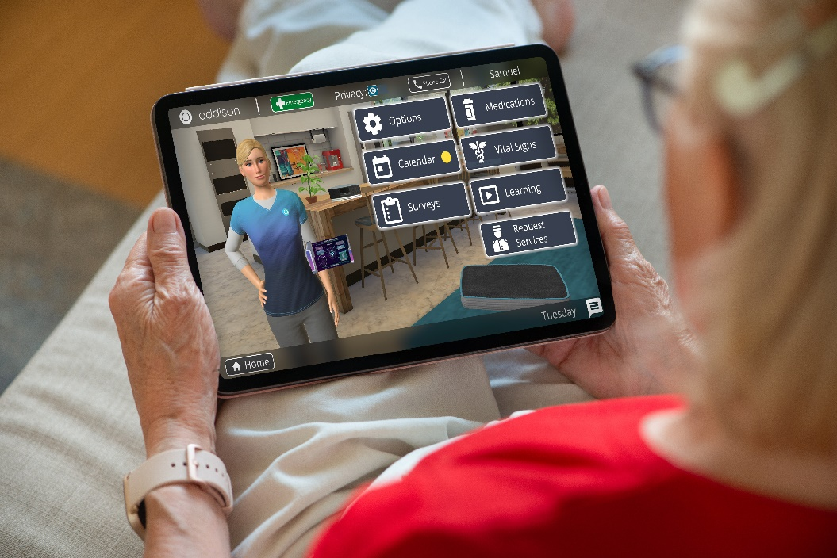

Las Cruces, New Mexico – February 27, 2025 – As the market demands excellence in resident care, Addison Care is revolutionizing independent and assisted living with its AI-powered virtual care solution. Offering unmatched support, safety, retention, and profitability, Addison Care empowers senior living communities to improve resident outcomes while reducing operational risks—at just $8 per day.
In a landscape where nearly all residents manage multiple chronic conditions and 7-14 medications, treatment non-adherence accounts for 50% of health setbacks. Addison Care’s 24/7 care management tackles this head-on, monitoring medication schedules and daily routines to extend functional lifespan and quality of life. “Our goal is to help residents live longer, happier, and more comfortably,” says Erika Ruiz, COO at Electronic Caregiver, Inc., “We’re closing the backdoor of resident turnover—saving operators $12,000 to $15,000 per lost resident.”
Post-COVID-19, infectious disease remains a top concern, with influenza and other illnesses historically plaguing communal living. Addison Care’s advanced monitoring identifies early signs of infection, enabling swift isolation to prevent outbreaks in dining rooms and common areas. This proactive approach protects communities and restores family confidence shaken by past pandemics. "The senior living industry has a great responsibility to ensure their residents are safe, secure and supported, especially with consideration to the high number of those living with multiple chronic illnesses, complex treatment regimens, and at higher risk of falls, accidents and infectious disease exposure," said Anthony Dohrmann, CEO of Electronic Caregiver, Inc., and inventor of Addison Care.
Loneliness, often called the silent killer, compounds these challenges as aging residents hesitate to report falls, symptoms, or side effects—fearing they’ll burden loved ones or reveal declining abilities. Addison Care counters this with 24/7 companionship, delivering games, entertainment, and cognitive stimulation. Non-invasive AI Wi-Fi tracks sleep and movement, while family apps provide real-time updates, fostering engagement and transparency.
Safety leaps forward with Addison’s 4-way emergency response system—voice, on-screen touch, wrist wearables, and mobile GPS—replacing outdated pull cords and glitch-prone pendants that contribute to preventable mortalities and escalations. Early detection of health anomalies ensures rapid response to accidents and emergencies, keeping residents secure across the property.
Negative chatter, a byproduct of resident deaths or departures, erodes trust as families question negligence and safety. Addison Care’s proactive oversight minimizes these events, reducing liabilities and preserving community reputation. “When residents thrive, families notice,” adds Dohrmann. “We’re not just enhancing care—we’re strengthening bonds.”
At $8/day (.34/hour) with a small one-time equipment fee, Addison Care delivers affordable excellence without extra staff or infrastructure. Managed by Addison’s 3D Virtual Caregiver and telecare team, it integrates seamlessly with property staff, doctors, and families—freeing operators to focus on community, not healthcare logistics. Optional resident-pay programs even turn care into a revenue stream.


Implementation is effortless: Addison provisions all technology, conducts resident classes, provides ongoing support, and coordinates launch PR events to boost brand visibility. “Traditional communities excel at filling units but lose revenue due to inadequate safety and health oversight,” says Dohrmann. “Addison Care fixes that, keeping residents healthier, happier, and in-place longer.”
With Addison Care, senior living operators gain a competitive edge—elevating care, engagement, and trust while stabilizing income. The future of senior living starts today.
About Addison Care
Addison Care, developed by xAI, is a pioneering AI virtual care solution designed to transform senior living. Offering 24/7 support, enhanced safety, and cost-effective care management, Addison Care empowers independent and assisted living communities to meet the market’s demand for excellence. For more information, visit electroniccaregiver.com or phone 833-324-5433 (Sales ext. 1)
Media Contact:
Travis Luevano
Director, Digital Marketing
575-649-7808
media@ecg-hq.com

