----------------------------------------------------------------------------------
Styled text version
----------------------------------------------------------------------------------
Aniko Official Launch Press Release 26th June 2018
Headline used on the website: Watchout! New Crypto Kids On The Block (Chain)- Aniko

Aniko is an exciting and compelling project about to hit the market. This project will leverage the power and exploding popularity of crypto technology to drive and deliver real benefits in the financial world. These benefits are not restricted to mass corporations or investors but will have a genuine benefit on driving social and economic stability and growth in developing markets.
Aniko Product Video: https://youtu.be/_5GmGgmboHo
The inspiration for the Aniko project came from the experience of its Founder and CEO, Kevin Kilty and in particular, his background of working in financial inclusion. Having worked as a pro-bono consultant in Africa and the Middle East, starting with Opportunity International in Malawi, Kevin was privileged to experience first-hand the challenges and opportunities faced in the real world. This first-hand insight into how basic banking services could transform the economic development of communities fueled his passion for financial inclusion. However, it was working in Kenya where he witnessed the powerful relationship between remittances and mobile money. Many Kenyans work in the cities, sending money back home to their families in the rural communities. What became a game changer was the launch of the M Pesa mobile money system in 2007; allowing users to send money and access financial services via their mobile phone. What was clear was that receiving money via a mobile phone engaged individuals in the financial system, making them more comfortable and inclined to expand this relationship into other transactions.

Some eight years on, the relentless pace of development of technology means that the majority of the world is already embracing smartphone technology and we have seen the explosion of blockchain technology (most commonly the chatter and impact of Bitcoin). This in turn has presented the potential and opportunity to create a low-cost, instant remittance and mobile money platform – Aniko.

With this in mind, Kevin moved on from his career in banking and relocated to Dubai in 2016 to conduct on-the-ground research into launching such a platform. The UAE and its neighboring countries send money back to the fastest growing mobile money markets in South Asia; India, Pakistan, Bangladesh and the Philippines and represents the most concentrated remittance market in the world.

What is Aniko?

The Aniko goal is to build a solution that serves the needs of real people across the globe. This solution is a reality for everybody from individuals remitting money and making purchases online right through businesses operating internationally and crypto-investors managing their portfolios. The Aniko team firmly believes there is significant value in a platform that brings together all these user groups and communities.
At the core of the proposition and platform is a proven crypto-arbitrage engine. This engine transfers value internationally by buying multiple crypto-currencies in one country and selling them in another.
The Aniko platform is a stake-to-play token. Aniko token holders earn rewards in Omega tokens; a private token on the Aniko platform used to pay for remittances and mobile money.

What we’ve done to date

Although the core proposition was developed in early 2017, the founding team took the decision to undertake extensive research and development with real ‘live’ people on the ground. This included financial modelling, customer-testing and development of the arbitrage engine across exchanges and markets (vs. OTC transactions) before moving onto the ICO.
The arbitrage engine was developed by JS Greenwood, a seasoned crypto investor and CTO. JS with Kevin developed the platform architecture for the Aniko platform, mapping the liquidity in the market from OTC to exchanges, that make the arbitrage engine possible.
The functionality and UX of the app (Aniko wallet) has been tested with our Indian and Filipino pilot groups and our business solution (Aniko Enterprise) has been developed in consultation with money exchange businesses.
The Aniko wallet app will be available for general release in August of 2018 for both Android and Apple users on the Play and Apple Store.

The core team

Although the ideas and vision behind the project have been cooking for some time, Kevin started researching and building the Aniko business in 2016. It was in 2017 that Kevin teamed up with JS to develop the technical aspects of the project as it started to evolve into a reality.

Bolstering the experience and true relevance of the proposition, Aijaz Khan was added to the team later in 2017. His outstanding track record in building mobile money businesses from scratch in Tanzania and India gave significant additional practical experience to galvanise the strong business acumen and technical expertise the team was displaying.

The Aniko team was further enhanced by recruiting the D Corp team to build out the token model on the Aniko Platform and Frank Bonnet came on board at the end of 2017 as token architect bringing with him the support of his core existing team members.

Aniko also have a fully fledged marketing team that are experts in community management (headed up by Frances Milligan) and digital growth marketing (headed up by Matias Jeldrez).

Partnerships and Advisors

Aniko has galvanised its market proposition by partnering with a variety of market specialists, all of which increase our capability and speed in execution.

Daniel Navarro and his team at Nimmok have been working with Kevin since November of 2016; helping to validate Kevin’s initial business plan and set-out the implementation strategy for the business. Nimmok have launched over 30 mobile money projects targeting specifically unbanked and underbanked customers and will be a on the ground consultant throughout the go to market strategy.

Gladius are Aniko’s cyber-security partner. Gladius’s CEO Max Niebylski has already launched a highly successful ICO of their own and is building a global anti-DDOS network. Cyber-security will be critical for the Aniko platform, Max and his team at Gladius will be valuable advisors covering this field.

Aniko has additionally partnered with crypto-exchanges such as Belfrics and crypto wallets Fortifex, as part of widening our network in the crypto market and our access to liquidity.

The Nonoo Exchange; the leading money exchanger in Bahrain has been a valuable advisor in the remittance market, transferring $100millions per annum, and will likely be our first customer for the Aniko Enterprise business.

On top of this core team, Aniko have additionally recruited valuable counsel from international leading law firm Pinsent Mason and our digital marketing team: Dynamo with CEO Adam Abbott at the forefront of growth marketing advisory.

Aniko’s App will launch the week commencing the 13th August 2018

The initial development and launch is focused on the low-to-middle income segment of the migrant worker population in developing countries. This sizable market is price sensitive, technologically proficient and offers a gateway to mobile wallet users in their home-countries.
In tandem, we are building the capability to offer our platform to existing remittance companies who serve the same consumer segment because of the immediate scale on offer.
We have already built out pilot groups for the first target markets: India and the Philippines and are currently testing our app with these groups in anticipation of Beta launch in August of this year. Here is a sneak preview of our app design (WIP, but almost there!):

Aniko’s go-to-market plan

- Aniko is airdropping a total budget of 1,025,000 ANKA tokens to airdrop participants. Token price, 1 ANKA is valued at 0.10 USD. Click here http://aniko.io/airdrop-ttw for more information.
- Aniko Million- Daily Quiz Competition! We’re is giving away 1 Million ANKA over 100 days- every day Aniko will be giving away 10,000 ANKA to 1 entrant. Click here https://www.aniko.io/news/aniko-million-daily-quiz-giveaway for more information.
- Bounty Program will be officially announced the early July 2018.

We will naturally be active with our community management teams on all platforms to keep all informed via all means available. These channels include:

- Website - https://aniko.io/
- Facebook - https://www.facebook.com/anikocorp/
- Twitter - https://twitter.com/Anikocorp
- News & updates - http://aniko.io/news
- Reddit - https://www.reddit.com/r/aniko
- Youtube - https://www.youtube.com/channel/UCn6bV-MbjeBxaubxEMvCupg/

The Aniko team is ready to answer any and all questions you may have regarding the progress, launch and the future of the project, for any queries please contact kevin@aniko.io. We look forward to expanding and improving not only the mechanisms in use but the lives and communities Aniko will benefit.

----------------------------------------------------------------------------------
anchor text version
----------------------------------------------------------------------------------
Aniko Official Launch Press Release 26th June 2018
Headline used on the website: Watchout! New Crypto Kids On The Block (Chain)- Aniko

<a href=”http://www.aniko.io”>Aniko</a> is an exciting and compelling project about to hit the market. This project will leverage the power and exploding popularity of crypto technology to drive and deliver real benefits in the financial world. These benefits are not restricted to mass corporations or investors but will have a genuine benefit on driving social and economic stability and growth in developing markets.
Aniko Product Video: https://youtu.be/_5GmGgmboHo
The inspiration for the Aniko project came from the experience of its Founder and CEO, Kevin Kilty and in particular, his background of working in financial inclusion. Having worked as a pro-bono consultant in Africa and the Middle East, starting with Opportunity International in Malawi, Kevin was privileged to experience first-hand the challenges and opportunities faced in the real world. This first-hand insight into how basic banking services could transform the economic development of communities fueled his passion for financial inclusion. However, it was working in Kenya where he witnessed the powerful relationship between remittances and mobile money. Many Kenyans work in the cities, sending money back home to their families in the rural communities. What became a game changer was the launch of the M Pesa mobile money system in 2007; allowing users to send money and access financial services via their mobile phone. What was clear was that receiving money via a mobile phone engaged individuals in the financial system, making them more comfortable and inclined to expand this relationship into other transactions.

Some eight years on, the relentless pace of development of <a href=”http://www.aniko.io”>technology</a> means that the majority of the world is already embracing <a href=”http://www.aniko.io”>smartphone technology</a> and we have seen the explosion of blockchain technology (most commonly the chatter and impact of Bitcoin). This in turn has presented the potential and opportunity to create a low-cost, instant <a href=”http://www.aniko.io”>remittance</a> and <a href=”http://www.aniko.io”>mobile money</a> platform – <a href=”http://www.aniko.io”>Aniko</a>.

With this in mind, Kevin moved on from his career in banking and relocated to Dubai in 2016 to conduct on-the-ground research into launching such a platform. The UAE and its neighboring countries <a href=”http://www.aniko.io”>send money</a> back to the fastest growing mobile money markets in South Asia; India, Pakistan, Bangladesh and the Philippines and represents the most concentrated <a href=”http://www.aniko.io”>remittance</a> market in the world.

What is Aniko?

The Aniko goal is to build a solution that serves the needs of real people across the globe. This solution is a reality for everybody from individuals <a href=”http://www.aniko.io”>remitting money</a> and making purchases online right through businesses operating internationally and crypto-investors managing their portfolios. The Aniko team firmly believes there is significant value in a platform that brings together all these user groups and communities.
At the core of the proposition and platform is a proven crypto-arbitrage engine. This engine transfers value internationally by buying multiple crypto-currencies in one country and selling them in another.
The Aniko platform is a stake-to-play token. Aniko token holders earn rewards in Omega tokens; a private token on the Aniko platform used to pay for remittances and mobile money.

What we’ve done to date

Although the core proposition was developed in early 2017, the founding team took the decision to undertake extensive research and development with real ‘live’ people on the ground. This included financial modelling, customer-testing and development of the arbitrage engine across exchanges and markets (vs. OTC transactions) before moving onto the ICO.
The arbitrage engine was developed by JS Greenwood, a seasoned crypto investor and CTO. JS with Kevin developed the platform architecture for the Aniko platform, mapping the liquidity in the market from OTC to exchanges, that make the arbitrage engine possible.
The functionality and UX of the app (Aniko wallet) has been tested with our Indian and Filipino pilot groups and our business solution (Aniko Enterprise) has been developed in consultation with money exchange businesses.
The Aniko wallet app will be available for general release in August of 2018 for both Android and Apple users on the Play and Apple Store. Here is a sneak preview of our app design (WIP, but almost there!):
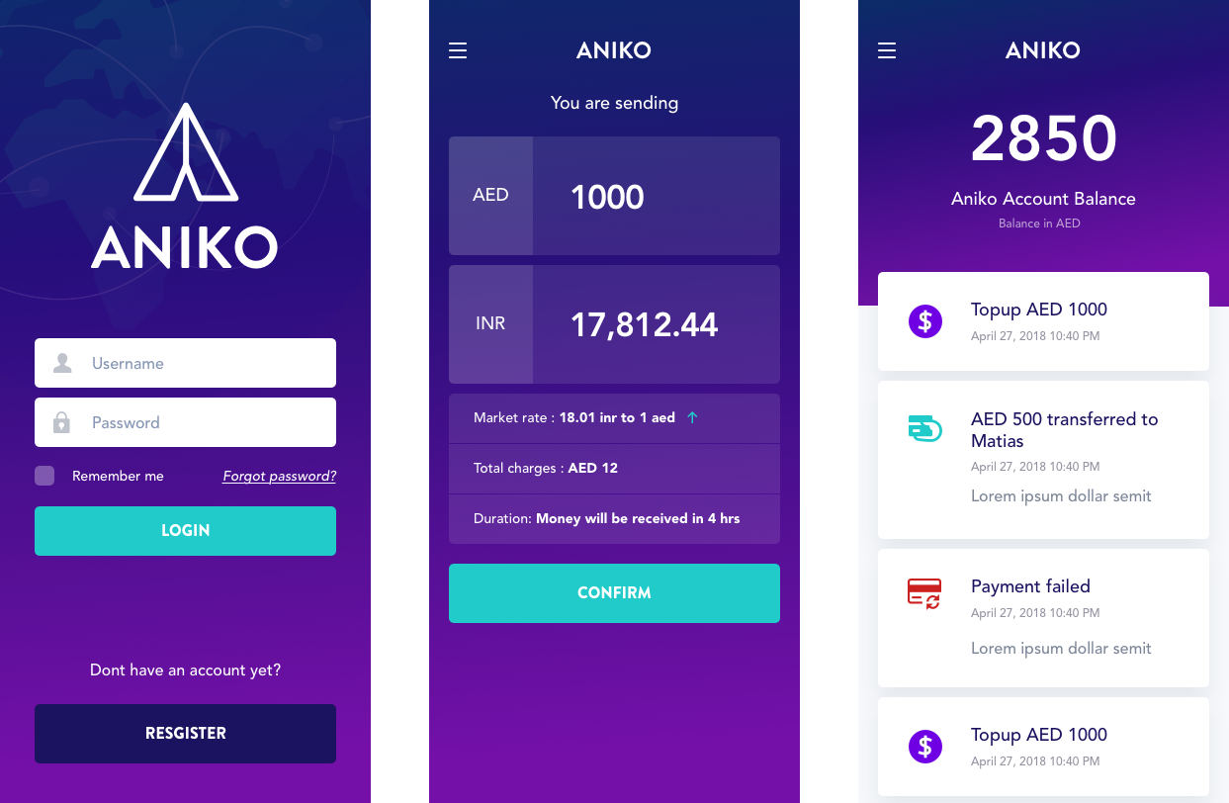

The core team

Although the ideas and vision behind the project have been cooking for some time, Kevin started researching and building the Aniko business in 2016. It was in 2017 that Kevin teamed up with JS to develop the technical aspects of the project as it started to evolve into a reality.

Bolstering the experience and true relevance of the proposition, Aijaz Khan was added to the team later in 2017. His outstanding track record in building mobile money businesses from scratch in Tanzania and India gave significant additional practical experience to galvanise the strong business acumen and technical expertise the team was displaying.

The Aniko team was further enhanced by recruiting the D Corp team to build out the token model on the Aniko Platform and Frank Bonnet came on board at the end of 2017 as token architect bringing with him the support of his core existing team members.

Aniko also have a fully fledged marketing team that are experts in community management (headed up by Frances Milligan) and digital growth marketing (headed up by Matias Jeldrez).

Partnerships and Advisors

Aniko has galvanised its market proposition by partnering with a variety of market specialists, all of which increase our capability and speed in execution.

<a href=”https://www.linkedin.com/in/dannynavarro/”><Daniel Navarro</a> and his team at Nimmok have been working with Kevin since November of 2016; helping to validate Kevin’s initial business plan and set-out the implementation strategy for the business. Nimmok have launched over 30 mobile money projects targeting specifically unbanked and underbanked customers and will be a on the ground consultant throughout the go to market strategy.

Gladius are Aniko’s cyber-security partner. Gladius’s CEO <a href=”https://www.linkedin.com/in/maxniebylski/”>Max Niebylski</a> has already launched a highly successful ICO of their own and is building a global anti-DDOS network. Cyber-security will be critical for the Aniko platform, Max and his team at Gladius will be valuable advisors covering this field.

Aniko has additionally partnered with crypto-exchanges such as Belfrics and crypto wallets Fortifex, as part of widening our network in the crypto market and our access to liquidity.

The Nonoo Exchange; the leading money exchanger in Bahrain has been a valuable advisor in the remittance market, transferring $100millions per annum, and will likely be our first customer for the Aniko Enterprise business.

On top of this core team, Aniko have additionally recruited valuable counsel from international leading law firm Pinsent Mason and our digital marketing team: <a href=”http://www.dynamoltd.com”>Dynamo</a> with CEO Adam Abbott at the forefront of growth marketing advisory.

Aniko’s App will launch the week commencing the 13th August 2018

The initial development and launch is focused on the low-to-middle income segment of the migrant worker population in developing countries. This sizable market is price sensitive, technologically proficient and offers a gateway to <a href=”http://www.aniko.io”>mobile wallet</a> users in their home-countries.
In tandem, we are building the capability to offer our platform to existing remittance companies who serve the same consumer segment because of the immediate scale on offer.
We have already built out pilot groups for the first target markets: India and the Philippines and are currently testing our app with these groups in anticipation of Beta launch in August of this year.

Aniko’s go-to-market plan

- Aniko is airdropping a total budget of 1,025,000 ANKA tokens to <a href=”http://aniko.io/airdrop-ttw”>airdrop</a> participants. Token price, 1 ANKA is valued at 0.10 USD. Click here http://aniko.io/airdrop-ttw for more information.
- Aniko Million- Daily Quiz <a href=”http://aniko.io/airdrop-ttw”>Competition!</a> We’re is giving away 1 Million ANKA over 100 days- every day Aniko will be giving away 10,000 ANKA to 1 entrant. Click here http://aniko.io/airdrop-ttw for more information.
- Aniko bounty program will be officially announced the week commencing July 1 2018.

We will naturally be active with our community management teams on all platforms to keep all informed via all means available. These channels include:

- Website - http://aniko.io/
- Facebook - https://www.facebook.com/anikocorp/
- Twitter - https://twitter.com/Anikocorp
- News & updates - http://aniko.io/news
- Reddit - https://www.reddit.com/r/aniko
- Youtube - https://www.youtube.com/channel/UCn6bV-MbjeBxaubxEMvCupg/

The Aniko team is ready to answer any and all questions you may have regarding the progress, launch and the future of the project, for any queries please contact kevin@aniko.io. We look forward to expanding and improving not only the mechanisms in use but the lives and communities Aniko will benefit.

----------------------------------------------------------------------------------
Facebook & Twitter Assets
----------------------------------------------------------------------------------

- Aniko Launch Twitter
New crypto kids on the block (chain) #Aniko is here! It's innovative technology will provide the fastest and cheapest way to send money across borders. Learn more about Aniko & how to get involved in our #Airdrop & #Bounty competition https://www.aniko.io/news/watchout-new-crypto-kids-on-the-block-chain-aniko #EmergingMarkets #ICO #Blockchain

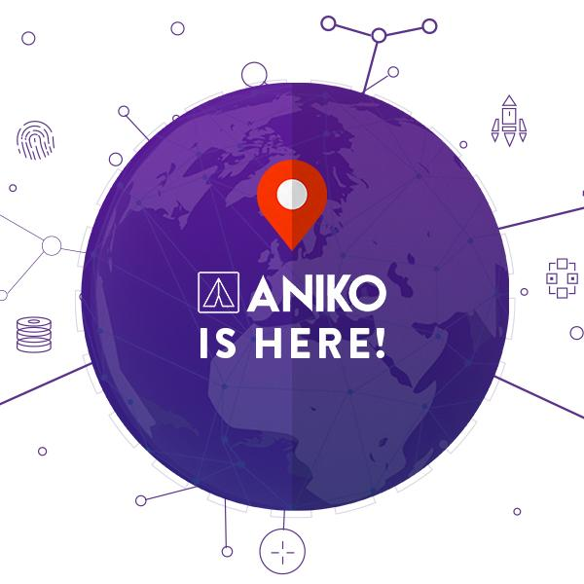

2) Aniko Launch Facebook

New crypto kids on the block (chain), Aniko, is here. It's innovative technology will provide the fastest and cheapest way to send money across borders. Visit our website to find out more about this exciting project, the founding team and how to get involved in our Airdrop and Bounty competition http://ow.ly/lAkA50hP8i0 #EmergingMarkets #ICO #Fintech #Blockchain #Airdrop #Bounty

3)Aniko Airdrop Twitter
#Aniko is airdropping a total of 1,025,000 ANKA tokens to lucky airdrop participants. To claim your coins, join our Telegram group, follow us on Twitter and join the Whitelist via our website https://www.aniko.io/airdrop-ttw #Airdrop #Crypto #Blockchain #EmergingMarkets

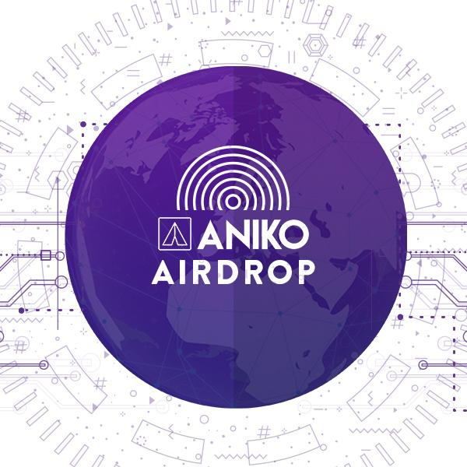

4) Aniko Airdrop Facebook
Aniko is giving away 1 Million ANKA tokens over 100 days in a daily quiz competition. To be in with a chance to WIN, join our Telegram Group to receive daily questions and be geared up to tweet the correct answer. Get involved NOW https://www.aniko.io/news/aniko-million-daily-quiz-competition

5) Aniko Telegram Competition Twitter

#Aniko is giving away 1 Million ANKA tokens over 100 days in a daily quiz competition. To be in with a chance to #WIN, join our Telegram Group to get daily questions & be geared up to tweet the correct answer. Get involved NOW https://www.aniko.io/news/aniko-million-daily-quiz-competition #Crypto #EmergingMarkets

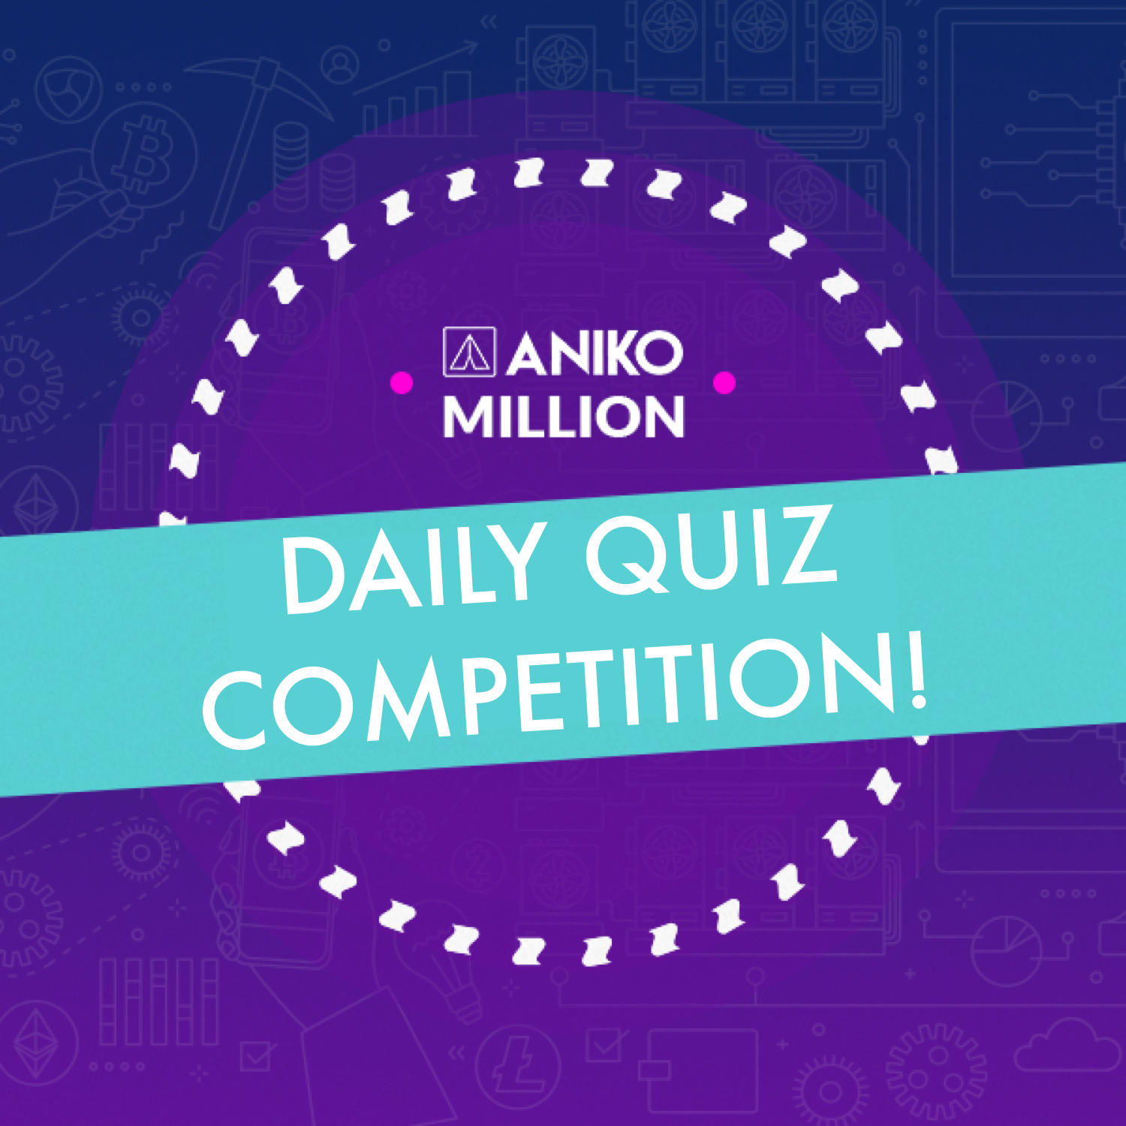

5) Aniko Telegram Competition Facebook

Aniko is airdropping a total of 1,025,000 ANKA tokens to lucky airdrop participants. To claim your coins, join our Telegram group, follow us on Twitter - @anikocorp and join the Whitelist via our website https://www.aniko.io/airdrop-ttw
#Airdrop #Crypto #Blockchain #EmergingMarkets

