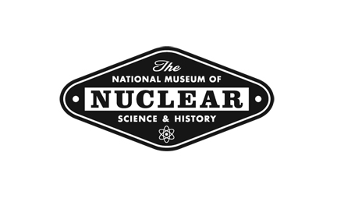
For Release: Immediately Contact: Jennifer Hayden, 245-2137 ext. 102
News Release
601 Eubank Blvd. SE
Albuquerque, New Mexico 87123
(505) 245-2137 Fax: (505) 242-4537

Historic B-52 Stratofortress to Receive Restoration
at the National Museum of Nuclear Science & History

Albuquerque, NM – Albuquerque’s very own Boeing B-52B Stratofortress s/n 52-0013, one of only a few B-models left in existence and one of only four in the world on display for public viewing, will be the focus of a special initiative within “Operation Preservation” – a multi-year campaign to repaint and refurbish the iconic aircraft in the National Museum of Nuclear Science & History’s nine-acre outdoor exhibit area, Heritage Park.

The B-52 Stratofortress is a long-range, subsonic, jet-powered strategic bomber. Built by Boeing – with a wingspan of 185 ft and a maximum takeoff weight of 488,000 lbs – B-52 airplanes have been operated by the United States Air Forces since the 1950s and the more recent models are expected to serve continuously into the future. The B-52B – the type of aircraft located at the National Museum of Nuclear Science & History – was the first truly operational version of the Stratofortress that featured an enhanced reconnaissance capability and was fitted with a bombing/navigation system, and they remained in service into the mid-1960s when they were traded in for more modern B-52s.

“Our B-52 at the National Museum of Nuclear Science & History is truly Albuquerque’s airplane,” said Jim Walther, Museum Director. “This airplane was delivered directly from Boeing to Kirtland in 1955, and it was never assigned to another Air Force base in all its existence.”

The Museum’s B-52B Stratofortress was used for atomic testing in the Pacific during Operation Redwing, 1956, and Operation Dominic, 1962. It remains the only B-52B in existence that has dropped an atomic bomb - dropped during testing. When the Limited Nuclear Test Ban treaty was signed in 1963, Albuquerque’s B-52B, serial number 52-0013, was removed from the roster and was later delivered to the Museum, formerly known as the National Atomic Museum, in 1971.

Restoration of the B-52B Stratofortress is scheduled to begin in April of 2016 under the supervision of Major Jerry Hanks, Project Manager, with help from Museum staff and volunteers and will be funded by a multi-program effort to engage supporters and entities with personal ties to the Museum and the historic aircraft. Restoration will include the B-52B receiving bodywork and a new coat of primer and paint. The total B-52B restoration cost is expected to be approximately $120,000, as the surface area of the B-52B takes up over 2/3 of an acre. Completion of this outdoor exhibit for visitor viewing will take place in November 2016.

“This particular aircraft represents Cold Warriors, the extensive work of Sandia National Labs, Kirtland Air Force Base and Albuquerque in general,” said Walther. “And we plan to restore it to its former glory as a proud and honorable reminder of all those efforts.”

Contributions to the B-52B Stratofortress restoration can be made online at nuclearmuseum.org under. Please designate the donation with the notation of “B-52B Restoration.”

The National Museum of Nuclear Science & History is located at 601 Eubank SE in Albuquerque, New Mexico. Formerly the National Atomic Museum, which opened in 1969 and was chartered by Congress in 1991, the Museum serves as a repository and steward of nuclear-related historical items and is a Smithsonian affiliate. The Museum is open 9 a.m. to 5 p.m. 361 days a year. The Museum’s website is nuclearmuseum.org and the phone number is 505-245-2137.
#

