FOR IMMEDIATE RELEASE
NEW READ CHALLENGES THE NETWORKING STATUS QUO!
Gastonia, NC – August 5, 2024
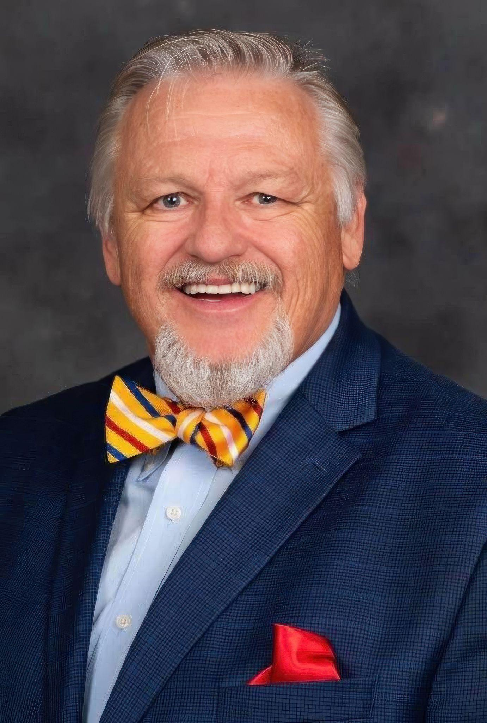
In an era when the mechanics of networking often overshadow the art of genuine connection, R. Dwayne Burks – Chaplain and Director of Gaston County North Carolina’s Resource Connection Gateway – introduces a transformative read, “STOP NETWORKING NOW! Start Connecting for The Common Good,” now available on Amazon.

Burks challenges the status quo by challenging readers to shift their focus toward meaningful connections and collaboration. Through enlightening insights and practical strategies, and drawing on his extensive experience in community service and organizational leadership, Burks illustrates how fostering relational mindsets can lead to sustainable business growth and societal benefit.

“STOP NETWORKING NOW!” is an essential read for anyone seeking to enhance their professional and personal relationships, from business leaders and entrepreneurs to community organizers and educators. It provides practical strategies and insights to help readers make a tangible impact in their professional and personal lives, catalyze true change, and drive success.

“Networking is not about collecting contacts; it’s about planting relationships,” says Burks. “When we prioritize genuine connections over superficial networking, we create environments where everyone thrives.”

“STOP NETWORKING NOW!” is more than a book; it’s a movement towards creating a world where relationships are the cornerstone of progress and success.
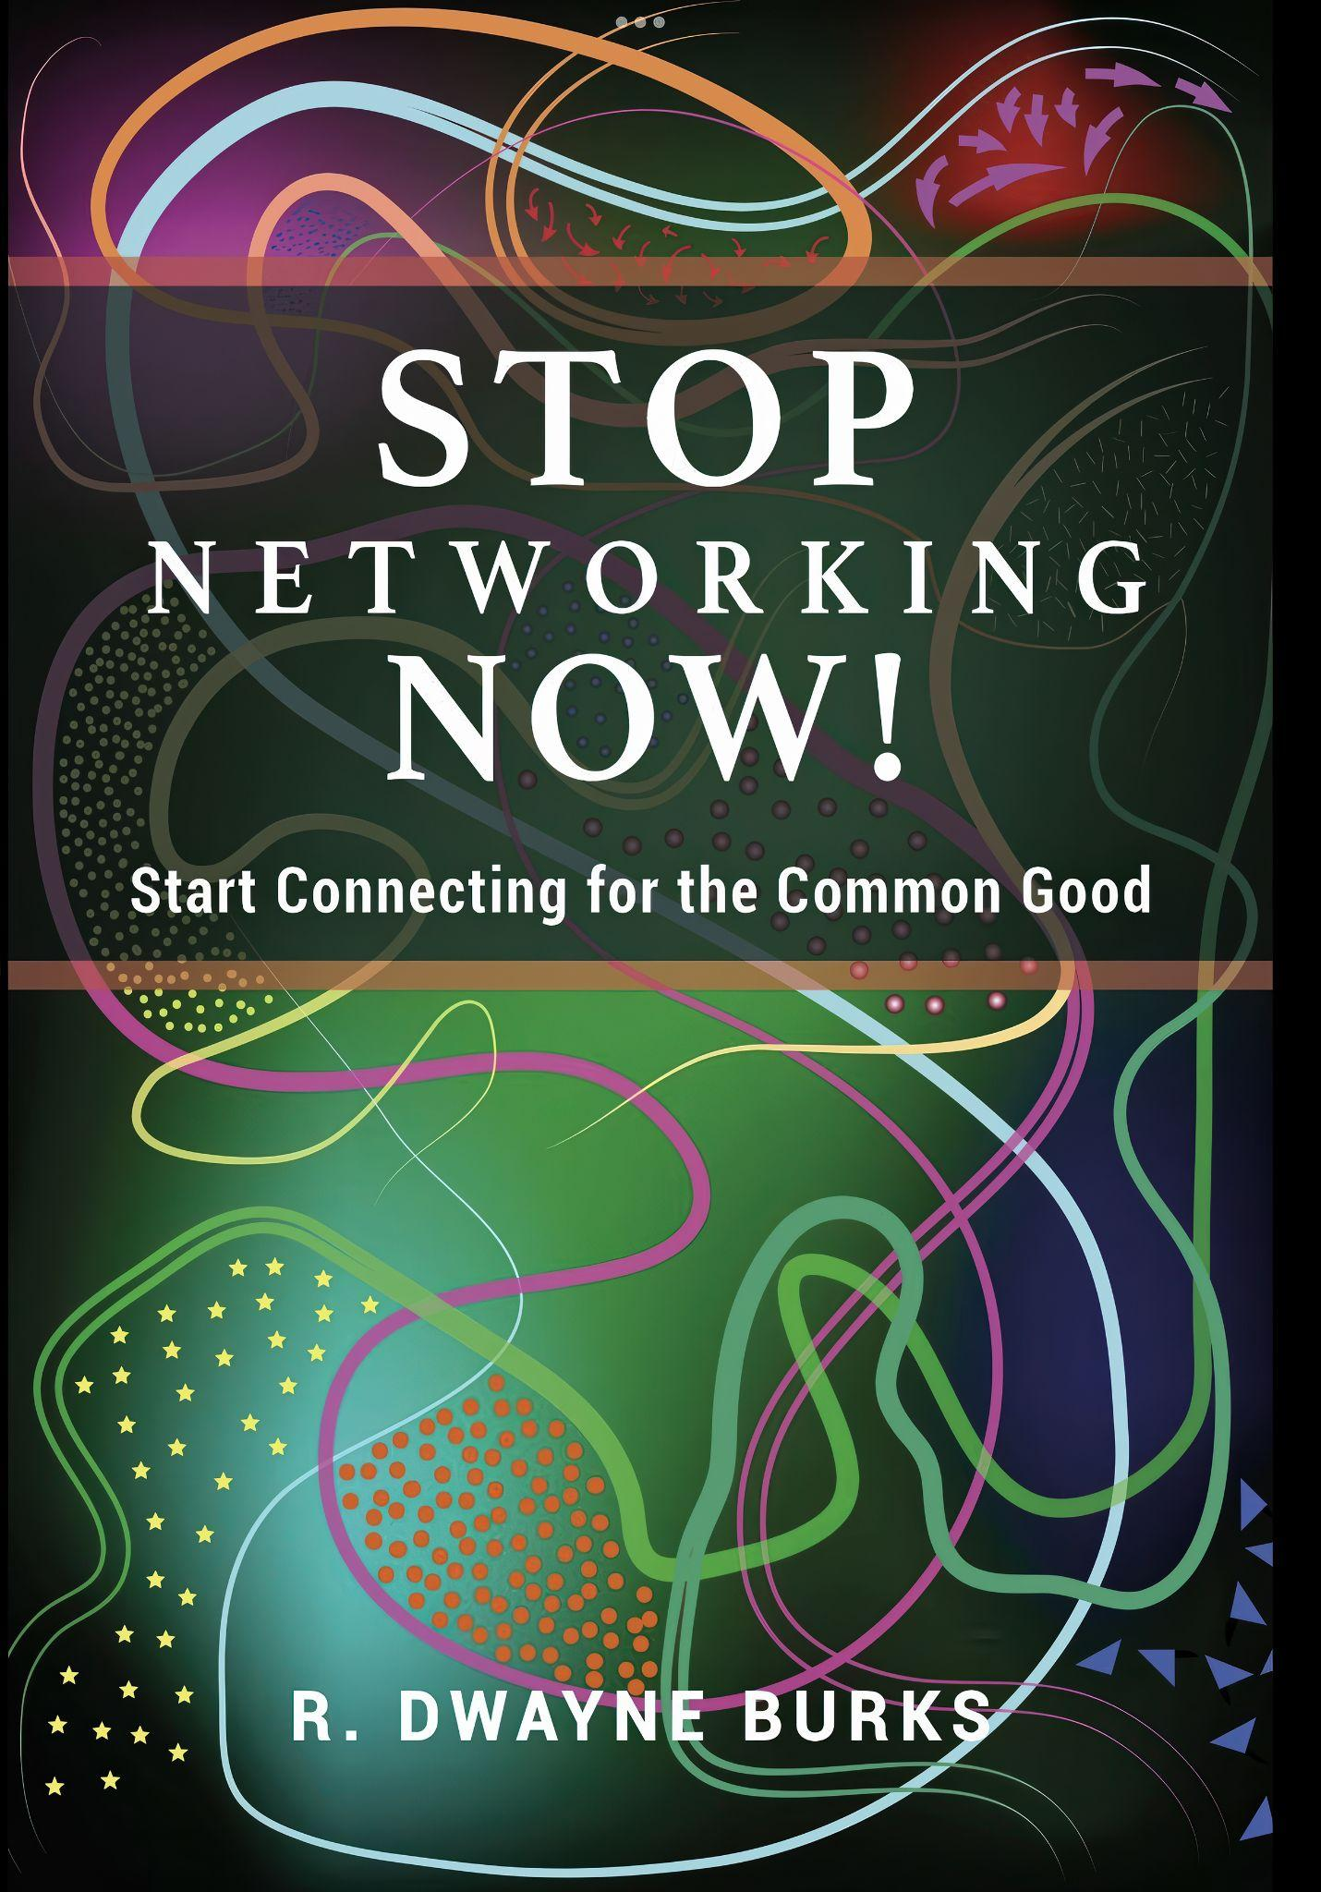
Key Highlights of the Book:
- The importance of a relational mindset for business and community growth
- Practical tips for fostering genuine connections
- Real-life examples of successful collaborations
- Strategies for creating a culture of trust and empathy

The book is poised to reshape mindsets and inspire a new generation of connectors. It is a must-read for anyone looking to make meaningful impacts in their community and industry. Secure your copy on Amazon today and take part in this transformative approach to networking.

For more information about “STOP NETWORKING NOW! Start Connecting for The Common Good,” or to schedule an interview with R. Dwayne Burks, please contact:
For more information, contact us at 704-865-8576 or visit us at www.fbcgastonia.org

