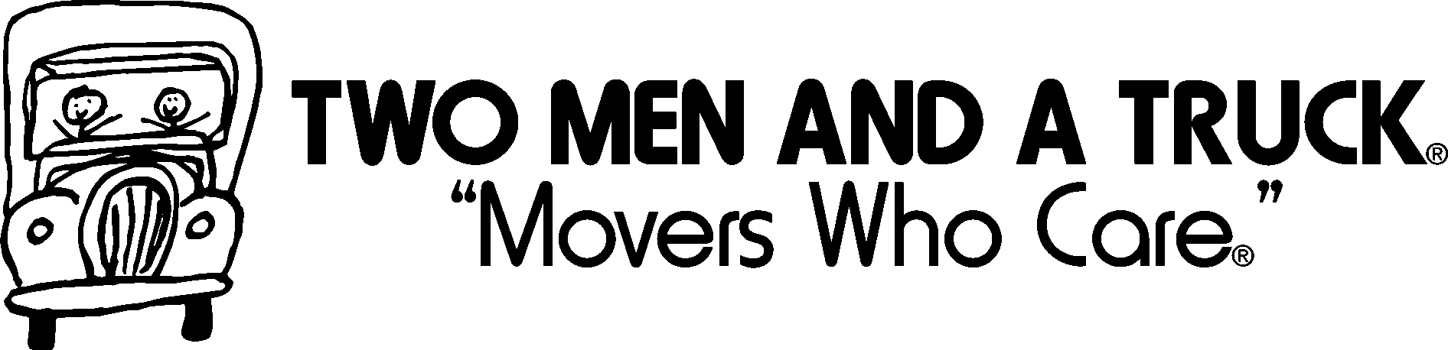

The local moving concept that has been key to TWO MEN AND A TRUCK®’s growth was developed when Mary Ellen Sheet’s two sons, Brig and Jon, started moving people in an old pickup truck for extra spending money while in high school. In an effort to help attract Customers for her sons’ business, Mary Ellen placed an ad in a local shopping guide that read “Two Men and A Truck” and included a simple graphic of two stick men in a truck cab to catch reader’s attention. Little did the family realize that the “cute little logo” sketched by “mom” would lead to a nationally recognized logo for the “Movers Who Care®.”
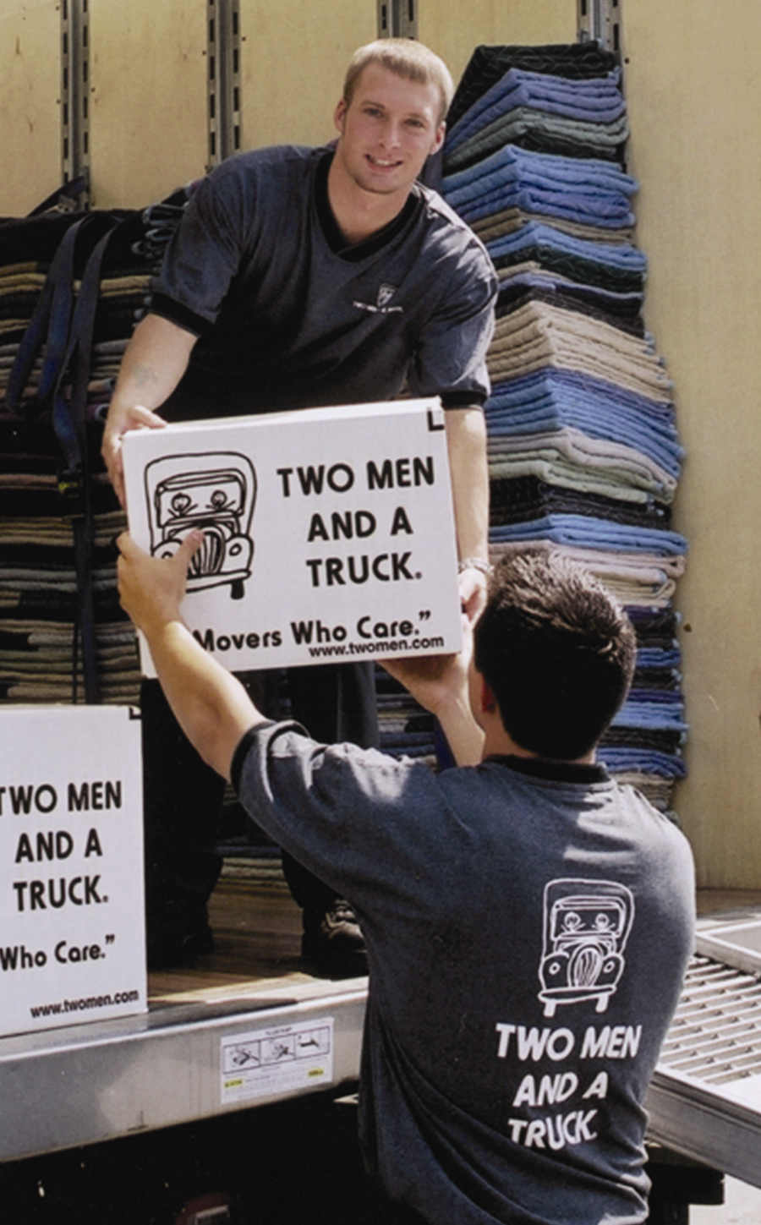

After Brig and Jon went away to college, the volume of phone calls requesting moving services amazed Mary Ellen. So in 1985, while she was still working full-time for the State of Michigan, Mary Ellen added the title of entrepreneur to her resume. She purchased a used 14’ truck, hired two Movers (“Joe and Elmer”), and started TWO MEN AND A TRUCK® in earnest. Mary Ellen’s focus on the Customer and thorough understanding of data, quickly garnered her a reputation as an up-and-coming business person, which in turn earned her a spot on a panel at a Michigan State University graduate business seminar in 1988. One of her fellow panelists inquired whether she had ever considered franchising. This comment sparked Mary Ellen to seek out an experienced franchise attorney, and in 1989 TWO MEN AND A TRUCK® awarded its first franchise.

When Mary Ellen first sketched the now famous TWO MEN AND A TRUCK® logo, she never guessed it would lead her to entrepreneurial success. Today, there over 150 locations in 27 states operating almost 1100 trucks.

TWO MEN AND A TRUCK®
Cal. P.U.C. T- 190058
4131 Power Inn Road, Suite C
Sacramento, CA. 95826
(916) 852-7411
For more information call or visit us at www.twomenandatruck.com

