LIFT Enters INTO AGREEMENT WITH NORTH ARROW MINERALS TO ACQUIRE 100% INTEREST IN THE dESTAFFANY, ldG & MACKAY LITHIUM PROJECTS, NWT, canada

December 19, 2024 – Vancouver, B.C., Li-FT Power Ltd. (“LIFT” or the “Company”) (TSXV: LIFT) (OTCQX: LIFFF) (Frankfurt: WS0) is pleased to announce that it has entered into a definitive agreement with North Arrow Minerals Inc. (TSXV: NAR) to acquire a 100% interest in the DeStaffany, LDG, and Mackay Lithium Projects, located in the Northwest Territories, Canada.

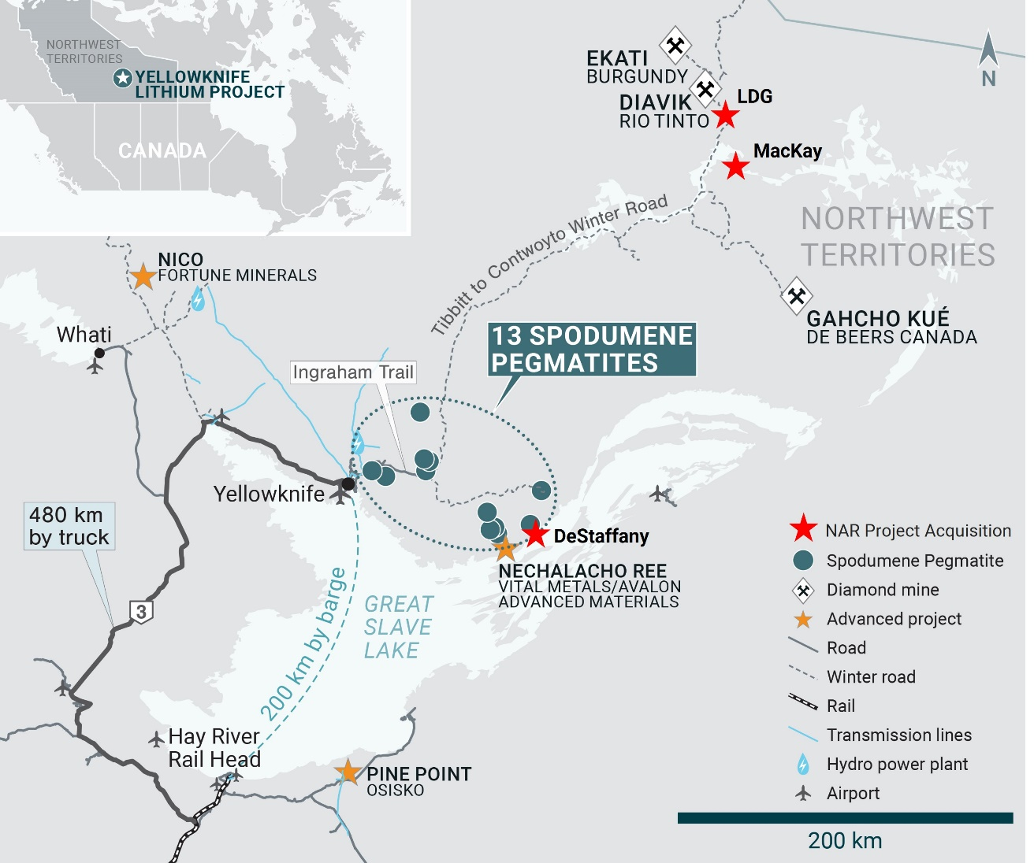
Figure 1 – Location of NAR’s DeStaffany, LDG & Mackay Lithium Projects along side LIFT’s Yellowknife Lithium Project. The pegmatites are located to the east and the northeast of the city of Yellowknife.

Francis MacDonald, CEO and Director of LIFT, commented, “The acquisition of North Arrow’s lithium portfolio further positions LIFT as the leading lithium exploration company in the Northwest Territories. The DeStaffany Project is located close to our BET and Echo pegmatites which creates synergies from a logistical standpoint, as well as increases the overall resource base for the eastern sector of the Yellowknife Pegmatite Province. The LDG and Mackay properties give LIFT a foothold in an emerging spodumene district located near the Diavik and Ekati diamond mines and provide long-term upside for the Company. We will continue to seek out accretive acquisitions within the Northwest Territories, especially around our existing resource base.”
Under the terms of the agreement, LIFT will acquire all rights, title, and interest in the, DeStaffany, LDG and Mackay Lithium Projects in exchange for an issuance of 250,000 common shares of LIFT to North Arrow Minerals. The agreement also includes provisions for the transfer of associated reclamation bonds, ensuring responsible environmental stewardship as these projects are developed.
The transaction is subject to customary closing conditions, including regulatory approvals.
DeStaffany Lithium Project
The DeStaffany lithium property covers 1,843 ha located on the north central shore of Great Slave Lake, appr oximately 18 km northeast of the Nechalacho mine and 115 km east of Yellowknife. The property hosts the Moose 1 and Moose 2 lithium-tantalum-niobium bearing pegmatites. The pegmatites were initially evaluated in the 1940’s for tantalum and niobium but have never been subject to a focused evaluation of their lithium potential. New discoveries are possible within the property as highlighted by the identification of additional pegmatites by North Arrow.
The Moose 1 pegmatite has never been drilled but has been traced over a 370 m strike, averaging 4.5 m to 6.0 m in width, with a maximum width of approximately 11 m, and hosts spodumene mineralization that returned 1.5% Li2O over 7.5 m from historic channel sampling in 2009.
The Moose 2 pegmatite has been mapped over a 450 m strike length, is up to 30 m wide. The pegmatite was bulk sampled for its tantalum and niobium potential in the 1940’s and 1950’s, producing tantalum and niobium concentrates, but has never been evaluated or drilled for its lithium potential. Spodumene mineralization is common throughout the pegmatite, with elevated lithium analyses of up to 1.98% Li2O returned from samples along at least a 250 m strike length of the body.
The Moose pegmatites are located within 1 km of Great Slave Lake, providing good year-round access to the property from both Yellowknife and Hay River on the south side of lake. Next steps for the property will include preparation for mapping, sampling and prospecting fieldwork ahead of initial drill testing of these mineralized spodumene pegmatites.
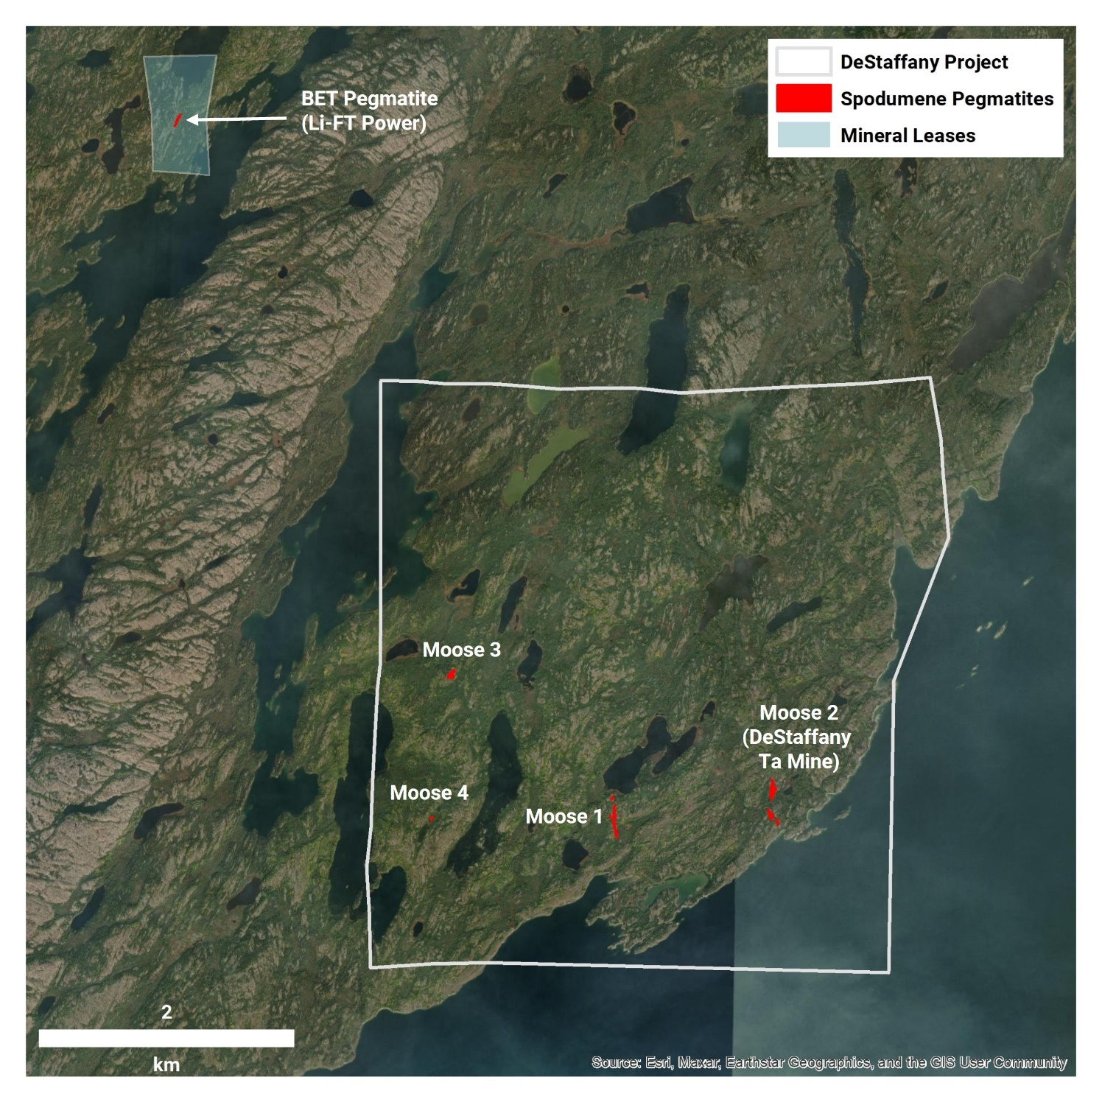
Figure 2 – DeStaffany Lithium Project spodumene pegmatite occurrences. The DaStaffany Project is located ~ 4 kilometers from LIFT’s BET pegmatite.
LDG Lithium Project
The LDG Project comprises 8,600 hectares of mineral claims and leases that are located 15 kilometers southwest of Rio Tinto’s Diavik diamond mine. To date, 10 spodumene pegmatite occurrences have been discovered by prospecting, including at least two undrilled spodumene pegmatites, each with outcropping dimensions estimated up to 20 meters in width and can be traced along 400 meters of strike length. The project area is covered by till which can be used an as exploration medium to discover buried deposits.
Mackay Lithium Project
The MacKay Project comprises 8,661 hectares of mineral claims approximately 30 kilometers to the south of the Rio Tinto’s Diavik diamond mine. To date, two spodumene occurrences have been discovered by prospecting. MK1 consists of a series of irregular sub-parallel pegmatite dykes ranging from 0.5 m to >10 m wide over a combined width of up to 150 m and traced over an interpreted strike extent of greater than 400 m; hand samples from four locations along 120 m of strike have returned 2.45%, 2.51%, 2.76% and 3.74% Li₂O.
MK3 (located ~ 4.5 km east northeast of MK1) is a prominent 15 to 20 m wide, white pegmatite exposure traced near continuously along strike for approximately 130 m; five grab samples returned 5.25%, 4.08%, 2.71%, 1.92% and 1.10% Li₂O.
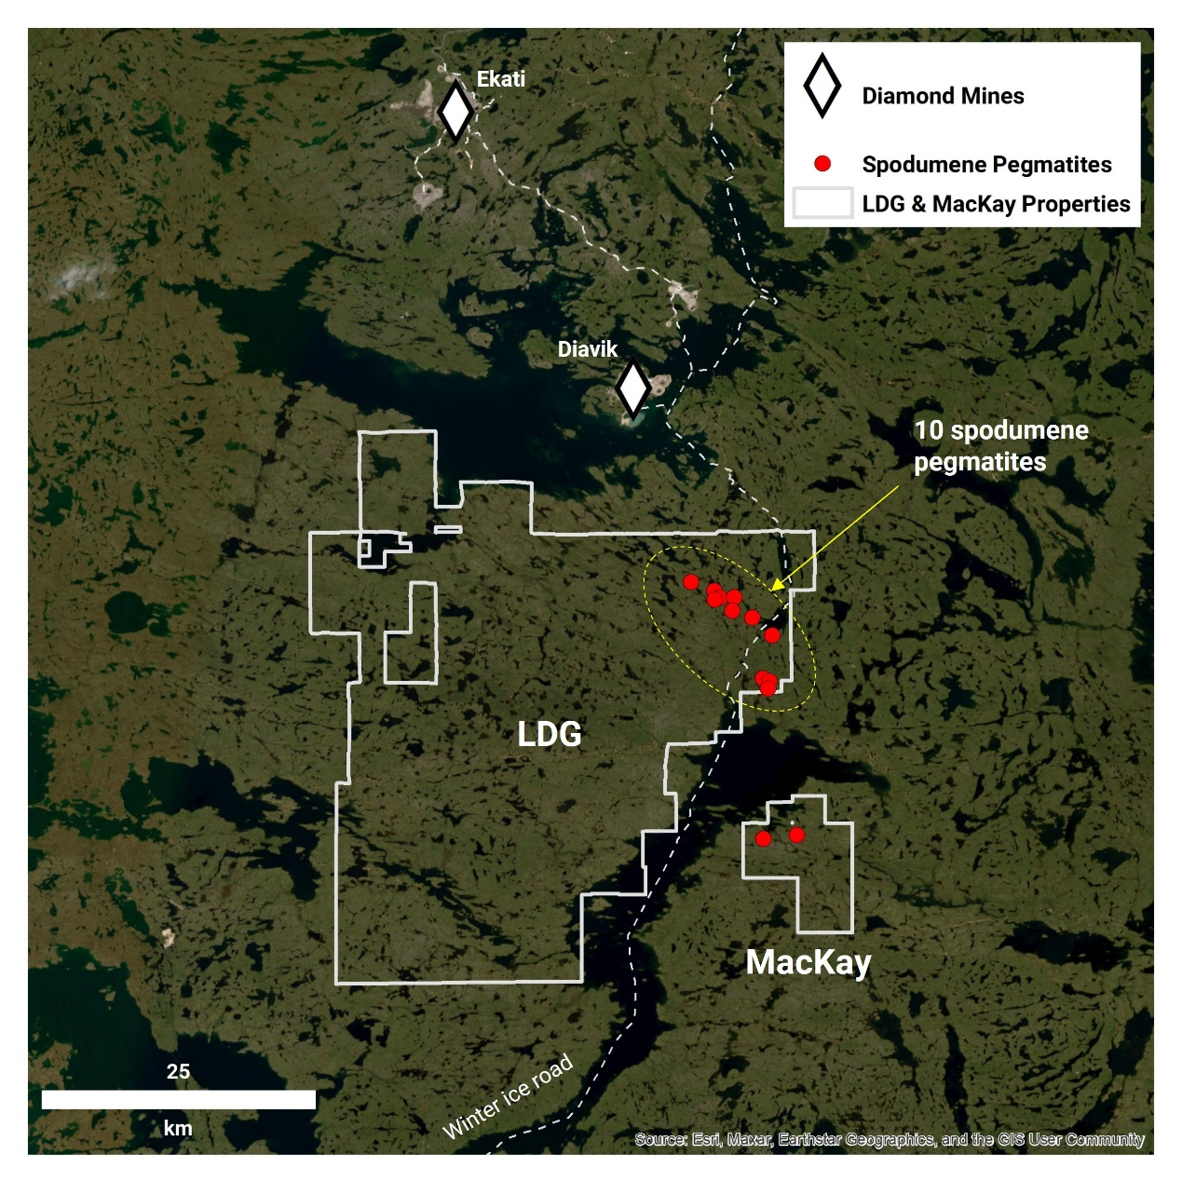
Figure 3 – Location of the LDG and MacKay projects in relation to the winter ice road and diamond mines

LIFT Announces DSU Grant
LIFT announces that it has granted a total of 7,432 Deferred Share Units (”DSU”) to certain independent directors of the Company in lieu of director fees for the fourth quarter, at a fair market value of C$2.69 per DSU. The DSUs were granted in accordance with the Company’s Omnibus Share Incentive Plan, which was approved by shareholders on February 13th, 2024.
Each DSU represents the right to receive one common share in the share capital of the Company. The DSUs vest one year from the grant date and are settled in accordance with the terms of the Company’s Share Incentive Plan, a copy of which is available on the Company’s SEDAR+ profile.

Stock Options Grant
The Company announces that it has granted stock options (the “Options”) to its directors, officers, employees and consultants to acquire a total of 499,500 common shares of the Company at an exercise price of $3.65 per share for a period of 5 years. The vesting terms are structured as follows: 499,500 options undergo a phased vesting, with 25% vested on the grant date and an additional 25% on each 6/12/18-month anniversary.

Qualified Person
The disclosure in this news release of scientific and technical information regarding LIFT’s mineral properties has been reviewed and approved by Ron Voordouw, Ph.D., P.Geo., Partner, Director Geoscience, Equity Exploration Consultants Ltd., and a Qualified Person as defined by National Instrument 43-101 Standards of Disclosure for Mineral Projects (NI 43-101) and member in good standing with the Northwest Territories and Nunavut Association of Professional Engineers and Geoscientists (NAPEG) (Geologist Registration number: L5245).

About LIFT
LIFT is a mineral exploration company engaged in the acquisition, exploration, and development of lithium pegmatite projects located in Canada. The Company’s flagship project is the Yellowknife Lithium Project located in Northwest Territories, Canada. LIFT also holds three early-stage exploration properties in Quebec, Canada with excellent potential for the discovery of buried lithium pegmatites, as well as the Cali Project in Northwest Territories within the Little Nahanni Pegmatite Group.

About NAR

North Arrow is a Vancouver, BC-based exploration company focused on the evaluation of the Kraaipan Gold Project in Botswana. North Arrow’s management, board of directors and advisors have significant successful experience in the global exploration and mining industry. North Arrow continues to maintain its diamond interests in the Naujaat (NU), Pikoo (SK), and Loki (NWT) Projects. North Arrow’s exploration programs are conducted under the direction of Kenneth Armstrong, P.Geo. (NWT/NU, ON), President and CEO of North Arrow and a Qualified Person under NI 43-101.
For further information, please contact:
Francis MacDonald Daniel Gordon
Chief Executive Officer Investor Relations
Tel: + 1.604.609.6185 Tel: +1.604.609.6185
Email: investors@li-ft.com Email: investors@li-ft.com
Website: www.li-ft.com

Cautionary Statement Regarding Forward-Looking Information
Certain statements included in this press release constitute forward-looking information or statements (collectively, “forward-looking statements”), including those identified by the expressions “anticipate”, “believe”, “plan”, “estimate”, “expect”, “intend”, “may”, “should” and similar expressions to the extent they relate to the Company or its management. The forward-looking statements are not historical facts but reflect current expectations regarding future results or events. This press release contains forward looking statements relating to the closing of the Offering, the use of proceeds of the Offering, the timing of incurring the Qualifying Expenditures and the renunciation of the Qualifying Expenditures as well as the approval of the TSXV. These forward-looking statements and information reflect management's current beliefs and are based on assumptions made by and information currently available to the company with respect to the matter described in this new release.
Forward-looking statements involve risks and uncertainties, which are based on current expectations as of the date of this release and subject to known and unknown risks and uncertainties that could cause actual results to differ materially from those expressed or implied by such statements. Additional information about these assumptions and risks and uncertainties is contained under "Risk Factors" in the Company's latest annual information form filed on March 27, 2024, which is available under the Company's SEDAR+ profile at www.sedarplus.ca, and in other filings that the Company has made and may make with applicable securities authorities in the future. Forward-looking statements contained herein are made only as to the date of this press release and we undertake no obligation to update or revise any forward-looking statements whether as a result of new information, future events or otherwise, except as required by law. We caution investors not to place considerable reliance on the forward-looking statements contained in this press release.
Neither the TSX Venture Exchange nor its Regulation Services Provider (as that term is defined in the policies of the TSX Venture Exchange) accepts responsibility for the adequacy or accuracy of this news release.

