
Crexendo Announces Record Fourth Quarter and Fiscal Year 2024 Results
PHOENIX, AZ / ACCESSWIRE / March 4, 2025 / Crexendo, Inc. (NASDAQ: CXDO), an award-winning software technology company that is a premier provider of cloud communication platform and services, video collaboration and managed IT services tailored to businesses of all sizes, today announced financial results for the fourth quarter and fiscal year ended December 31, 2024.
Financial highlights:
- Net income for the year of $1.7 million and non-GAAP net income of $7.7 million.
- Revenue for the year of $60.8 million, up 14% year-over-year.
- Fourth quarter net income of $0.5 million and non-GAAP net income of $2.0 million.
- Fourth quarter revenue of $16.2 million, up 15% year-over-year.

Financial Results for the Fourth Quarter of 2024
Total Revenue: Consolidated total revenue for the fourth quarter of 2024 increased 15%, or $2.0 million, to $16.2 million compared to $14.2 million for the fourth quarter of 2023.
Service Revenue: Consolidated service revenue for the fourth quarter of 2024 increased 4%, or $0.3 million, to $8.0 million compared to $7.7 million for the fourth quarter of 2023.
Software Solutions Revenue: Consolidated software solutions revenue for the fourth quarter of 2024 increased 32%, or $1.7 million, to $7.0 million compared to $5.3 million for the fourth quarter of 2023.
Product Revenue: Consolidated product revenue for the fourth quarter of 2024 increased 4%, or less than $0.1 million, to $1.2 million compared to $1.2 million for the fourth quarter of 2023.
Operating Expenses: Consolidated operating expenses for the fourth quarter of 2024 increased 11%, or $1.5 million, to $15.6 million compared to $14.1 million for the fourth quarter of 2023.
Net Income/(Loss): The Company reported net income of $0.5 million for the fourth quarter of 2024, or $0.02 per basic and diluted common share, compared to net income of $0.1 million, or $0.00 per basic and diluted common share for the fourth quarter of 2023.
Non-GAAP: Non-GAAP net income of $2.0 million for the fourth quarter of 2024, or $0.07 per basic common share and $0.06 per diluted common share, compared to non-GAAP net income of $1.6 million or $0.06 per basic and diluted common share, for the fourth quarter of 2023.
EBITDA and Adjusted EBITDA: EBITDA for the fourth quarter of 2024 of $1.5 million compared to $0.9 million for the fourth quarter of 2023. Adjusted EBITDA for the fourth quarter of 2024 of $2.2 million compared to $1.7 million for the fourth quarter of 2023.
Financial Results for the Full Year 2024
Total Revenue: Consolidated total revenue for the year ended December 31, 2024 increased 14%, or $7.6 million, to $60.8 million compared to $53.2 million for the year ended December 31, 2023.
Service Revenue: Consolidated service revenue for the year ended December 31, 2024 increased 7%, or $2.1 million, to $31.8 million compared to $29.7 million for the year ended December 31, 2023.
Software Solutions Revenue: Consolidated software solutions revenue for the year ended December 31, 2024 increased 30%, or $5.4 million, to $23.4 million compared to $18.0 million for the year ended December 31, 2023.
Product Revenue: Consolidated product revenue for the year ended December 31, 2024 increased 2%, or $0.1 million, to $5.6 million compared to $5.5 million for the year ended December 31, 2023.
Operating Expenses: Consolidated operating expenses for the year ended December 31, 2024 increased 8%, or $4.1 million, to $59.0 million compared to $54.9 million for the year ended December 31, 2023.
Net Income/(Loss): The Company reported net income of $1.7 million for the year ended December 31, 2024, or $0.06 per basic and diluted common share, compared to a net loss of $(0.3) million, or $(0.01) loss per basic and diluted common share for the year ended December 31, 2023.
Non-GAAP: Non-GAAP net income of $7.7 million for the year ended December 31, 2024, or $0.29 per basic and $0.26 per diluted common share, compared to non-GAAP net income of $6.7 million, or $0.26 per basic common share and $0.24 per diluted common share for the year ended December 31, 2023.
EBITDA and Adjusted EBITDA: EBITDA for the year ended December 31, 2024 of $5.2 million, compared to $1.9 million for the year ended December 31, 2023. Adjusted EBITDA for the year ended December 31, 2024 of $8.2 million compared to $5.7 million for the year ended December 31, 2023.
Cash and Cash Equivalents: Total cash and cash equivalents at December 31, 2024 was $18.2 million compared to $10.3 million at December 31, 2023.
Cash Flow: Cash provided by operating activities for the year ended December 31, 2024 was $6.3 million compared to $3.5 million provided by operating activities for the year ended December 31, 2023. Cash used in investing activities for the year ended December 31, 2024 was $(0.0) million compared to $3.7 million provided by investing activities for the year ended December 31, 2023. Cash provided by financing activities for the year ended December 31, 2024 was $1.6 million compared to $(2.3) million used in financing activities for the year ended December 31, 2023.
Management Commentary
“Crexendo delivered another outstanding performance in the fourth quarter and full year of 2024, with double-digit revenue growth, GAAP profitability, and strong cash flow. These results are due to the continued efforts of our team, who continue to deliver strong efforts and results. I am extremely excited by our results across the board. We are seeing tremendous growth in our software solutions segment, which grew 30% year over year fueled by many opportunities being created by our two largest competitors in that sector, Cisco and Microsoft, not focusing on and enhancing that part of their business. In fact, Microsoft recently announced the sale of its Metaswitch platform division, causing further instability and concern in the industry. This disruption plays to our strengths—a highly stable, adaptable platform backed by a long history of reliability. We believe this continued upheaval presents a significant opportunity for us. Additionally, we are seeing strong momentum in our telecom services sales, with continued growth driven by the integration of artificial intelligence applications designed to support small, mid-size, and enterprise-level customers," said Jeff Korn, Crexendo Chief Executive Officer.
Korn continued “We have substantial competitive advantages that we will continue to leverage to drive conversions to our platform and expand our market presence. Our relentless focus on innovation, customer service, and strategic growth is paying off, and I firmly believe the future has never been more exciting for Crexendo. We remain committed to investing in our technology, expanding our offerings, and delivering best-in-class solutions to our customers. I look forward to continued strong momentum as we build on our success in 2025 and beyond.”
Conference Call
Crexendo management will hold a conference call today, March 4, 2025, at 4:30 PM Eastern time to discuss these results. Company CEO Jeff Korn, CFO Ron Vincent, and President and COO Doug Gaylor will host the call, followed by a question-and-answer period.

Dial-in Numbers:
Domestic Participants: 888-506-0062
International Participants: 973-528-0011
Participant Access Code 834644
Please dial in five minutes prior to the beginning of the call at 4:30 PM Eastern time and reference participant access code 834644 and the Crexendo earnings call. A replay of the call will be available until March 11, 2025 by dialing toll-free at 877-481-4010 or 919-882-2331 for international callers. The replay passcode is 52036.
About Crexendo
Crexendo, Inc. is an award-winning software technology company that is a premier provider of cloud communication platform and services, video collaboration and managed IT services tailored to businesses of all sizes. Our solutions currently support over five million end users globally, through our extensive global network of over 235 cloud communication platform software subscribers and our direct retail offering.
Safe Harbor Statement
This press release contains forward-looking statements. The Private Securities Litigation Reform Act of 1995 provides a "safe harbor" for such forward-looking statements. The words "believe," "expect," "anticipate," "estimate," "will" and other similar statements of expectation identify forward-looking statements. Specific forward-looking statements in this press release include information about Crexendo: (i) delivering another outstanding performance in the fourth quarter and full year of 2024; (ii) believing these results are due to the continued efforts of our team who continue to deliver strong efforts and results; (iii) being extremely excited by results across the board including seeing tremendous growth in our software solutions segment; (iv) believing that growth was fueled by opportunities that our two largest competitors in that sector, Cisco and Microsoft, created by not focusing on that part of their business; (v) believing that instability and concern in the industry disruption plays to its strengths—a highly stable, adaptable platform backed by a long history of reliability; (vi) believing this continued upheaval presents a significant opportunity for the Company; (vii) seeing strong momentum in our telecom services sales, with continued growth driven by the integration of artificial intelligence applications designed to support small, mid-size, and enterprise-level customers; (viii) having substantial competitive advantages that will continue to leverage to drive conversions to the platform and expand market presence; (ix) believing that the relentless focus on innovation, customer service, and strategic growth is paying off; (x) believing the future has never been more exciting; (xi) remaining committed to investing in technology, expanding offerings, and delivering best-in-class solutions to customers and (xii) looking forward to continued strong momentum and building on the success in 2025 and beyond.
For a more detailed discussion of risk factors that may affect Crexendo's operations and results, please refer to the company's Form 10-K for the year ended December 31, 2024, and quarterly Form 10-Qs as filed with the SEC. These forward-looking statements speak only as of the date on which such statements are made, and the company undertakes no obligation to update such forward-looking statements, except as required by law.

Company Contact:

Crexendo, Inc.
Doug Gaylor
President and Chief Operating Officer
602-732-7990
dgaylor@crexendo.com

CREXENDO, INC. AND SUBSIDIARIES
Consolidated Balance Sheets
(In thousands, except par value and share data)

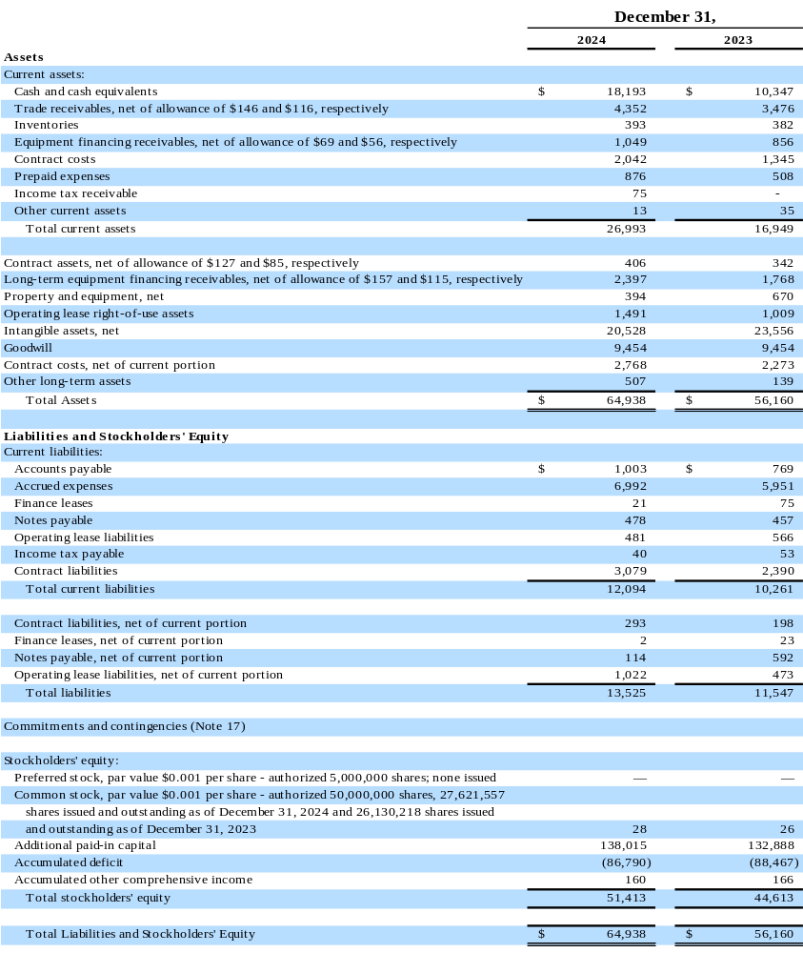

CREXENDO, INC. AND SUBSIDIARIES
Consolidated Statements of Operations
(In thousands, except per share and share data)

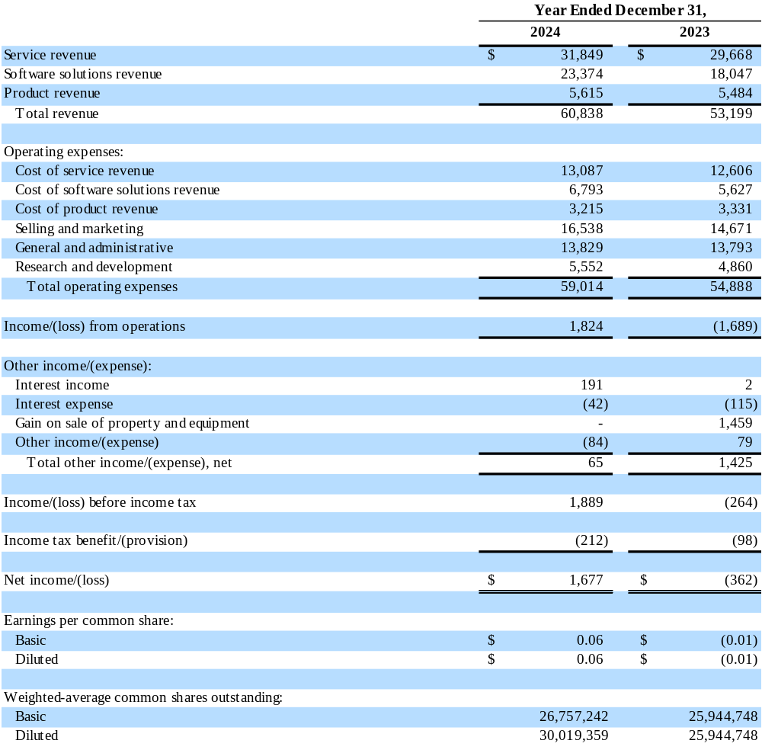

CREXENDO, INC. AND SUBSIDIARIES
Consolidated Statements of Cash Flows
(In thousands)
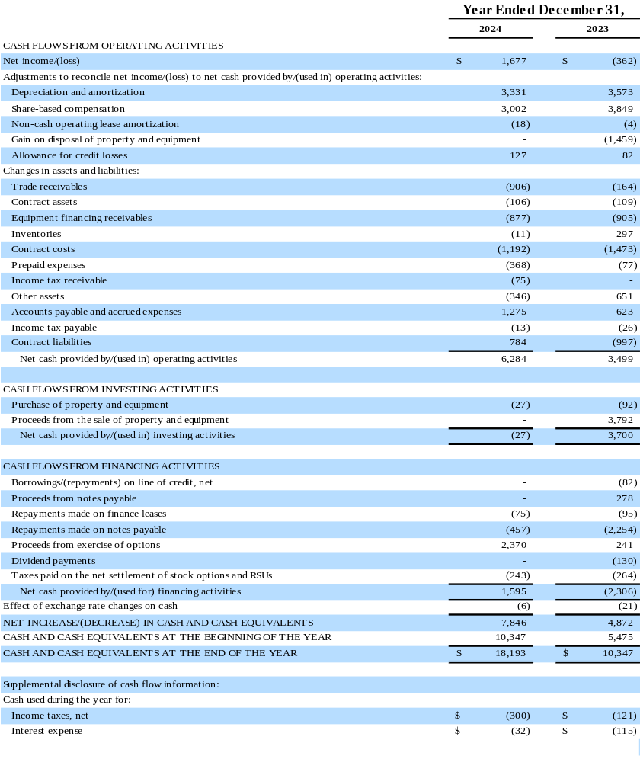
Use of Non-GAAP Financial Measures

To evaluate our business, we consider and use non-generally accepted accounting principles (“Non-GAAP”) net income and Adjusted EBITDA as a supplemental measure of operating performance. These measures include the same adjustments that management takes into account when it reviews and assesses operating performance on a period-to-period basis. We consider Non-GAAP net income to be an important indicator of overall business performance because it allows us to evaluate results without the effects of share-based compensation, acquisition related expenses, changes in fair value of contingent consideration, amortization of intangibles, and goodwill and long-lived asset impairment. We define EBITDA as U.S. GAAP net income/(loss) before interest expense, interest income and other expense/(income), the gain/(loss) on the sale of property and equipment, goodwill and long-lived asset impairments, provision/(benefit) for income taxes, and depreciation and amortization. We believe EBITDA provides a useful metric to investors to compare us with other companies within our industry and across industries. We define Adjusted EBITDA as EBITDA adjusted for acquisition related expenses, changes in fair value of contingent consideration and share-based compensation. We use Adjusted EBITDA as a supplemental measure to review and assess operating performance. We also believe use of Adjusted EBITDA facilitates investors’ use of operating performance comparisons from period to period, as well as across companies.

In our March 4, 2025 earnings press release, as furnished on Form 8-K, we included Non-GAAP net income, EBITDA and Adjusted EBITDA. The terms Non-GAAP net income, EBITDA, and Adjusted EBITDA are not defined under U.S. GAAP, and are not measures of operating income, operating performance or liquidity presented in analytical tools, and when assessing our operating performance, Non-GAAP net income, EBITDA, and Adjusted EBITDA should not be considered in isolation, or as a substitute for net income/(loss) or other consolidated income statement data prepared in accordance with U.S. GAAP. Some of these limitations include, but are not limited to:

- EBITDA and Adjusted EBITDA do not reflect our cash expenditures or future requirements for capital expenditures or contractual commitments;
- they do not reflect changes in, or cash requirements for, our working capital needs;
- they do not reflect the interest expense, or the cash requirements necessary to service interest or principal payments, on our debt that we may incur;
- they do not reflect income taxes or the cash requirements for any tax payments;
- although depreciation and amortization are non-cash charges, the assets being depreciated and amortized will be replaced sometime in the future, and EBITDA and Adjusted EBITDA do not reflect any cash requirements for such replacements;
- while share-based compensation is a component of operating expense, the impact on our financial statements compared to other companies can vary significantly due to such factors as the assumed life of the options and the assumed volatility of our common stock; and
- other companies may calculate EBITDA and Adjusted EBITDA differently than we do, limiting their usefulness as comparative measures.

We compensate for these limitations by relying primarily on our U.S. GAAP results and using Non-GAAP net income, EBITDA, and Adjusted EBITDA only as supplemental support for management’s analysis of business performance. Non-GAAP net income, EBITDA and Adjusted EBITDA are calculated as follows for the periods presented.

Reconciliation of Non-GAAP Financial Measures

In accordance with the requirements of Regulation G issued by the SEC, we are presenting the most directly comparable U.S. GAAP financial measures and reconciling the unaudited Non-GAAP financial metrics to the comparable U.S. GAAP measures.

Reconciliation of U.S. GAAP Net Income to Non-GAAP Net Income
(Unaudited, in thousands, except per share and share data)

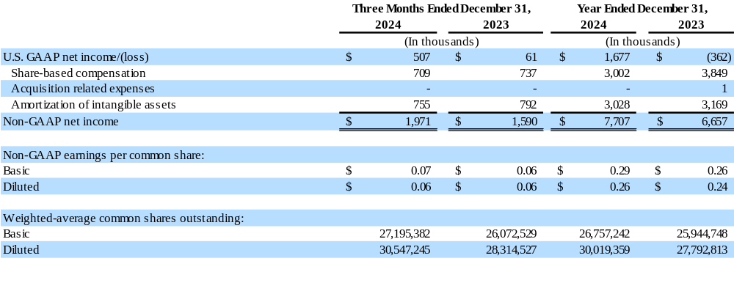

Reconciliation of U.S. GAAP Net Income to EBITDA to Adjusted EBITDA
(Unaudited, in thousands)

