 | 

YOUNGBLOOD FEATURE ADAPTATION
BEGINS PRINCIPAL PHOTOGRAPHY

Academy Award® Nominee Hubert Davis to Direct Film Based on ‘80s Sports Drama

TORONTO and LOS ANGELES – February 10, 2025 – Academy Award® and Emmy Award® nominated production company Aircraft Pictures in association with Dolphin Entertainment (NASDAQ:DLPN), a leading entertainment marketing and premium content production company, and Canadian theatrical distributor Photon Films announced today the start of principal photography for their theatrical feature film adaptation of the 1986 sports drama, Youngblood, with rising filmmaker Hubert Davis (The Well, Black Ice) on board to direct. Principal photography will take place in Hamilton and Barrie, Canada.

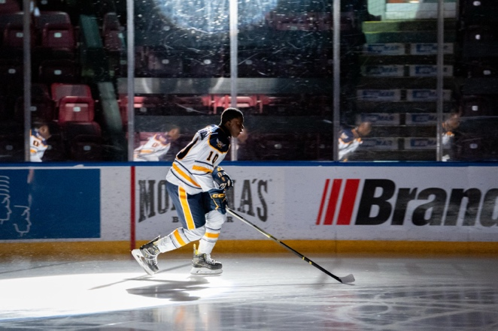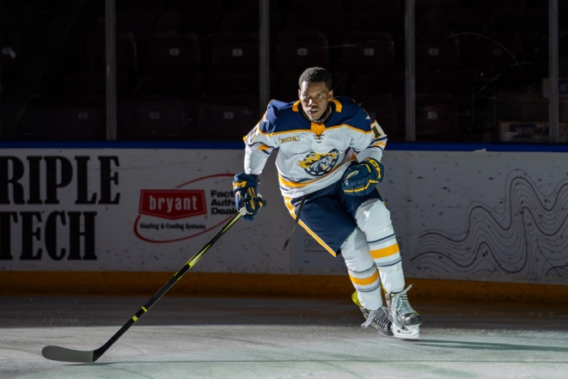

The film follows hockey prodigy Dean Youngblood who joins the Hamilton Mustangs and discovers he must face off against toxic behavior on the ice and within himself to fulfill his potential as professional hockey player. The original 1986 film, distributed by MGM, starred Rob Lowe, Patrick Swayze and Keanu Reeves in his feature film debut, and has since become a cult classic among hockey fans.

The Youngblood adaptation is based on a script by screenwriters Josh Epstein & Kyle Rideout, Seneca Aaron and the late Charles Officer. The film will be distributed in Canada by Photon Films. Dolphin’s Bill O’Dowd and Emerson Davis will serve as Executive Producers, alongside Photon Films’ Mark Slone and Zanne Devine. Aircraft’s Anthony Leo and Andrew Rosen will produce. Associate Producer Christopher V. Nelson (Miracle, The Mighty Ducks: Gamechangers) serves as Hockey Consultant. The film is produced with the financial participation of Telefilm Canada and the Talent Fund, Ontario Creates and the Shaw Rocket Fund.

The cast will include Ashton James (Boxcutter, Revenge of the Black Best Friend) in the title role of Dean Youngblood, Blair Underwood (Longlegs, Deep Impact, LA Law) as his father Blane Youngblood, Shawn Doyle (The Expanse, Fargo, Big Love) as Coach Chadwick, Alexandra McDonald (Night Blooms, Testament) as Jessie Chadwick, Henri Picard (The Dishwasher, For Those Who Don’t Read Me) as Denis Sutton, Donald MacLean Jr. (Workin’ Moms, Nurses) as Carl Racki, Olunike Adeliyi (The Expanse, Workin’ Moms) as Ruby Youngblood, Emidio Lopes (Painkiller, The Changeling) as Kelly Youngblood and Tamara Podemski (Outer Range, Reservation Dogs) as Ms. McGill. Rounding out the rest of the Hamilton Mustangs hockey team are Jonathan Valvano, Ty Neckar, Dylan Hawco and Alexei Morita.

"Youngblood is not an homage to the movies of the 80s but a re-orienting of these films and ideas - especially those about masculinity which my generation grew up on,” commented Davis. “Through our protagonist Dean Youngblood, we explore the nuances of the Black masculine experience via the camaraderie, brutality and triumph of the world of hockey."

Davis’ directorial debut, the short film Hardwood, was nominated for both an Academy Award® and Emmy Award® and explored the relationship between Hubert and his Harlem Globetrotter father, Mel Davis. He then directed the critically acclaimed Invisible City and Giants of Africa which centres on Toronto Raptors President Masai Ujuri and his efforts to empower the youth of Africa through basketball camps. Davis’ film, Black Ice, about the contributions of Black players to Canadian hockey and the experiences with racism that they continue to face today, won the People’s Choice Documentary Award at the Toronto International Film Festival and was voted one TIFF’s Top 10 Canadian films of 2022. His recently completed eco-thriller feature The Well is being distributed globally by XYZ Films.
About YOUNGBLOOD
Dean Youngblood was raised by his father, Blane, on a diet of toughness and hockey. When Dean is invited to join the Hamilton Mustangs, he travels to Canada from Detroit where his skill commands respect and his arrogance earns him fast enemies. Coach Chadwick, resentful of being saddled with such a toxic player, keeps Dean benched game after game. Dean’s frustration builds, culminating in a violent outburst involving rival goon Carl Racki that costs the Mustangs a significant win. As Team Captain Sutton takes him under his wing, Dean begins to buck Blane’s teachings and his growing maturity spurs a relationship with Jessie – Coach Chadwick’s daughter - who gives Dean a run for his money on and off the ice. His newfound resolve draws the ire of Racki, who provokes Dean during a game by attacking and seriously injuring Sutton. As the final game of the Eastern Final approaches, so does his showdown with Racki and Dean’s choice as to what kind of man he wants to be.

About Aircraft Pictures
Based in Toronto, Aircraft Pictures was founded by Anthony Leo and Andrew Rosen to create high quality, scripted content for kids, families, and young adults. Recent projects include the Netflix Global Top 10 drama series Geek Girl, the CBC/BBC scripted K-pop drama Gangnam Project; the YTV/Nickelodeon scripted comedy Popularity Papers, the Apple TV+ series Circuit Breakers, the Hulu Original series Holly Hobbie; the Family Channel/Roku animated series Summer Memories; and the Academy Award® and Golden Globe Award nominated animated feature film The Breadwinner. For more information, visit www.aircraftpictures.com.
About Dolphin Entertainment
Dolphin Entertainment, founded by Emmy-nominated producer Bill O'Dowd, has financed and produced award-winning television, digital, and feature film content for nearly three decades. Dolphin Entertainment's television division has produced hundreds of hours of content for a wide variety of networks such as ABC, CBS, Nickelodeon, and MTV. Dolphin Entertainment has also produced Streamy-award winning digital content for platforms such as Hulu, YouTube, and Facebook — the latter two in partnership with Warner Bros. Dolphin Entertainment's first feature film release was Justin Bieber's concert film, Justin Bieber's Believe, directed by Jon M. Chu. Most recently, Dolphin Entertainment co-financed and produced a feature documentary called The Blue Angels. Partners included IMAX, Bad Robot, and Glen Powell. The film was released in IMAX on May 17th followed by a global release on Prime Video May 23rd. The film was the number one movie over Memorial Day weekend on Amazon.

About Photon Films and Media
Launched in 2010, Photon Films and Media (photonfilms.ca), formerly Pacific Northwest Pictures, is a leading Canadian entertainment company specializing in the development, financing, production and distribution of feature films for the domestic and international marketplace. With an emphasis on high quality films from leading filmmakers in diverse genres, Photon Films brings those films to consumers with innovative forms of marketing and distribution across all distribution platforms.

###

James Carbonara
Hayden IR
(646)-755-7412
james@haydenir.com

