Adnexus Biotechnologies Unveils AI-Driven Malaria Cure with Trapicolast

DALLAS, TX / ACCESSWIRE / January 7, 2025 - Adnexus Biotechnologies Inc. proudly announces the launch of Trapicolast, a pioneering antimalarial drug developed through its innovative AI-powered Sutra™ platform. Integrating AI Platform discovered ADX1 and ADX2, this breakthrough medication targets dual mechanisms within the Plasmodium parasite, attacking both the apicoplast and vesicular trafficking pathways.

A New Era in Malaria Treatment
Traditional antimalarial treatments have primarily ignored the apicoplast, an organelle crucial for the parasite's survival. Trapicolast introduces a novel strategy by focusing on this overlooked target, providing a potent defence against the escalating challenge of drug resistance, especially against artemisinin-based therapies.

Revolutionizing Treatment with Dual-Target Mechanism
Trapicolast's unique dual-target approach disrupts the parasite's apicoplast DNA synthesis and vesicular trafficking, offering a robust and sustainable treatment option. This mechanism is particularly vital in areas where resistance to existing treatments is prevalent, offering new hope in regions like Sub-Saharan Africa and Southeast Asia.

The Power of AI in Drug Discovery
The creation of Trapicolast underscores the transformative impact of artificial intelligence in pharmaceuticals. Leveraging the Sutra™ AI platform, Adnexus analyzed over 8 million molecular compounds, swiftly identifying Trapicolast. This approach exemplifies how AI can accelerate drug discovery, making it faster and more cost-effective. This discovery has been covered in a patent application.

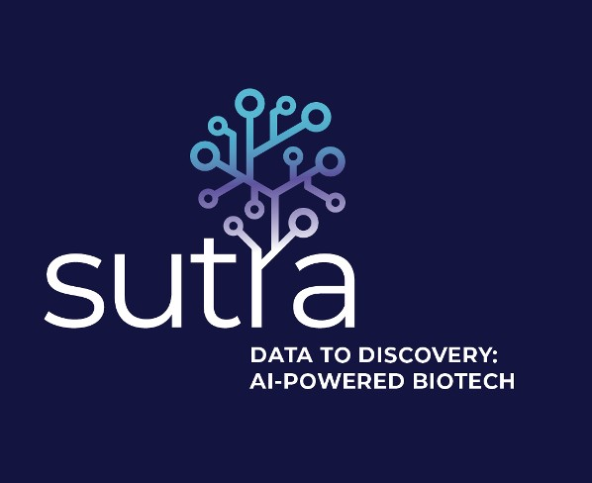
Figure 1 demonstrates the Sutra™ AI Platform logo.

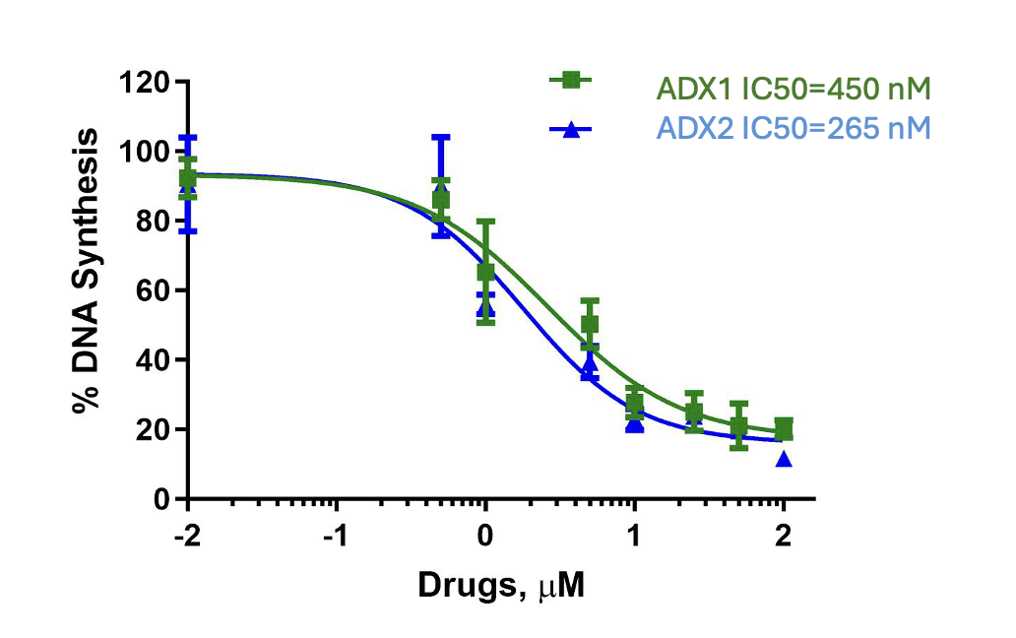

Figure 2 provides compelling evidence of how the Sutra™ AI Platform-driven discovery of ADX1 and ADX2 halt the DNA synthesis in malaria parasites, demonstrating Trapicolast's unique mechanism of action.

Key Features and Insights
- Apicoplast Targeting: Trapicolast uniquely targets the apicoplast, a vital component of the Plasmodium parasite that previous treatments have largely neglected.
- Dual-Target Mechanism: The combination of ADX1 and ADX2 in Trapicolast inhibits DNA synthesis and vesicular trafficking in the malaria parasite, making it resistant to developing resistance mechanisms.
- Resistance Overcoming: With the rise of drug-resistant malaria strains, Trapicolast offers a promising new solution, especially in high-transmission areas like Sub-Saharan Africa and Southeast Asia.
Visionary Insights from Leadership
- Dr. Kirsten Bischof, a distinguished member of Adnexus's Advisory Board and co-inventor, stated, "We have unlocked a new frontier in drug discovery by targeting the apicoplast to bypass resistance, potentially saving countless lives in regions heavily affected by malaria. Given the severe impact of malaria in high-transmission areas such as Africa and Asia, this innovation offers a more effective and sustainable management strategy, bringing hope for saving many lives. This is not just science; it is a beacon of hope."
- Dr. Gaurav Chandra, CEO of Adnexus, exclaims, "The discovery of Trapicolast via our Sutra™ AI platform isn't just an advancement; it's a revolution. It showcases our commitment to pushing the boundaries of what's possible in medical science, promising a future where malaria might no longer claim lives. It also validates the potential of the Sutra™ AI platform in drug discovery." He further added.” While meeting our milestones for our HIV assets is a priority, we will further advance this Malaria drug in collaboration with our partners in India with access to specific models and resistant strains.”
Strategic Partnerships for Global Impact
Adnexus has solidified its commitment to innovation through a strategic partnership with 1606 Corp (OTC: CBDW), aiming to expand its AI-driven healthcare solutions. This collaboration underscores Adnexus's dedication to advancing global health outcomes.

About Adnexus Biotechnologies Inc.
Adnexus Biotechnologies stands at the forefront of AI-enabled drug discovery, concentrating on treatments for infectious diseases like malaria and HIV. The company's proprietary Sutra™ AI platform is instrumental in:
- Accelerating drug discovery processes
- Identifying novel biomarkers for diseases
- Advancing personalized medicine approaches

Market Insights
- Global Malaria Treatment Market: This market is expected to grow to USD 2.93 billion by 2033, with the antimalarial drug sector growing at a CAGR of 4.26% from 2024 to 2030.
- AI in Drug Discovery: The market for AI in drug discovery is expanding, highlighting AI's pivotal role in identifying new treatments for various diseases.

Forward-Looking Statements
This press release includes forward-looking statements that reflect Adnexus’s goals and expectations regarding future developments, including Trapicolast's progress and AI's impact on drug discovery. These statements are based on current assumptions and are subject to risks and uncertainties that may cause actual results to differ.

Contact Us:
Dr. Gaurav Chandra
gaurav.chandra@adnexusbiotech.com
adnexusbiotech.com
cbdw.ai (www.cbdw.ai )

