TWO MEN AND A TRUCK®/Sacramento

Benefits of Using TWO MEN AND A TRUCK®
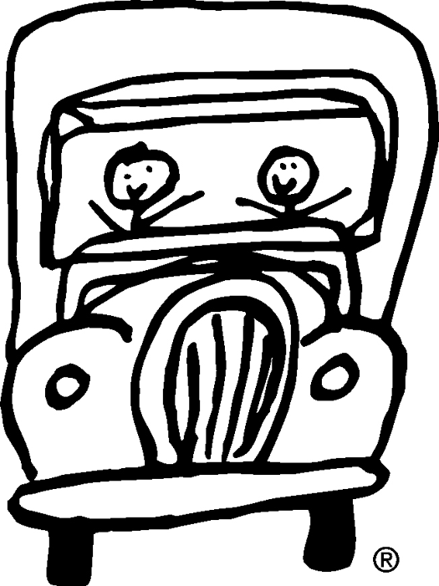
- Communication is important to a successful move. TWO MEN AND A TRUCK® Customer Service Representatives are always happy to answer your questions about moving, packing, costs and scheduling. We want both you and our staff members to be prepared on moving day so your move goes exactly as planned.
- TWO MEN AND A TRUCK® has an excellent reputation. Over 94% of our customers refer us to family and friends.
- TWO MEN AND A TRUCK® movers are professionally trained and work in uniforms.
- TWO MEN AND A TRUCK® provides all moving-related equipment which is clean and well-maintained.
- TWO MEN AND A TRUCK® staff members are courteous, hard-working and conscientious.
- TWO MEN AND A TRUCK® movers hustle to keep customer costs as low as possible.
- TWO MEN AND A TRUCK® will pack and move as little or as much as you like, even just moving the big screen TV from one end of the house to the other. We have no minimum time.
- TWO MEN AND A TRUCK® offers competitively priced boxes and packing supplies.
- TWO MEN AND A TRUCK® offers complete packing and unpacking services.
- TWO MEN AND A TRUCK® movers can disassemble and reassemble furniture if you like, although they are unable to disconnect or reconnect any hard wired items.
- The cost of your move will be based on actual time spent on your move and drive time.
- TWO MEN AND A TRUCK® offers free padding and stretch wrapping. By doing this, not only does it protect your furniture from scratches or chipping, but allows you to leave your clothes in the dressers.
- TWO MEN AND A TRUCK® is bonded and insured.
- TWO MEN AND A TRUCK® does not use a labor ready service or temporary agency. All our employees are full-time.
- TWO MEN AND A TRUCK® offers several methods of payment at the end of the move including cash, check, Visa or MasterCard.
- By the way, did we mention that we are the 4th largest Moving Company in the Nation.

Sacramento, CA. (916) 852-7411

