Navitas Life Sciences Named a Major Contender in Everest Group Clinical Data Management Operations PEAK Matrix® Assessment 2025

Recognized for innovation in Biostatistics, Clinical Data Management, and Real-World Evidence, powered by AI-driven platforms

Maryland, US– (October 2, 2025) – Navitas Life Sciences, a global CRO delivering end-to-end solutions across clinical, regulatory, and safety operations, today announced that it has been recognized as a Major Contender in the Everest Group Clinical Data Management (CDM) Operations PEAK Matrix® Assessment 2025. The report evaluates leading providers based on their market impact, vision, and delivery capabilities in clinical data management services.
"We are proud to be recognized by Everest Group in the 2025 PEAK Matrix® for Clinical Data Management Operations," said Srinivasan H Ramani, CEO, Navitas Life Sciences. “This recognition validates our commitment to combining technology, therapeutic expertise and operational excellence to drive patient-centric outcomes and thereby we help sponsors accelerate development, ensure compliance and bring therapies to patients faster.”
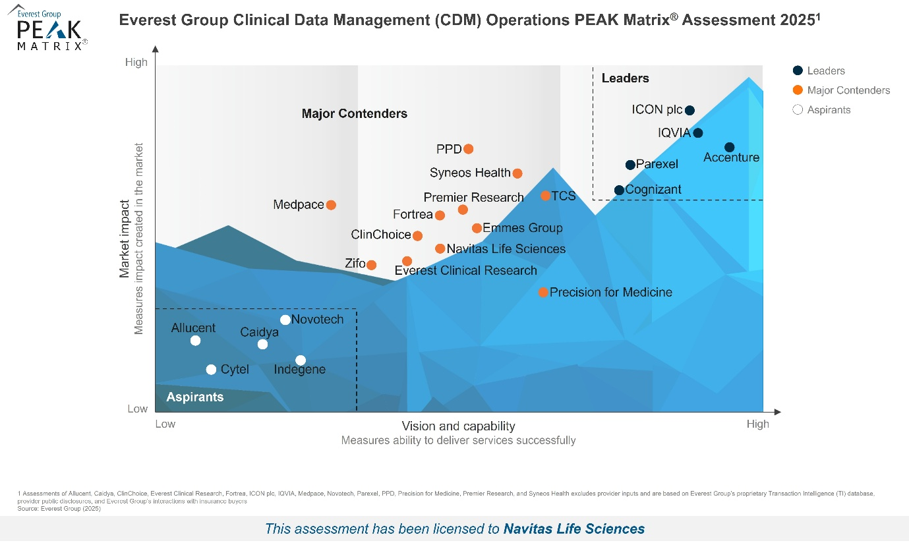

“As clinical data management evolves with the growing emphasis on real-time insights, scalability, and the integration of AI-driven platforms, enterprises are seeking partners with strong flexibility and deep therapeutic expertise,” said Vandana Sharma, Practice Director at Everest Group. “Navitas Life Sciences distinguishes itself through its end-to-end CDM capabilities, supported by its proprietary OneClinical® platform, which enables AI-driven analytics, data harmonization, and cross-study standardization. It has a strong presence in large-scale oncology and neurology programs, complemented by strategic partnerships with ThoughtSphere, Unlearn, and Readout AI. This unique blend of advanced technology, therapeutic expertise, and client-centric flexibility positions Navitas Life Sciences as a Major Contender in Everest Group's Clinical Data Management Operations PEAK Matrix® Assessment 2025.”
About Navitas Life Sciences
Navitas Life Sciences, headquartered in Gaithersburg, MD, is a global CRO helping pharma and biotech accelerate development and improve patient outcomes. With expertise in Clinical Data Management, Biostatistics, and Real-World Evidence, powered by AI/ML-enabled platforms, Navitas delivers smarter, faster, and compliant clinical research solutions worldwide. Learn more at www.navitaslifesciences.com
Disclaimer
Licensed extracts from Everest Group’s PEAK Matrix® Reports may be used by licensed third parties. Selected extracts do not necessarily provide full context. Everest Group research is independent, and no organization has paid a fee to influence ranking. To access complete research, visit Everest Group PEAK Matrix® Reports.

