FOR IMMEDIATE RELEASE
Settle Buddy launches Settle Business serving cross-border commerce in Vietnam-Canada trades
Vancouver, BC 25 September , 2024 – Settle Buddy a digital settlement & expansion services marketplace that streamlines booking and the entire settlement process for both newcomers and foreign businesses. In partnership with Sparkcorpnet, a business expansion & technology consulting firm, dedicated to helping small & medium enterprises (SMEs) and startups with end-to-end solutions for smooth operations in multi countries, Settle Buddy proudly announces the latest Settle Business services, which have the exclusive trading & commerce packages dedicated for market expansion and sustainable Business to Business freeway between Vietnam and Canada . The service will assist both countries' companies in trading collaboratively and operating business with a strong foundation in Canada.
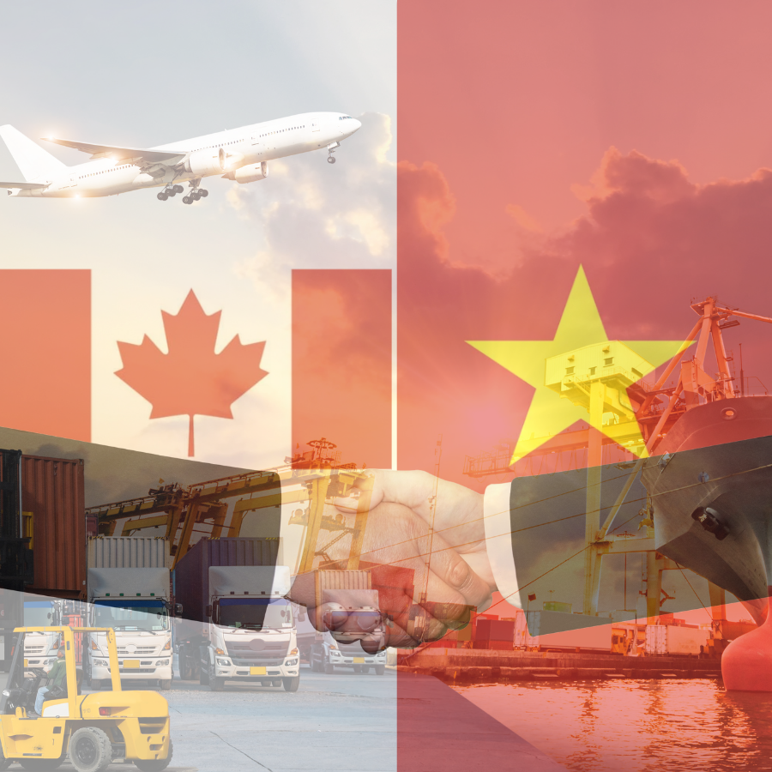
Canada is well-known as one of the largest economies in the world. It offers international businesses a stable economy, high development opportunities, and many connections with other countries. It has become an excellent destination for companies to come and operate in Canada.
Vietnam, a developing country with a well-performing economy through the years, has reached 5th place in GDP among SEA countries and is expected to be one of the fastest-growing economies in the world in 2024 (as predicted by IMF).

There is much space for companies in both countries to collaborate to build and upgrade trade and commerce relations. Sparkcorpnet wants to become the bridge for ready-to-go-global companies in Canada and Vietnam in terms of trade & commerce. Therefore, we launch the service and offer 6 Exclusive Trading Packages:

Incorporation package
The package helps the companies register a representative office in Canada to improve brand visibility and set up cooperation partners.


Trade Representative package
The package sets up a representative office, promotes products & services and connects businesses with local partners & customers.


Marketing & Branding package
For companies that demand a distinct brand identity, build a brand image, and connect products and services to the target audience by marketing.


Distribution Development package
A tailored package for companies focusing on trade, export-import, and distribution of products and services to Canada.


E-commerce package
A package assists companies in selling products and services via e-commerce platforms in Canada.


Full package for Representative Office and Operation
A full package for all services is available for companies wanting to have a seamless experience with Sparkcorpnet in Trade & Commerce, Distribution, Marketing, and Operations.

We are happy and ready to let companies spark with Exclusive Trading Packages. And it is our pleasure to serve and stand alongside you to conquer success.

For more information about Sparkcorpnet and its services or to book a consultation session, visit https://www.settlebuddy.net/packages/settle/business or https://sparkcorp.net/exclusive-trading-packages/

About Sparkcorpnet:
Sparkcorpnet is a business expansion and technology consulting firm that supports SMEs and startups. Sparkcorpnet offers end-to-end solutions for business operations, even from scratch. With 10+ years of collective experience and success in 10+ projects in various industries, we are committed to creating an inspiring and dynamic work environment where our customers are empowered to ignite their passion, shape the future of global contribution, and transform lives across the globe.

Media Contact:
Cara Hoang
Management Support Team
Email: management@settlebuddy.ca
Website: https://www.settlebuddy.net/

