FOR IMMEDIATE RELEASE
Contact:
Camila Quiñones Bernaola
Euroky, LLC
info@euroky.com
www.euroky.com

Euroky Vitality Drink® Art Carton Challenge

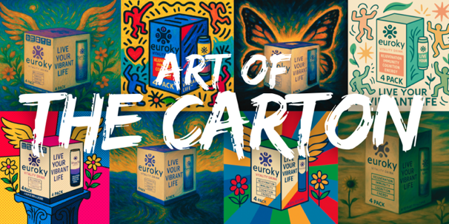
Euroky™ Launches the Art of the Carton Challenge: A National Call for Artists to Repurpose Euroky™ Cartons into Stunning Works of Art
Honoring National Arts and Humanities Month by Transforming Obsolete Cartons into Works of Art
Miami, FL — August 2025 —In celebration of the upcoming National Arts and Humanities Month, Euroky Vitality Drink® is launching the Art of the Carton Challenge, a nationwide creative call to action. Artists, students, and creators are invited to repurpose obsolete Euroky™ 4-pack cartons—turning them into original paintings, sculptures, mixed-media installations, and more.
The Euroky™ Art of the Carton Challenge is part art competition, part environmental statement. Instead of sending outdated cartons to recycling or landfill, Euroky™ is encouraging participants to give them a second life as paintings, sculptures, mixed-media pieces, and other original creations. This nationwide competition celebrates creativity, sustainability, and artistic innovation, offering winners the chance to earn cash prizes and Euroky Vitality Drink®, in addition to having their artwork featured in Euroky™-sponsored exhibitions and campaigns.
“National Arts and Humanities Month is about celebrating the power of creativity to connect communities and inspire change,” said Thomas Shaver, Co-Founder. “By repurposing our obsolete cartons, we’re not only reducing waste—we’re sparking a national conversation how art can reimagine the everyday.”

How It Works
- Participants are encouraged to paint, sculpt, cut, fold, or collage Euroky’s 4-pack cartons into unique, visually striking artworks. There are no limits to the imagination—whether it’s a bold abstract painting, a detailed portrait, a 3D sculpture, or a mixed-media piece—creativity is the key.
- The only way to participate in the Euroky Art Carton Challenge is by submitting your entry through the official form at https://euroky.com/euroky-art-carton-challenge/. You must upload high-quality photos of your artwork and a brief artist statement using this link. Posts on Instagram or TikTok using #EurokyArtCarton are welcome for sharing and visibility but will not count as official entries.

Prizes & Recognition
- Grand Prize: $2,000 cash + feature in a Euroky™ pop-up gallery + digital campaign + Euroky™ swag
- Additional prizes available for 2nd and 3rd place details at www.euroky.com

Important Dates
- Submission Window: August 18 – November 30, 2025
- Public Voting & Winners Announced: Early December, 2025

About Euroky Vitality Drink®
Euroky Vitality Drink®, the world’s first physician-approved and evidence-based multifunctional vitality drink, designed to optimize vitality and well-being. Euroky™ provides a scientifically formulated blend of premium ingredients to support rejuvenation, immunity, cognition, and energy—all in a refreshing, lightly carbonated beverage—Live Your Vibrant Life™. Available on Amazon.
About National Arts and Humanities Month
Established in 1993, National Arts and Humanities Month is the largest annual celebration of the arts and humanities in the United States. Originating from the National Arts Week, it encourages Americans to deepen engagement with cultural expression and creativity.
For more details visit: Americans for the Arts: www.americansforthearts.org/events/national-arts-and-humanities-month

Media Inquiries
For further information, please contact us at info@euroky.com or message us @eurokyvitalitydrink on IG.

