Kaya Holdings, Inc. and The Sacred Mushroom ™ Psilocybin Treatment Facility Announce Inaugural Open House and New Series of Low-Dose Psilocybin Sessions

Portland, Oregon – December 23, 2024 – Kaya Holdings, Inc. (OTCQB:KAYS) and The Sacred Mushroom™, Portland's one-of-a-kind psilocybin treatment center, are excited to announce their first Open House event to be held on Friday, December 27, 2024, from 5:00 PM to 8:00 PM.

This event offers the community a unique opportunity to explore our state-of-the-art facility, meet the team, and learn about the transformative potential of psilocybin-assisted therapies.

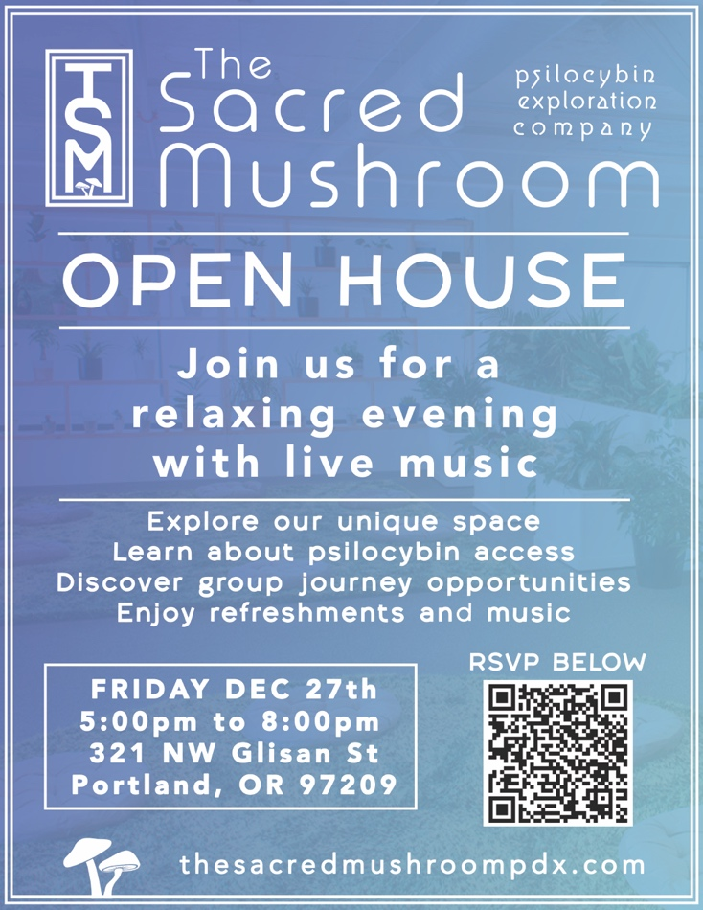

To get tickets to the event please access the following link:

https://www.eventbrite.com/e/the-sacred-mushroom-open-house-tickets-1116887333079?aff=oddtdtcreator

During the Open House, attendees will have the chance to tour private treatment rooms, experience the indoor garden, and discover the many activities offered, including art and musical expression, body movement, and mindfulness practices. The Sacred Mushroom™ emphasizes the importance of a curated setting, providing a safe and enriching environment for personal growth and healing. Whether you're curious, exploring options for yourself or a loved one, or simply seeking a moment of relaxation, this open house is a perfect opportunity to unwind, connect, and explore what we offer.

As part of its mission to foster deeper connections and healing through creativity and introspection, The Sacred Mushroom™ is also thrilled to announce the launch of its “Community, Culture, and a Touch of Psilocybin” series. These group sessions, centered around low-dose psilocybin experiences, will celebrate the works of respected musicians, authors, poets, and visual artists. Each session is designed to blend artistic appreciation with guided introspection, creating a space for participants to explore while building community bonds.

Bryan Arnold, Chief Facilitator of The Sacred Mushroom™, shared: “We are committed to making psilocybin therapy accessible and impactful. With our new series, we aim to merge the transformative power of psilocybin with the inspiration of art, music, and literature to foster growth, healing, and connection.”

Attendees of the Open House will receive exclusive details about upcoming sessions in the series and have the opportunity to reserve spots at a special introductory rate. The public (over age 21) is invited to visit The Sacred Mushroom™ at 321 SW Glisan Street in Old Towne Portland on December 27 to experience The Sacred Mushroom’s™ revolutionary approach to psilocybin therapy and learn more about how art and culture can intersect with personal transformation.

Free e-Book
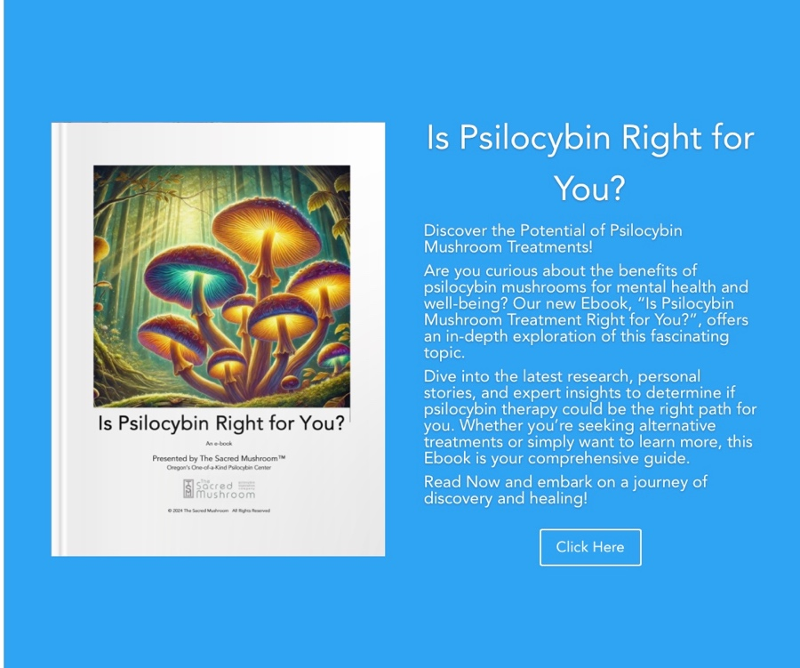

Titled “Is Psilocybin Right for You?”, the e-book details the therapeutic benefits psilocybin can offer to people with mental health concerns or those simply curious. To access a copy of our e-book “Is Psilocybin Right for You?”, please click on the above image or go to:

https://thesacredmushroompdx.com/e-book-library/

Once you have accessed the site you can read the book online or download it to be read later offline.

Topics addressed in the book include: What is Psilocybin, How Does Psilocybin Affect the Brain, History of Psilocybin, Is Psilocybin Treatment Right for You, Psilocybin & Personal Growth, Psilocybin & Happiness, Psilocybin & Inner Peace, Psilocybin & Creativity, Psilocybin & Post Traumatic Stress Disorder, Psilocybin & Depression, Psilocybin & Obsessive-Compulsive Disorder, Psilocybin & Sexual Trauma, Psilocybin & Anxiety, Psilocybin & Substance/Alcohol Abuse & Addiction, Psilocybin & Eating Disorders, Psilocybin & Alzheimer's Disease, Psilocybin & End of Life Anxiety, Psilocybin & Cluster Headaches, Understanding Dosing, Risks, The Importance of Integration, and Exploring the Power of Psilocybin at The Sacred Mushroom™.

About The Sacred Mushroom™ (https://thesacredmushroompdx.com)
The Sacred Mushroom™ is a legally licensed psilocybin treatment center authorized by the State of Oregon to administer psilocybin treatments within the regulations set forth by the Oregon Health Authority.


The Sacred Mushroom™, at 11,000 sq. ft., has been purposely curated to provide every TSM guest with the full transformative potential of the psychedelic journey. Guests can access their perfect setting through TSM's proprietary "Synergy by Design" and interact with journey-enhancing activities such as art expression, body movement, and journaling.
For more information or to make an appointment for psilocybin services at The Sacred Mushroom™, please go to https://thesacredmushroompdx.com or send an email to info@tsmpdx.com

KAYS Stockholders and Other Interested Parties - Please Update Your Contact Information:
We routinely receive calls and emails from shareholders and other interested parties seeking an update on our operations. We are asking all KAYS stockholders and interested parties to email us and confirm their contact info. Please email info@kayaholdings.com with "KAYS stockholder update" in the subject line and include your name, address, phone number and number of shares you own so that we can make sure you receive all updates and respond to inquiries. If you would like to speak to someone at the Company, please call or text 954-480-3960 and someone will get right back to you.

About Kaya Holdings, Inc. (https://kayaholdings.com)
Kaya Holdings, Inc is a "mind care" company with operations in the emerging psilocybin sector and in medical/recreational cannabis. KAYS is a fully reporting, US-based publicly traded company, listed for trading on the OTCQB market under the symbol KAYS.

In 2014 KAYS became the first US public company to own and operate a medical cannabis dispensary (in Portland, Oregon). Today, KAYS has interests in three cannabis licenses (1 in Portland Oregon, USA and 2 in Greece). Resuming its role as innovator and trend setter, the Company is again breaking ground in the United States with The Sacred Mushroom™ psychedelic treatment centers through its majority owned subsidiary, Fifth Dimension Therapeutics, Inc.

Important Disclosure
KAYS is planning execution of its stated business objectives in accordance with current understanding of state and local laws and federal enforcement policies and priorities as it relates to psychedelics and cannabis. Potential investors and shareholders are cautioned that KAYS and subsidiaries including FDT will obtain advice of counsel prior to actualizing any portion of their business plan (including but not limited to license applications for the cultivation, distribution or sale of marijuana and psychedelic products, engaging in said activities or acquiring existing production/sales operations). Advice of counsel with regard to specific activities of KAYS, federal, state, or local legal action or changes in federal government policy and/or state and local laws may adversely affect business operations and shareholder value.

Disclaimer
The information set forth above is for general consumer understanding and education and should not be considered or used as a substitute for medical advice, diagnosis or treatment. Psilocybin is not an alternative to any prescription drug. A physician should be consulted prior to making any changes in prescription drug treatment.

The information set forth above and the information contained herein has not been evaluated by the FDA. Psilocybin is not intended to diagnose, treat or cure any disease. Results of psilocybin treatment may vary. Psilocybin is not federally legal in the United States.

Forward-Looking Statements
This press release includes statements that may constitute "forward-looking" statements, usually containing the words "believe," "estimate," "project," "expect" or similar statements are made pursuant to the safe harbor provisions of the Private Securities Litigation Reform Act of 1995. Forward-looking statements inherently involve risks and uncertainties that could cause actual results to differ materially from the forward-looking statements. Factors that would cause or contribute to such differences include, but are not limited to, acceptance of the Company's current and future products and services in the marketplace, the ability of the Company to develop effective new products and receive regulatory approvals of such products, competitive factors, dependence upon third-party vendors, and other risks detailed in the Company's periodic report filings with the Securities and Exchange Commission. By making these forward-looking statements, the Company undertakes no obligation to update these statements for revisions or changes after the date of this release.

CONTACT:
Stockholder Relations
954-480-3960
SOURCE: Kaya Holdings, Inc.

