

FOR IMMEDIATE RELEASE
Gaston Community Foundation Presents 35th Annual Allen H. Sims Award
Celebrates 25th Anniversary of the Next Generation Giving Circle.

GASTONIA, N.C. — September 18, 2025 — The Gaston Community Foundation hosted a memorable evening on Thursday, September 18, honoring the 35th Annual Allen H. Sims Award recipient and celebrating the 25th anniversary of the Next Generation Giving Circle. The event took place at the breathtaking Daniel Stowe Conservancy, where guests enjoyed a cocktail hour amid the gardens, music, and a variety of gourmet food stations.

The evening began with a warm welcome from Board Chair Bob Spencer, who recognized the leadership of former President Ernest Sumner and welcomed new President Dr. Richard Rankin. “This was a special occasion—not only to celebrate a remarkable community leader, but also to honor 25 years of the Next Generation Giving Circle and look forward to an exciting future for philanthropy in Gaston County,” said Spencer.

Nina Greene, the Foundation’s Grants and Scholarships Officer, presented the Foundation’s accomplishments over the past year, including $19 million in gifts, over $11.5 million in grants, and the awarding of $345,000 in scholarships to 119 students: a year resulting in the Foundation managing over $150 million in assets.
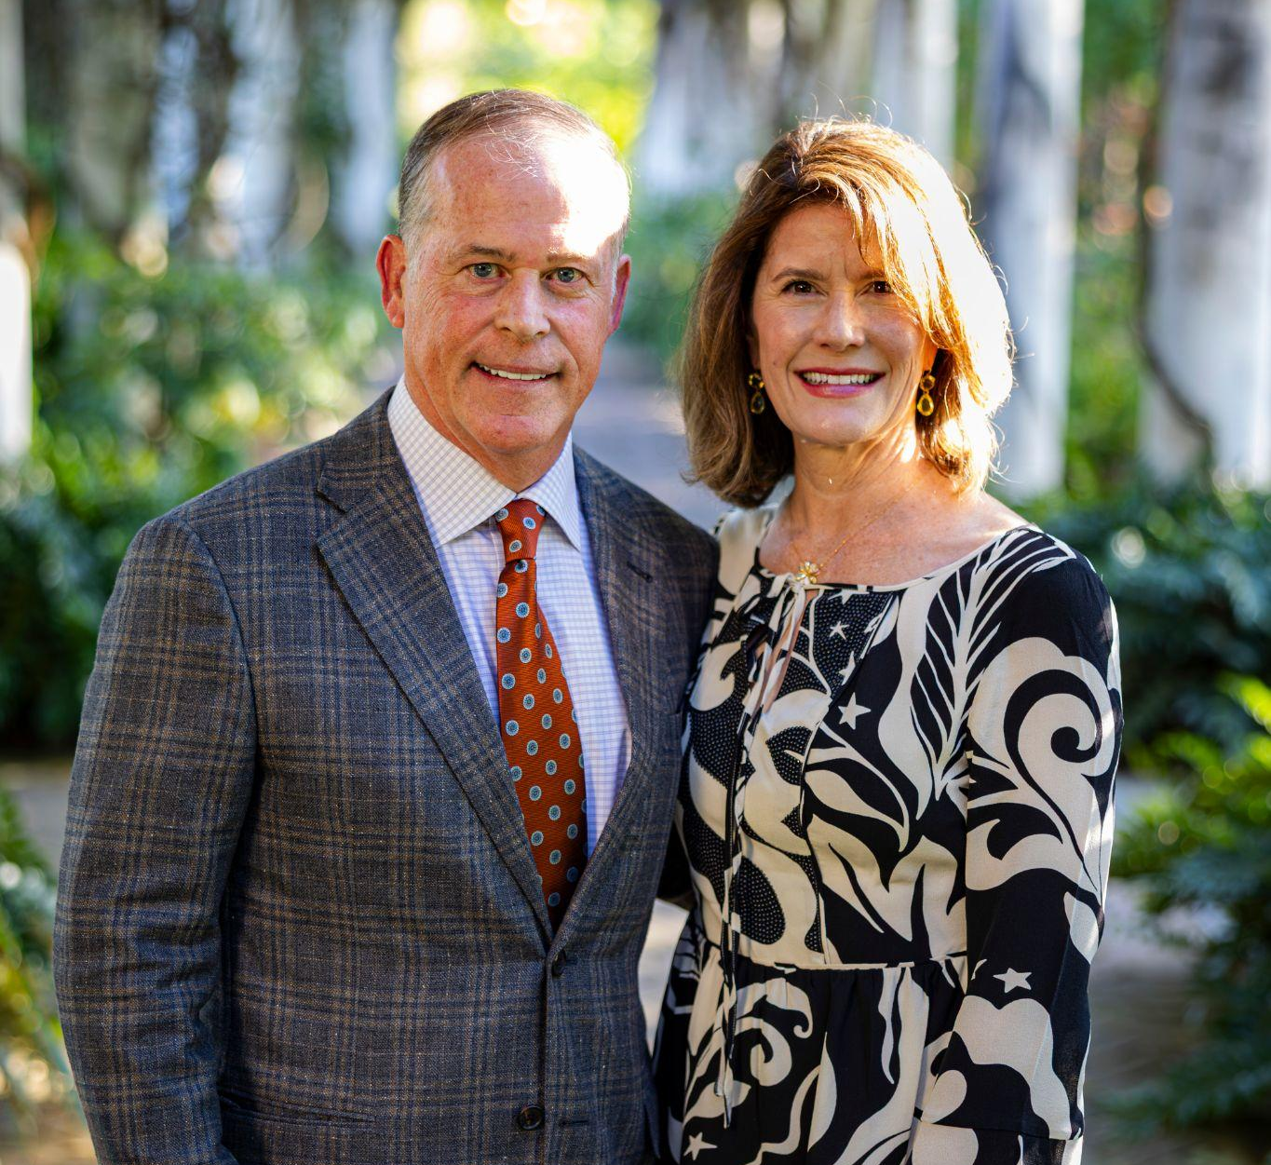
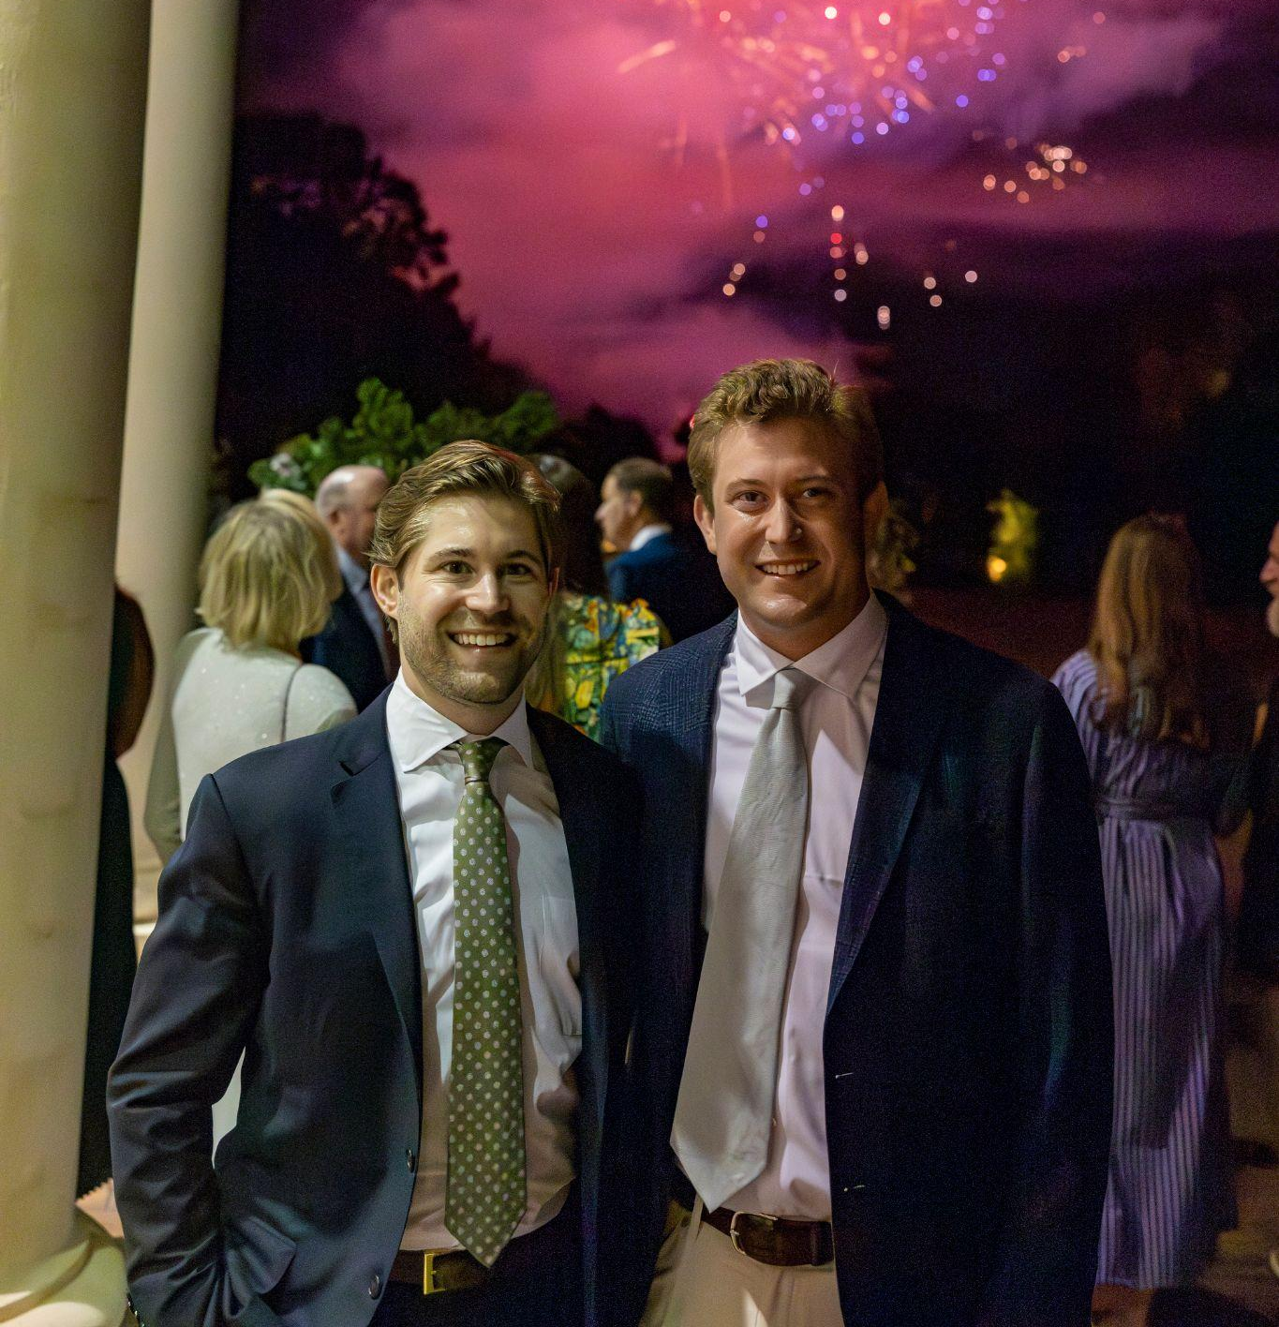
The highlight of the evening was the presentation of the 2025 Allen H. Sims Award to Bill Carstarphen, recognized for his visionary leadership, dedication to community, and commitment to conservation. Tim Belk, who presented the award, praised Carstarphen for his work in developing the Matthews-Belk South Fork Corridor—a 23-mile trail linking Spencer Mountain to Daniel Stowe Conservancy, creating a lasting legacy for the region.

Carstarphen, humbled by the recognition, reflected on his family’s deep roots in McAdenville and the importance of giving back to the community. “None of us are here long,” he said. “That makes it so important that we continue to press on, using whatever gifts we have, and leave a mark of kindness, generosity, and service.”

The evening continued with reflections on the Next Generation Giving Circle, led by Natalie Tindol, founding co-chair, and Lauren Vanacore, Community Engagement Officer. Since its inception in 2000, Next Gen has distributed over $207,000 in grants and engaged hundreds of volunteers in service projects benefiting children, families, the environment, and local nonprofits.

Dr. Richard Rankin highlighted the ongoing impact of philanthropy in Gaston County: “With generous people like you forming a current of giving, we are building a river of generosity that will flow for generations to come. Tonight, we celebrate not just history, but the promise of what is ahead.”

The celebration concluded with a sparkling surprise fireworks display, providing a fitting finale to a night honoring past accomplishments, thanksgiving for the leaders of today, and inspiring future generosity in the community.

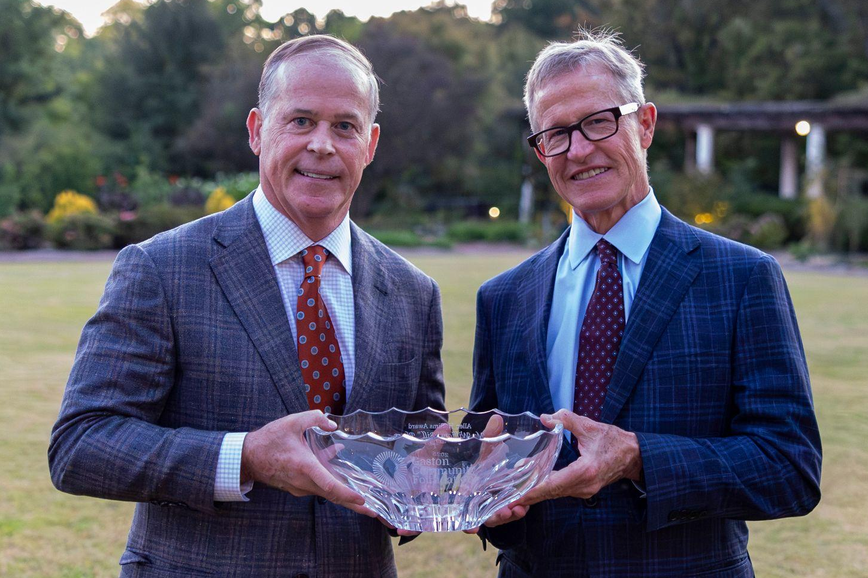
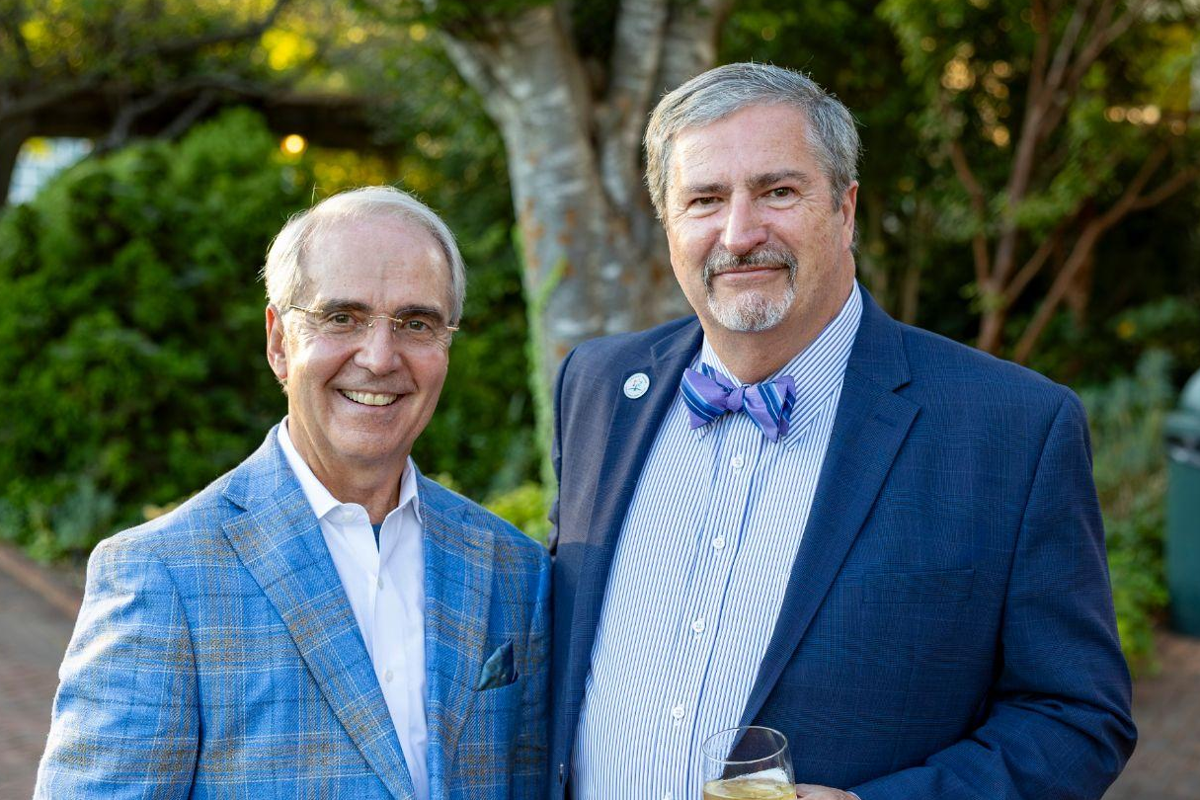
About the Gaston Community Foundation
Founded in 1978, the Gaston Community Foundation connects donors to local causes, manages charitable funds, and uplifts nonprofits working to improve Gaston County. Through grants, scholarships, programs, and initiatives, the Foundation strengthens the community by inspiring giving and building lasting legacies.
